

**AAPP011-4-2 Capstone Project – Cover Sheet**

ASSIGNMENT

**Instruction:**

* Marks will be awarded for good presentation and thoroughness in your approach.
* Referencing Code: If you use some code, or ideas for code, that are taken or adapted from another source (book, magazine, internet, discussion forum, etc), then this **must** be cited and referenced using the APA convention within your source code. Failure to reference code properly is considered plagiarism.
* Complete this cover sheet and attach it to your project's first page.
* This project is to be attempted by a group of 6 students.

|  |  |  |
| --- | --- | --- |
| **Student declaration:** | | |
| *I declare that:* | 1. *We understand what is meant by plagiarism* 2. *The implications of plagiarism have been explained to us by our lecturer* 3. *This project is all our work and we have acknowledged any use of the published or unpublished works of other people.* | |
|  | | Date: 1/1/2025 |

|  |  |
| --- | --- |
| **Project Title:** Fitness Management System with Personalized Diet Plans | **Intake:** UCDF2304ICT(SE) |
| **Name** | **Signature** |
| Wong Kap Onn (TP074292) |  |
| Wong Zheng Han (TP074212 ) |  |
| Ng Wei Yang (TP074904) |  |
| Calvin Giam Jian Tao (TP068321) |  |
| Tan Yen Hann (TP073629) |  |
| Timothy Tan Chern Tian (TP074658) |  |

**Table of Contents**

1.0 Workload Matrix - Proposal 4

2.0 Introduction 7

2.1 Project Background 7

2.2 Project Context 7

2.3 Project Solution 8

2.4 Project Objectives 9

2.5 Project Scope 11

3.0 Project Plan 11

3.1 System Development Methodology 11

3.2 Project Gantt Chart 13

4.0 System Hierarchy Chart 14

5.0 Context Diagram 16

5.1 Data Flow Diagram Level 0 17

5.2 Data Flow Diagram Level 1 and Data Dictionary 18

6.0 Entity Relationship Diagram 61

7.0 Flowchart 61

8.0 Screen Design and User Manual 81

9.0 Report Design and User Manual 95

10.0 Test Plan 99

11.0 Installation & Setup Guide 112

12.0 Conclusion 121

13.0 References 123

14.0 Appendix 124

**List of Figures**

Figure 1: Project Gantt Chart 14

Figure 2: System Hierarchy Chart 15

Figure 3: Context Diagram 16

Figure 4: DFD Level 0 17

Figure 5: Process 1.0 Sign_in 18

Figure 6: Process 2.0 Sign_up 20

Figure 7: Process 3.0 Homepage 23

Figure 8: Process 4.0 Recover_Password 28

Figure 9: Process 5.0 Fitness Tracking 31

Figure 10: Process 6.0 Personalized Diet Plan 35

Figure 11: Process 7.0 Account Settings 38

Figure 12: Process 8.0 Exercise Suggestions 41

Figure 13: Process 9.0 Reports & Analytics 44

Figure 14: Process 10.0 Content Management 47

Figure 15: Process 11.0 User Management 51

Figure 16: Process 12.0 Logs & Feedback 53

Figure 17: Process 13.0 Sign_out 55

Figure 18: Process 14 Admin Registration 59

Figure 19: Entity Relationship Diagram 61

Figure 20: Sign_in Flowchart 62

Figure 21: Sign_ up Flow chart 63

Figure 22: Homepage flowchart 65

Figure 23: Recover_ password Flow chart 66

Figure 24: Fitness Tracking Flowchart 67

Figure 25: Activity Log Flowchart 69

Figure 26: Track Progress Flowchart 70

Figure 27: Account settings Flowchart 71

Figure 28: Exercise Suggestions Flowchart 72

Figure 29: Personalized Diet Plan Flowchart 73

Figure 30: Sign_out Flowchart 74

Figure 31: Report and Analytics Flowchart 75

Figure 32: Content Management Flowchart 76

Figure 33: User Management Flowchart 77

Figure 34: User Logs & Feedback flowchart 78

Figure 35: Admin Registration Flowchart 79

Figure 36: Admin Dashboard flowchart 80

Figure 38: Sign_in 81

Figure 39: Sign_up 82

Figure 40: Homepage 83

Figure 41: Recover_Password 84

Figure 42: Fitness Tracking 85

Figure 43: Account Settings 86

Figure 44: Exercise Suggestion 87

Figure 45: Sign_out 88

Figure 46: Admin Dashboard 89

Figure 47: Reports & Analytics 90

Figure 48: Content Management (Exercise) 91

Figure 49: Content Management (Workout Plan) 92

Figure 50: Content Management (Plan Assignments) 92

Figure 51: User Logs & Feedback 94

Figure 52: Active Users Chart 95

Figure 53: Meal Plan Popularity 96

Figure 54: Exercise Selection Count 97

Figure 55: Personalized diet plan 98

**List of Tables**

Table 1: Workload Matrix - Report 6

Table 2: Testing Administrative Functions 109

Table 3: Testing Customer Functions 110

Table 4: Testing Administrative Functions 111

# 1.0 Workload Matrix - Report

|  |  |  |  |  |  |  |
| --- | --- | --- | --- | --- | --- | --- |
| **Task** | Wong Kap Onn (TP074292) | Ng Wei Yang (TP074904) | Wong Zheng Han (TP074212) | Tan Yen Hann (TP073629) | Calvin Giam Jian Tao (TP068321) | Timothy Tan Chern Tian (TP074658) |
| Introduction | 10% | 15% | 15% | 15% | 15% | 15% |
| Project Plan Methodology and Project Plan & Gantt Chart | 33.33% | 0% | 0% | 33.33% | 0% | 33.33% |
| System Hierarchy Chart | 33.33% | 0% | 33.33% | 0% | 33.33% | 0% |
| Context Diagram | 16.67% | 16.67% | 16.67% | 16.67% | 16.67% | 16.67% |
| Data Flow Diagram Level 0 | 16.67% | 16.67% | 16.67% | 16.67% | 16.67% | 16.67% |
| Data Flow Diagram Level 1 & Data Dictionary | 16.67% | 16.67% | 16.67% | 16.67% | 16.67% | 16.67% |
| Entity Relationship Diagram | 0% | 50% | 50% | 0% | 0% | 0% |
| Flowchart | 16.67% | 16.67% | 16.67% | 16.67% | 16.67% | 16.67% |
| Screen Design and User Manual | 16.67% | 16.67% | 16.67% | 16.67% | 16.67% | 16.67% |
| Report Design and User Manual | 0% | 50% | 50% | 0% | 0% | 0% |
| Test Plan | 20% | 20% | 20% | 20% | 20% | 20% |
| Installation & Setup Guide | 100% | 0% | 0% | 0% | 0% | 0% |
| Conclusion | 0% | 100% | 0% | 0% | 0% | 0% |
| Minutes of Meeting | 100% | 0% | 0% | 0% | 0% | 0% |
| References | 16.67% | 16.67% | 16.67% | 16.67% | 16.67% | 16.67% |
| Group Effort | 16.67% | 16.67% | 16.67% | 16.67% | 16.67% | 16.67% |
| Signature |  |  |  |  |  |  |

Table 1: Workload Matrix - Report

# 2.0 Introduction

## **2.1 Project Background** (Timothy Tan Chern Tian TP074658)

In the fast-moving world we live in today, it has really become very difficult to keep up with keeping fit and one's mental wellbeing due to numerous factors. Very often, it becomes challenging for people to develop personalized fitness, and diet plans as generic health programs often lack consideration for factors such as age, gender, level of activity, or dietary constraints. Additionally, the lack of real-time progress tracking in traditional methods makes it hard for users to monitor their achievements which will often lead to a decrease in motivation and commitment. Moreover, people often have a limited knowledge of nutritional requirements in our daily food intake, such as macronutrient distribution and caloric needs will result in ineffective and unhealthy food practices. To address this issue, our proposed solution is to create a Fitness Management System that will provide personalized solutions, real-time tracking, and educational insights to help users achieve their fitness goals sustainably.

## **2.2 Project Context** (Calvin Giam Jian Tao TP068321)

Problem 1: Difficulty in Personalized Fitness and Diet Planning

Many people struggle with creating fitness and diet programs that meet their goals such as losing weight or building muscle because generic diet and exercise programs may not consider gender, age, exercise level or dietary restrictions (Fitness Guide: A Holistic Approach for Personalized Health and Wellness Recommendation System, 2024).

Problem 2: Lack of Real Time Progress Tracking

Traditional fitness and diet methods often lack tools for real-time tracking and feedback, making it hard for users to monitor their progress. This can lead to decreased motivation and commitment. (Health monitoring web platform for real-time expert-user interaction, 2017)

Problem 3: Limited Knowledge of Nutritional Requirements

Users may not understand the importance of macronutrient distribution (carbs, proteins, fats) and caloric needs for their goals. This gap often leads to ineffective plans or unhealthy practices.

## **2.3 Project Solution** (Wong Zheng Han TP074212)

Problem 1: Difficulty in Personalized Fitness and Diet Planning

Solution: Personalized Diet Plan Module

* Input Details: Users provide their personal details, such as age, gender, weight, height, activity level, dietary preferences, and fitness goals. This ensures the diet plan is specifically tailored to their individual needs.
* Calorie Calculation: By using scientific methods like the Harris-Benedict Equation, the system calculates caloric requirements accurately. This precision helps users stay on track with their fitness goals.
* Meal Plan Generation: The system creates personalized meal plans, complete with a macronutrient breakdown. This provides users with a clear and practical guide to follow to achieve their fitness objectives.

Problem 2: Lack of Real-Time Progress Tracking

Solution: Fitness Tracking Module

* Activity Log: Users can log their daily exercise routines and physical activities, giving them a full overview of their fitness habits.
* Progress Tracking: The system keeps track of key metrics like weight and BMI in real time, making it easier for users to monitor their progress.
* Interactive Dashboard: Graphs and stats are used to display progress trends, helping users stay motivated and committed to their goals.

Problem 3: Limited Knowledge of Nutritional Requirements

Solution: Recommendations Module

* Exercise Suggestions: The system recommends exercises that align with the user’s goals, such as cardio for weight loss or strength training for building muscle.
* Diet Tips: Practical advice is provided on healthy eating habits and food substitutions, improving the user’s understanding of nutrition.
* Macronutrient Information: Each meal plan includes a breakdown of carbs, proteins, and fats, helping users understand their nutritional needs and make informed choices.

System Functionalities Supporting the Solutions

* User Management
  + Registration and Profile Management: Users can create and update their profiles, ensuring the system adapts to their changing fitness needs.

Dashboard

* User-Friendly Interface: The system is designed to be easy to use, so users can quickly access their fitness stats, meal plans, and recommendations.
* Progress Visualization: Charts and graphs display user achievements and highlight areas for improvement, making progress tracking more engaging and effective.

## **2.4 Project Objectives** (Ng Wei Yang TP074904)

**Main Objectives**

* Empower Users with Fitness and Health Plans

Fitness Management System with Personalized Diet Plans is designed to help the users get fit with whichever fitness and health plan they choose. Our system approaches this by providing users with personalized recommendations, followed up with suitable diets and exercise routines.

* Support Personalized Diet Plans

To generate a personalized diet plan for each user, we take into the account information such as their age, weight, gender, their exercise routine. It also takes the user's dietary preferences to encourage users to stick to the diet plans, as meals the users enjoy are more successful. These plans will help the users build muscle, lose weight, or maintain their muscle mass, depending on their goals, this is all done by using the Harris Benedict Equation (HBE) to calculate Basal Metabolic Rate (BMR).

* Facilitate Progress Monitoring

Users will be able to hold themselves accountable by logging they’re weight and Body Mass Index (BMI) daily and thus reviewing and learning from their progress, be it good or bad. It will give them a clear overview through interactive charts graphs that will let the users see the trends to understand or track the improvements towards their fitness target goals.

**Secondary Objectives**

* Encourage Sustainable Health

Our goal is to not only want to give users what they may need in the short term in terms of fitness, but to foster their lifelong wellness by continuously engaging with them, tracking for them, and using the data to provide tailored recommendations for them. Empowering users with the tools to help them stay on track in the long term.

* Ensure User Privacy and Data Integrity

Secure authentication will secure user data from being accessed by anyone who’s not authorized, the users will be able to manage and change their profile securely. Essentially, it features password reset, but also information privacy protection, ensuring safety, while maintaining ease of use.

* Deliver Custom Recommendations

The system will offer specially designed exercise routines and healthy diet advise based on the user’s data. For example, this could include both cardio for weight loss, or strength training for muscle gain and diet recommendations that lean more toward nutrition headed in a healthier eating habits and preference.

**Features and Priorities**

* User-Friendly Interface

The system will offer specially designed exercise routines and healthy diet advise based on the user’s data. For example, this could include both cardio for weight loss, or strength training for muscle gain and diet recommendations that lean more toward nutrition headed in a healthier eating habits and preference.

* Secure Data Management

Key features including, profile management, fitness tracking, personalized meal plans, and recommendations, will be brought under a user-friendly dashboard within the system. To accommodate users of differing technical proficiency, the interface will be responsive across devices, giving them a smooth interactive experience on the platform.

* Progress Tracking with Visual Insights

Reliable data store will be maintained through a centralized database, preventing unauthorized access or data corruption at all steps. This will ensure the integrity of the user's data and accuracy of their fitness calculations.

## **2.5 Project Scope** (Tan Yen Hann TP073629)

1. Core Functionalities

* User Management
  + User registration and login to securely access the system.
* Personalized Diet Plans
  + Collect user input, generate meal plans with calorie counts, macronutrient breakdowns and provide diet tips and healthy eating recommendations.
* Fitness Tracking
  + Log daily activities, such as exercises or steps taken. Monitor and visualize progress metrics like weight and BMI.
* Recommendation
  + Suggest exercises tailored to user goals and offer insights on food substitutions and nutritional improvements.
* Dashboard
  + Display fitness stats, diet plans, and progress through graphs and charts.

2. System Requirements

* A user-friendly, responsive interface compatible with web and mobile platforms.
* Secure database to store user information and progress data.

3. Inclusions

* Tailored diet and fitness plans based on user-provided data.
* Tools for tracking progress and setting fitness goals.
* Educational resources on healthy eating and fitness habits.

4. Exclusions

* The system will not provide medical-grade fitness or diet advice. Integrate with external healthcare or fitness tracking devices

# 3.0 Project Plan

**3.1 System Development Methodology** (Timothy Tan Chern Tian TP074658) (Tan Yen Hann TP073629)

The Waterfall methodology is a step-by-step process where each project phase, like analysis, design, and testing, is completed before moving to the next. It relies on thorough upfront planning and documentation to ensure accurate timelines and predictable outcomes. However, it is less flexible to changes compared to Agile. (Adobe Communications Team)

**Phases of the Waterfall Methodology**

Phase 1: Requirements Gathering and Analysis

In the first phase, all the functional and non-functional requirements for the Fitness Management System are collected from stakeholders to figure out what requirements are needed. We can get then get the requirements through various methods such as interviews, surveys, and questionnaires. The data collected includes users' registration, personalized diet plans, tracking progress, and a simple dashboard. With this information, a Requirements Specification Document (RSD) for the system’s objectives and features can then be created. *GeeksforGeeks. (2018, March 18)*

Phase 2: System Design

Once all the requirements are gathered, the system architecture is then developed. This phase will include creating a detailed system diagrams and database schemas to elaborate on the flow and storage of data. In addition, a user interface prototype is also made for ensuring a seamless and user-friendly experience. *GeeksforGeeks. (2018, March 18)*

Phase 3: Development

In this phase, the Fitness Management System is built based on the design specifications. Developers write the code for various modules, including user management, diet plan generation, activity logging, and progress tracking, while also ensuring that all components integrate effectively. *GeeksforGeeks. (2018, March 18)*

Phase 4: Testing

After the Development phase, the system is then intensively and rigorously tested to ensure that there are no bugs. This will include unit testing for each component, integration testing seamless operation of modules together, and lastly user acceptance testing (UAT) to verify the system meets user requirements. *GeeksforGeeks. (2018, March 18)*

Phase 5: Deployment

Once the testing phase is completed, the system is then deployed to a live environment where users can interact with the Fitness Management System and can use it. The deployment must also ensure that all the features such as diet planning, progress tracking and fitness recommendations work as intended. *GeeksforGeeks. (2018, March 18)*

Phase 6: Maintenance

In the last phase, the system is then maintained to ensure that the fitness management system work as intended. This will include monitoring for bugs, implementing updates and addressing user feedback. The Fitness Management System must also ensure that regular enhancement/updates are made to keep up with the overall user trends and fitness trends. *GeeksforGeeks. (2018, March 18)*

**3.2 Project Gantt Chart** (Wong Kap Onn TP074292)

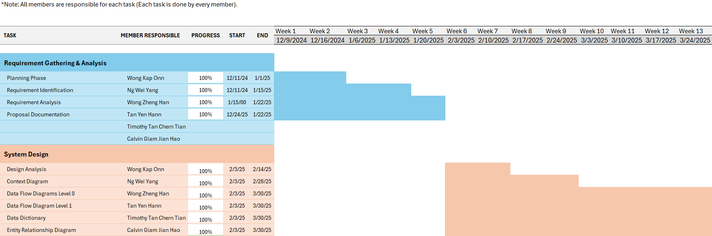

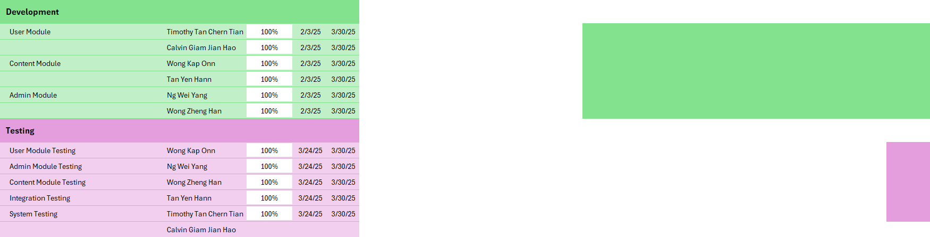

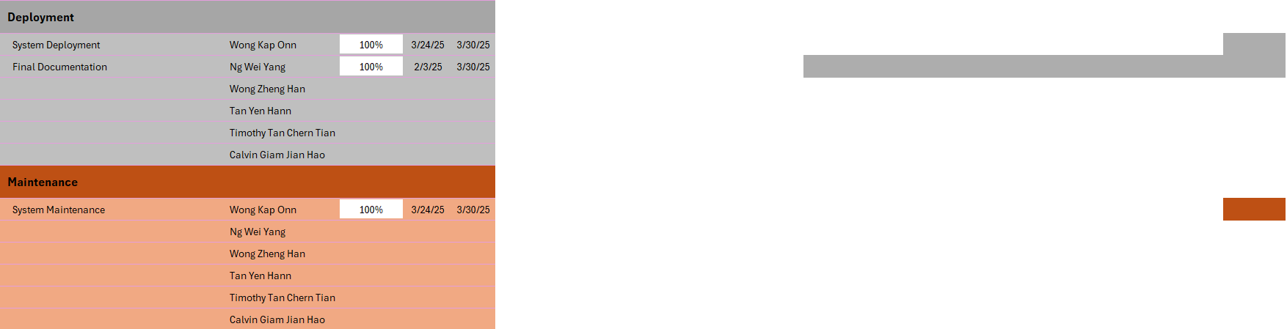

Figure 1: Project Gantt Chart

The Project Gannt Chart is used so that a visual and organized timeline is provided for project planning, scheduling and tracking. As the project is complex, the Project Gantt Chart helps break down the project into small tasks which helps in project planning. With the help of the Project Gantt Chart, the team will have a visual overview of the project information. Last but not least, the project progress can be monitored to ensure that the project is fully completed in a timely manner. Each task is responsible for each member, meaning each member needs to contribute to each task. However, for development task, each member is assigned to modules (e.g. 2 members in one module).

# 4.0 System Hierarchy Chart (Calvin Giam Jian Tao TP068321, Wong Zheng Han TP074212 and Wong Kap Onn TP074292)

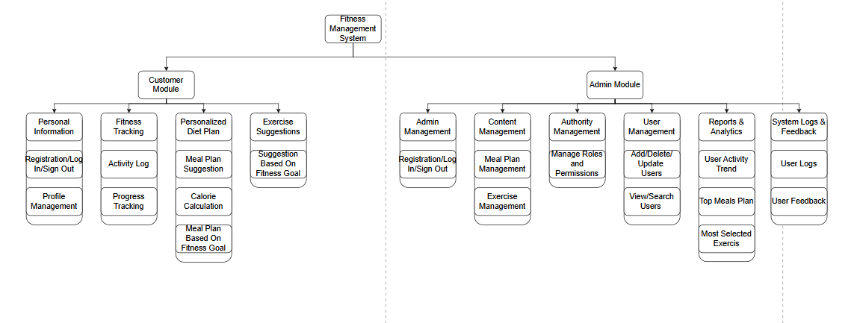

Figure 2: System Hierarchy Chart

The system hierarchy chart for the Fitness Management System is organized and split into sections. The top-level entity is the Fitness Management System which has two main modules: User Module and Admin Module.

The user module is focused on the end-users of the system, where customer can register for the system, log in to their account and sign out. Customers can also manage their profile by updating their personal details like name, weight and age. For fitness tracking section, customers can record daily exercises to keep track of progress. Customers can view their workout progress (e.g. calories burned, total weight volume) to see improvements over time. For personalized diet plans, there are suggested meals that are tailored to user’s fitness goal (e.g. weight loss, muscle gain). The meals will be tailored according to the calories required for customers based on customers’ data. Lastly, exercises will be recommended to customers based on their fitness goal to help accomplish their fitness goal.

The admin module is focused on admins who oversee the system. The admins will be able to register, log in and sign out. For content management section, admins can create, update or remove meal plans or exercises that are recommended for customers. For authority management, admins are allowed to manage customer’s account including updating customer information and deactivating customer account. Admin can also view and search for users. For reports and analytics, reports like Top Meals Plan and Most Selected Exerciseare displayed to help identify trends and for decision making. Lastly, for system logs and feedback, system logs record activities within the system for monitoring and customers can submit feedback about the system to help improve system.

Overall, the system hierarchy chart visualises the structure and flow of the fitness management system’s functionalities, differentiating clearly the what the end-users and admins can do.

# 5.0 Context Diagram (Ng Wei Yang TP074905 and Wong Kap Onn TP074292)

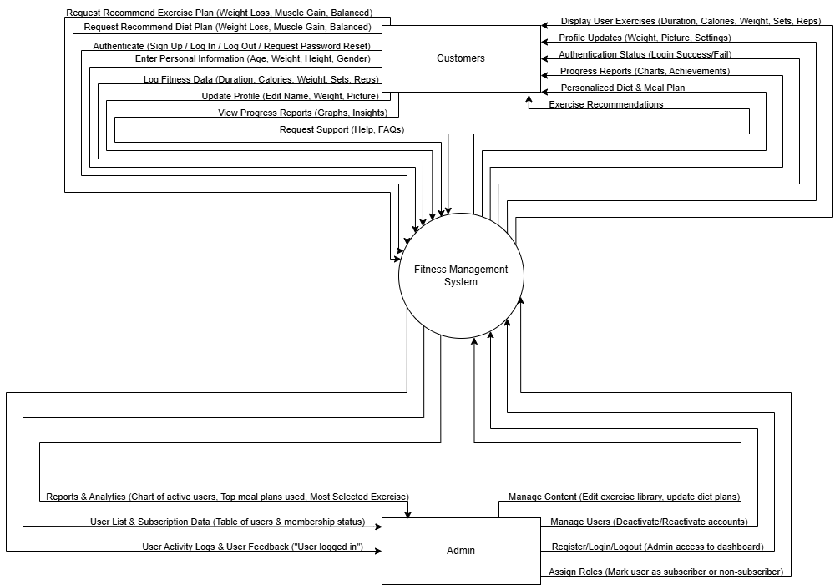

Figure 3: Context Diagram

## **5.1 Data Flow Diagram Level 0**

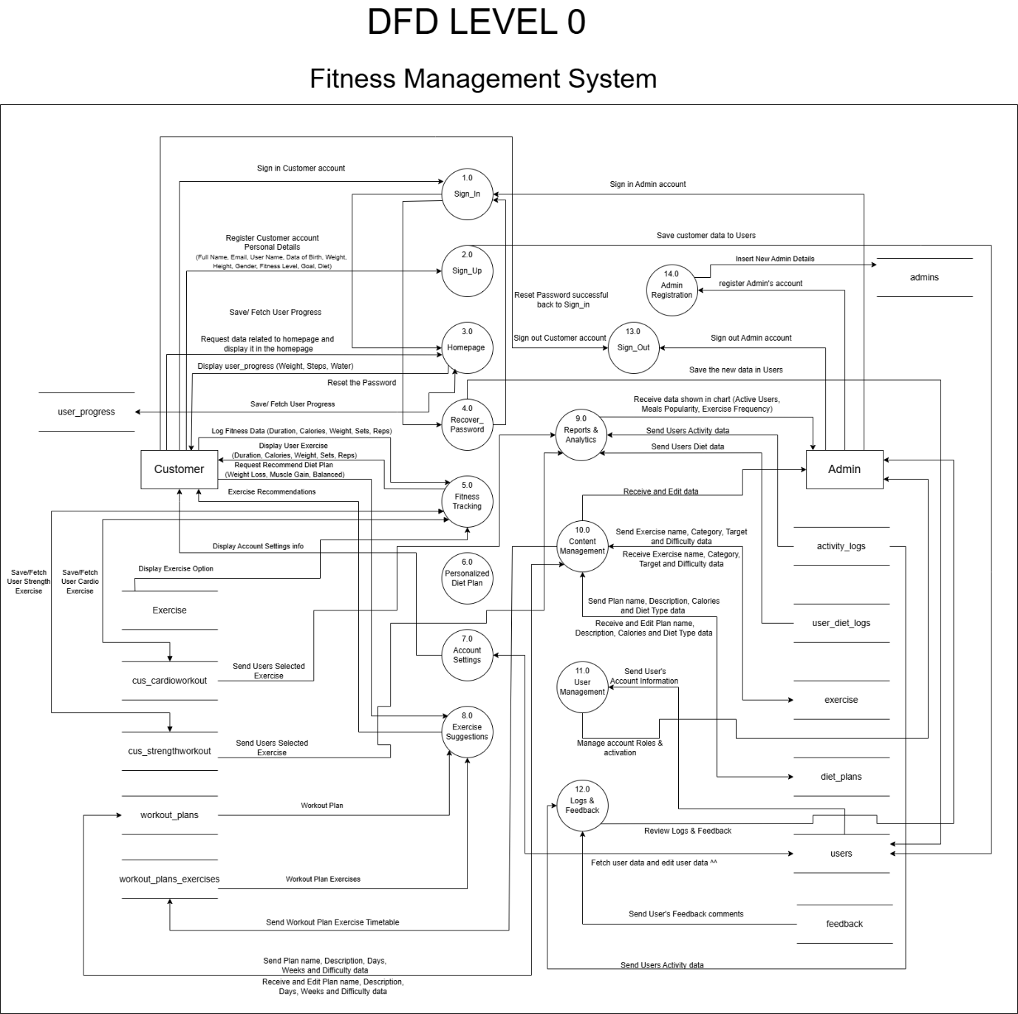

Figure 4: DFD Level 0

## **5.2 Data Flow Diagram Level 1 and Data Dictionary**

**Process 1.0: Sign_in** (Calvin Giam Jian Tao TP068321)

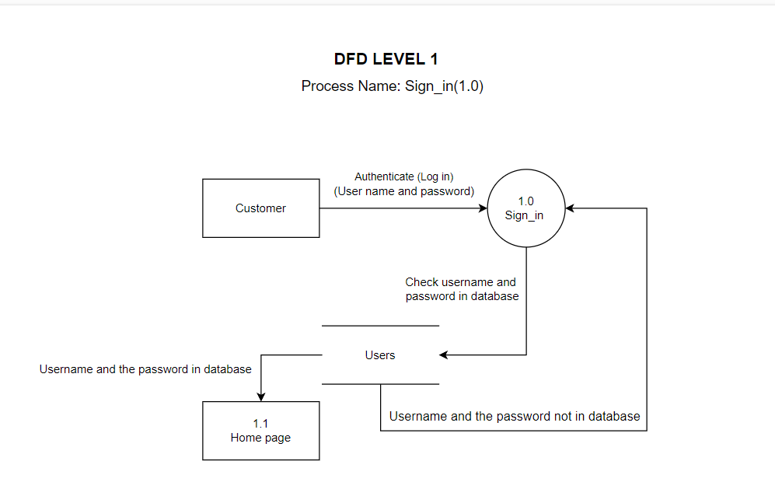

Figure 5: Process 1.0 Sign_in

**Data Dictionary:**

External Entities

Name: CUSTOMER  
Description: The end-user who interacts with the system by attempting to log in.  
Input Data Flows: Authenticate (Log in) (Username, Password)  
Output Data Flows**:** Access Home Page, Error Message (Invalid Username or Password)

Processes

Name: 1.0 Sign_in  
Description: Authenticates the customer by verifying their username and password against the database.  
Input Data Flows: Authenticate (Log in) (Username, Password)  
Output Data Flows: Check username and password in database

Name: 1.1 Home Page  
Description: Grants access to the system if authentication is successful.  
Input Data Flows: Username and Password verified in the database  
Output Data Flows: Display Home Page

Data Flows

Name: Authenticate (Log in)  
Description: Customer inputs their username and password to log in.  
Origin/Source: CUSTOMER  
Destination/Sink: Process 1.0 Sign_in  
Data Structure: Username, Password

Name: Check username and password in database  
Description: The system checks if the entered username and password exist in the database.  
Origin/Source: Process 1.0 Sign_in  
Destination/Sink: Users (Database)  
Data Structure: Username, Password

Name: Username and password in database  
Description: If the credentials match an existing user, access is granted.  
Origin/Source: Users (Database)  
Destination/Sink: Process 1.1 Home Page  
Data Structure: Username, Password

Name: Username and password not in database  
Description: If the credentials do not match, an error message is displayed.  
Origin/Source: Users (Database)  
Destination/Sink: CUSTOMER  
Data Structure: Error Message (Invalid Username or Password)

Name: Users  
Description: List of registered users stored in the database for authentication.  
Origin/Source: Process 1.0 Sign_in  
Destination/Sink: Users (Database)  
Data Structure: User ID, Username, Password, Email

**Process 2.0: Sign_up** (Calvin Giam Jian Tao TP068321)

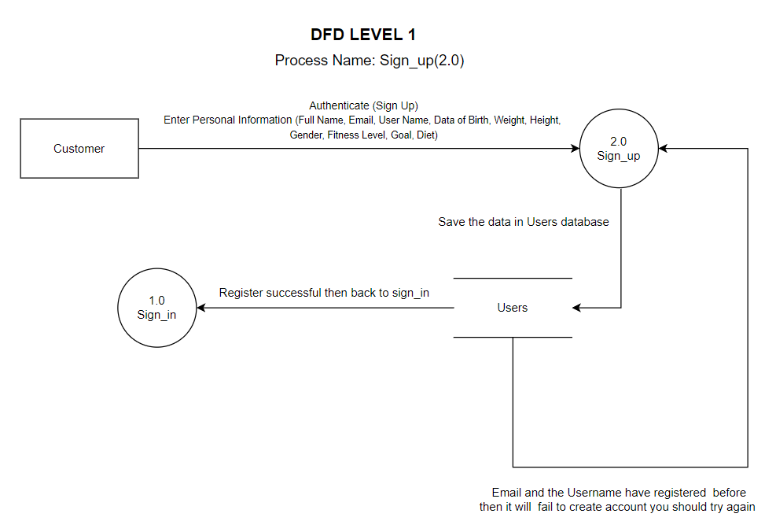

Figure 6: Process 2.0 Sign_up

**Data Dictionary:**

External Entities

Name: CUSTOMER  
Description: The end-user who interacts with the system by signing up for an account.  
Input Data Flows: Authenticate (Sign Up) (Full Name, Email, Username, Date of Birth, Weight, Height, Gender, Fitness Level, Goal, Diet)  
Output Data Flows: Register successful (redirect to Sign_in), Error Message (Email or Username already exists)

Processes

Name: 2.0 Sign_up  
Description: Registers a new customer by collecting their personal information and storing it in the Users database.  
Input Data Flows: Authenticate (Sign Up) (Full Name, Email, Username, Date of Birth, Weight, Height, Gender, Fitness Level, Goal, Diet)  
Output Data Flows: Save the data in Users database, Registration Successful (redirect to Sign_in), Error Message (Email or Username already exists)

Data Flows

Name: Authenticate (Sign Up)  
Description: Customer inputs their personal details to create a new account.  
Origin/Source: CUSTOMER  
Destination/Sink: Process 2.0 Sign_up  
Data Structure: Full Name, Email, Username, Date of Birth, Weight, Height, Gender, Fitness Level, Goal, Diet

Name: Save the data in Users database  
Description: Stores the customer’s information into the Users database if the username and email are unique.  
Origin/Source: Process 2.0 Sign_up  
Destination/Sink: Users (Database)  
Data Structure: User ID, Full Name, Email, Username, Date of Birth, Weight, Height, Gender, Fitness Level, Goal, Diet

Name: Register successful (redirect to Sign_in)  
Description: If the registration is successful, the system redirects the user to the Sign_in page.  
Origin/Source: Process 2.0 Sign_up  
Destination/Sink: Process 1.0 Sign_in  
Data Structure: Success Message

Name: Email or Username already exists  
Description: If the email or username is already registered, the system displays an error message prompting the user to try again.  
Origin/Source: Users (Database)  
Destination/Sink: CUSTOMER  
Data Structure: Error Message

Data Store

Name: Users  
Description: Stores customer details for authentication and profile management.  
Input Data Flows: Save the data in Users database  
Output Data Flows: Check for existing email and username, Register successful (redirect to Sign_in)  
Data Structure: User ID, Full Name, Email, Username, Date of Birth, Weight, Height, Gender, Fitness Level, Goal, Diet

**Process 3.0: Homepage (Timothy Tan Chern Tian TP074658)**

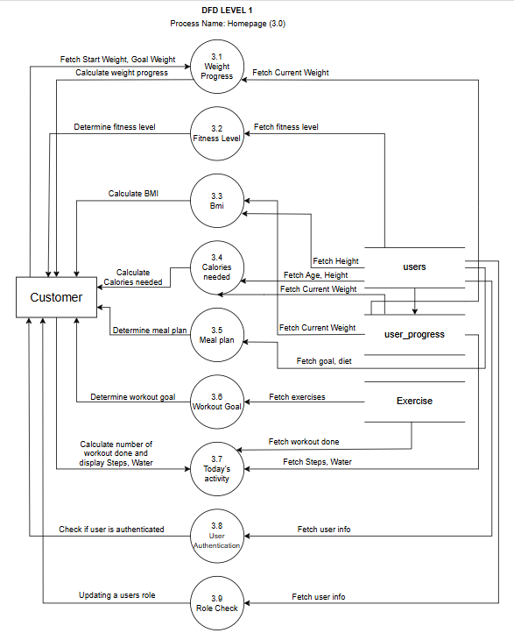

Figure 7: Process 3.0 Homepage

**Data Dictionary:**

Name: Customer

Description: The end users can see all the details on the homepage such as Weight progress, fitness level, bmi, calories needed, meal plan, workout goal, today’s activity, user authentication and role check.

Input Data Flow: Current weight, steps, and water intake

Output data flow: Weight progress, fitness level, bmi, calories needed, meal plan, workout goal and today’s activity

Processes

Name: 3.1 Weight Progress

Description: Display customer’s weight progress

Input data flows: Fetch start weight, goal weight, current weight

Output data flows: Start weight, Current Weight, Goal Weight, Calculate weight progress

Name: 3.2 Fitness Level

Description: Determines the user's fitness level based on weight, height, and age.

Input data flows: Fetch fitness level

Output data flows: Determine Fitness Level

Name: 3.3 BMI

Description: Calculate and display BMI

Input data flows: Fetch current weight, height

Output data flows: Calculate BMI

Name: 3.4 Calories Needed

Description: Calculate and display Calories needed

Input data flows: Fetch age, height, current weight

Output data flows: Calculate Calories Needed

Name: 3.5 Meal Plan

Description: Show what meals to eat

Input data flows: Fetch current weight, goal, diet

Output data flows: Determine meal plan

Name: 3.6 Workout Goal

Description: Show what workouts to do

Input data flows: Fetch Exercises

Output data flows: Determine Workout Goal

Name: 3.7 Today’s activity

Description: Tracks the number of workouts completed and displays steps and water intake

Input data flows: Steps, water intake, fetch workout done

Output data flows: Calculate Number of Workouts Done and Display Steps, Water

Name: 3.8 User Authentication

Description: Checks if the user is authenticated to access the system

Input data flows: Fetch User info

Output data flows: Check if User is Authenticated

Name: 3.9 Role Check

Description: Checking and updating a user's role based on how long they have been registered in the system

Input data flows: users (table)

Output data flows: Stores the modified role if an update was needed.

Data Flows

Name: Fetch start weight, goal weight

Description: Used to calculate weight progress

Origin/Source: users (table)

Destination/Sink: 3.1 Weight Progress

Data structure: Start Weight, Goal Weight

Name: Fetch Current weight

Description: Used in weight progress, BMI calculation, and meal plan determination.

Origin/Source: user_progress (table)

Destination/Sink: 3.1 Weight Progress, 3.3 BMI, 3.5 Meal Plan

Data structure: Current weight

Name: Fetch Height, Age

Description: Used in BMI and calories needed calculations.

Origin/Source: users (table)

Destination/Sink: 3.3 BMI, 3.4 Calories needed

Data structure: Height, Age

Name: Fetch Fitness Level

Description: Used to determine user fitness level.

Origin/Source: users (table)

Destination/Sink: 3.2 Fitness level

Data structure: Fitness level

Name: Fetch goal, diet

Description: Used in meal plan determination.

Origin/Source: users (table)

Destination/Sink: 3.5 meal plan

Data structure: Goal, Diet

Name: Fetch Exercises

Description: Used to determine workout goals.

Origin/Source: exercise (table)

Destination/Sink: 3.6 workout goal

Data structure: Exercise list

Name: Fetch Workout Done

Description: Used to track progress and daily activity.

Origin/Source: exercise (table)

Destination/Sink: 3.6 Workout Goal, 3.7 Today's Activity

Data structure: Workout Done

Name: Fetch Steps, Water

Description: Used to display daily activity data.

Origin/Source: user_progress (table)

Destination/Sink: 3.7 Today's Activity

Data structure: Steps, water intake

Name: Fetch User Info

Description: Used in authentication and role checking.

Origin/Source: users (table)

Destination/Sink: 3.8 User Authentication, 3.9 Role Check

Data structure: User info

Data Store

Name: Users

Description: Store users personal information related to the homepage

Input data flows:

Output data flows: Display user id, weight, height, fitness level, goal, goal value, diet

Data structure: user_id, full_name, email, username, password, dob, height, weight, fitness_level, gender, goal, goal_value, diet, created_at, status, role

Name: users_progress

Description: Store information such as current weight, steps, water intake

Input data flows: Current Weight, Steps, Water intake

Output data flows: Display current weight, steps, water intake

Data structure: id, user_id, weight, steps, water, date

Name: exercise

Description: Stores exercise data for different fitness activities

Input data flows:

Output data flows: Display user id, weight, height, fitness level, goal, goal value, diet

Data structure: E_id, E_name, E_category, E_target, E-difficulty

**Process 4.0: Recover_Password** (Calvin Giam Jian Tao TP078321)

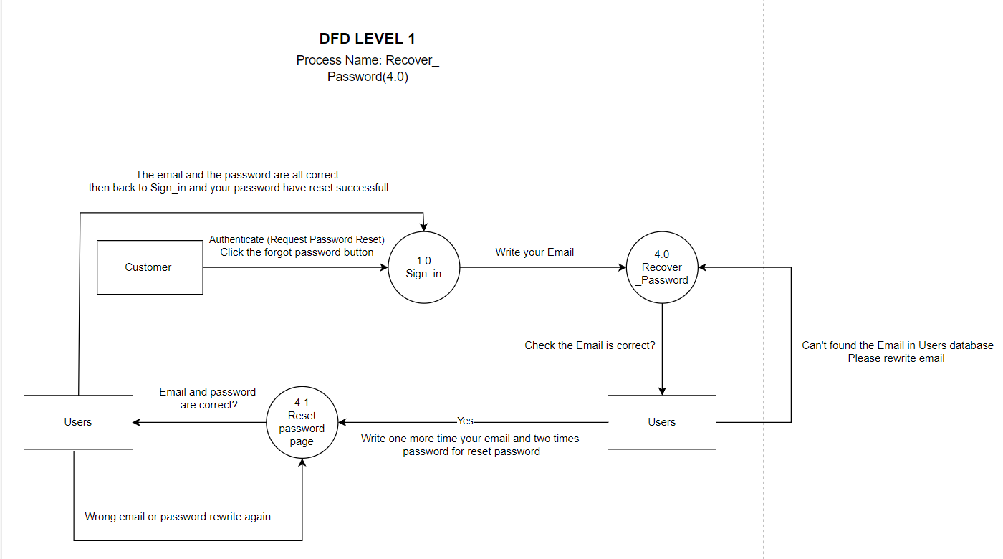

Figure 8: Process 4.0 Recover_Password

**Data Dictionary:**

External Entities

Name: CUSTOMER  
Description: The end-user who interacts with the system to recover their password.  
Input Data Flows: Authenticate (Request Password Reset), Write Email  
Output Data Flows: Email not found (Prompt user to re-enter email), Password Reset Success

Processes

Name: 4.0 Recover_Password  
Description: Verifies if the entered email exists in the database and allows the user to proceed with password recovery.  
Input Data Flows: Write Your Email  
Output Data Flows: Check if Email Exists, Can't Find Email (Prompt to re-enter)

Name: 4.1 Reset_password_page  
Description: If the email is found in the database, the user is prompted to enter a new password twice to confirm it.  
Input Data Flows: Email Verification Success, Enter New Password Twice  
Output Data Flows: Validate Password, Password Reset Successful (Redirect to Sign_in), Wrong Email/Password (Prompt to rewrite)

Data Flows

Name: Authenticate (Request Password Reset)  
Description: The customer initiates a password reset request by clicking "Forgot Password."  
Origin/Source: CUSTOMER  
Destination/Sink: Process 1.0 Sign_in  
Data Structure: Request Password Reset

Name: Write Your Email  
Description: The customer inputs their email to verify their identity for password recovery.  
Origin/Source: CUSTOMER  
Destination/Sink: Process 4.0 Recover_Password  
Data Structure: Email

Name: Check if Email Exists  
Description: The system verifies if the entered email is registered in the Users database.  
Origin/Source: Process 4.0 Recover_Password  
Destination/Sink: Users (Database)  
Data Structure: Email

Name: Can't Find Email  
Description: If the email does not exist in the database, the user is prompted to re-enter their email.  
Origin/Source: Users (Database)  
Destination/Sink: CUSTOMER  
Data Structure: Error Message

Name: Enter New Password Twice  
Description: If the email exists, the user enters a new password twice for confirmation.  
Origin/Source: CUSTOMER  
Destination/Sink: Process 4.1 Reset_password_page  
Data Structure: Email, New Password (Confirmed)

Name: Validate Password  
Description: The system verifies if the entered password is valid and matches the confirmation password.  
Origin/Source: Process 4.1 Reset_password_page  
Destination/Sink: Users (Database)  
Data Structure: New Password

Name: Password Reset Successful  
Description: If the password reset is successful, the user is redirected to the sign-in page.  
Origin/Source: Users (Database)  
Destination/Sink: CUSTOMER (Redirect to Sign_in)  
Data Structure: Success Message

Name: Wrong Email/Password  
Description: If the entered email or password is incorrect, the user is asked to retry.  
Origin/Source: Users (Database)  
Destination/Sink: CUSTOMER  
Data Structure: Error Message

Data Store

Name: Users  
Description: Stores user account details, including email and passwords.  
Input Data Flows: Validate Password (Stores New Password)  
Output Data Flows: Check if Email Exists, Password Reset Successful

**Process 5.0: Fitness Tracking** (Wong Kap Onn TP074292)

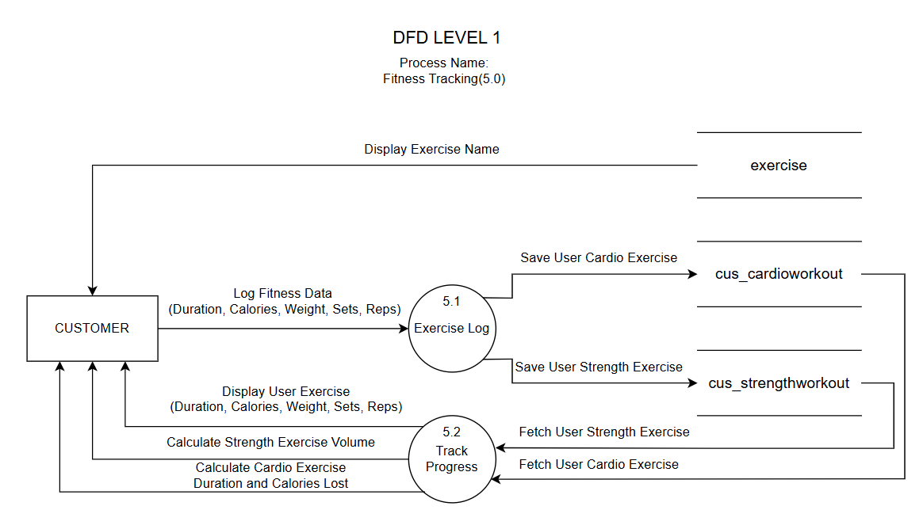

Figure 9: Process 5.0 Fitness Tracking

Data Dictionary:

External Entities

Name: CUSTOMER

Description: The end-user that interacts with the system. Customer inputs fitness data and retrieves exercise data to track progress.

Input data flows: Log Fitness Data (Duration, Calories, Weight, Sets, Reps)

Output data flows: Display User Exercise (Duration, Calories, Weight, Sets, Reps), Calculate Strength Exercise Volume, Calculate Cardio Exercise Duration and Calories Lost.

Process

Name: 5.1 Exercise Log

Description: Saves exercise data that customer inputs and saves it to corresponding database tables (cus_cardioworkout table and cus_strengthworkout table).

Input data flows: Log Fitness Data (Duration, Calories, Weight, Sets, Reps)

Output data flows: Save User Cardio Exercise, Save User Strength Exercise

Name: 5.2 Track Progress

Description: Displays retrieved exercise data from database tables (cus_cardioworkout table and cus_strengthworkout table) and calculate workout progress for customer (total volume, total minutes and total calories).

Input data flows: Fetch User Strength Exercise, Fetch User Cardio Exercise

Output data flows: Display User Exercise (Duration, Calories, Weight, Sets, Reps), Calculate Strength Exercise Volume, Calculate Cardio Exercise Duration and Calories Lost

Data Flow

Name: Display Exercise Data

Description: Displays exercise name for customer to add exercise data.

Origin/Source: exercise table

Destination/Sink: CUSTOMER

Data structure: Exercise name

Name: Log Fitness Data

Description: Customer input fitness data.

Origin/Source: CUSTOMER

Destination/Sink: Process 5.1 Exercise Log

Data structure: Exercise name, Exercise data (cardiovascular: minutes and calories) (strength: weight, reps and sets)

Name: Save User Cardio Exercise

Description: Customer cardio exercise data is saved into database table.

Origin/Source: Process 5.1 Exercise Log

Destination/Sink: cus_cardioworkout table

Data structure: Exercise name, Exercise data (cardiovascular: minutes and calories)

Name: Save User Strength Exercise

Description: Customer strength exercise data is saved into database table.

Origin/Source: Process 5.1 Exercise Log

Destination/Sink: cus_strengthworkout table

Data structure: Exercise name, Exercise data (strength: weight, sets and reps)

Name: Fetch User Cardio Exercise

Description: Retrieve customer cardio exercise data from database table.

Origin/Source: cus_cardioworkout table

Destination/Sink: Process 5.2 Track Progess

Data structure: Exercise name, Exercise data (cardiovascular: minutes and calories)

Name: Fetch User Strength Exercise

Description: Retrieve customer strength exercise data from database table.

Origin/Source: cus_strengthworkout table

Destination/Sink: Process 5.2 Track Progess

Data structure: Exercise name, Exercise data (strength: weight, sets and reps)

Name: Display User Exercise

Description: Display the retrieved customer strength and cardio exercise data from database table.

Origin/Source: Process 5.2 Track Progess

Destination/Sink: CUSTOMER

Data structure: Exercise name, Exercise data (strength: weight, sets and reps) (cardiovascular: minutes and calories)

Name: Calculate Strength Exercise Volume

Description: Calculate the total volume for strength exercise (weight x sets x reps).

Origin/Source: Process 5.2 Track Progess

Destination/Sink: CUSTOMER

Data structure: total volume

Name: Calculate Cardio Exercise Duration and Calories Lost

Description: Calculate the total duration and calories lost for cardio exercise.

Origin/Source: Process 5.2 Track Progess

Destination/Sink: CUSTOMER

Data structure: total minutes and total calories

Data Store

Name: cus_cardioworkout

Description: Stores customer cardio exercise data.

Input data flows: Saves User Cardio Exercise

Output data flows: Fetch User Cardio Exercise

Data structure: CW_id, E_id, CW_minutes, CW_calories, CW_date, user_id

Name: cus_strengthworkout

Description: Stores customer strength exercise data.

Input data flows: Saves User Strength Exercise

Output data flows: Fetch User Strength Exercise

Data structure: SW_id, E_id, SW_minutes, SW_calories, SW_date, user_id

Name: exercise

Description: Stores exercise data.

Input data flows:

Output data flows: Display Exercise Name

Data structure: E_id, E_name, E_category, E_target, E-difficulty

**Process 6.0: Personalized Diet Plan** (Tan Yen Hann Tp073629)

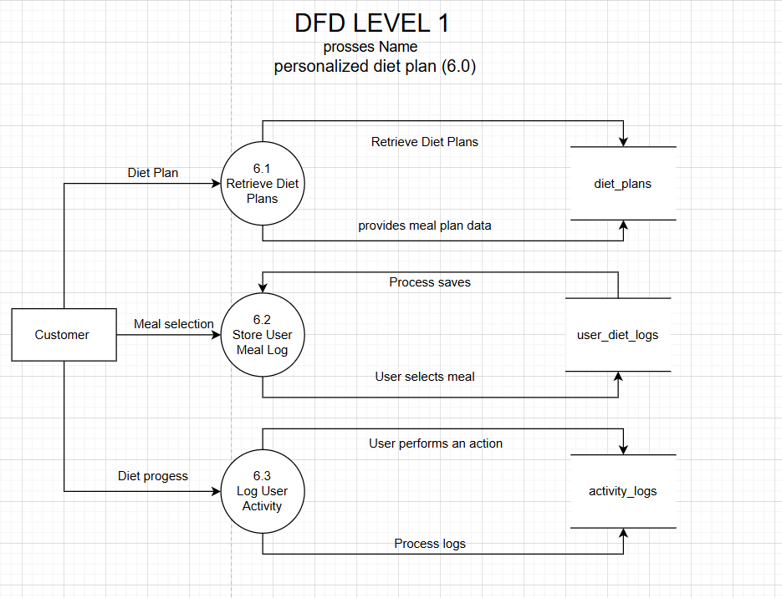

Figure 10: Process 6.0 Personalized Diet Plan

Data Dictionary:

External Entities:

Name: USER

Description: The user interacts with the system to retrieve and log diet plans.  
 Input Data Flows: Select Date, Log Diet Plan  
 Output Data Flows: View Diet Plans, Confirmation Message

**Process:**

Name: 6.1 Retrieve Diet Plans

Description: Fetches available diet plans from the database based on the selected date.  
 Input Data Flows: Select Date  
 Output Data Flows: View Diet Plans

Name: 6.2 Log Diet Plan

Description: Stores the user's selected diet plan in the database.  
 Input Data Flows: Select Diet Plan  
 Output Data Flows: Confirmation Message

Data Flow:

Name: Select Date

Description: User selects a date to retrieve diet plans.  
Origin/Source: USER  
Destination/Sink: 1.1 Retrieve Diet Plans  
Data Structure: user_id, selected_date

Name: View Diet Plans

Description: Displays retrieved diet plans to the user.  
Origin/Source: 1.1 Retrieve Diet Plans  
Destination/Sink: USER  
Data Structure: diet_id, diet_name, calories, description

Name: Select Diet Plan

Description: User selects a specific diet plan to log.  
Origin/Source: USER  
Destination/Sink: 1.2 Log Diet Plan  
Data Structure: user_id, diet_id, meal_time

Name: Confirmation Message

Description: User selects a specific diet plan to log.  
Origin/Source: USER  
Destination/Sink: 1.2 Log Diet Plan

Destination/Sink: USER  
 Data Structure: message_id, status, timestamp

Data Store:

Name: diet_plans

Description: Stores preset diet plans.  
 Input Data Flows:  
 Output Data Flows: View Diet Plans  
 Data Structure: diet_id, diet_name, calories, description

Name: user_diet_logs

Description: Stores user-selected diet logs.  
 Input Data Flows: Select Diet Plan  
 Output Data Flows: Confirmation Message  
 Data Structure: log_id, user_id, diet_id, meal_time, logged_at

**Process 7.0: Account settings (Timothy Tan Chern Tian TP074658)**

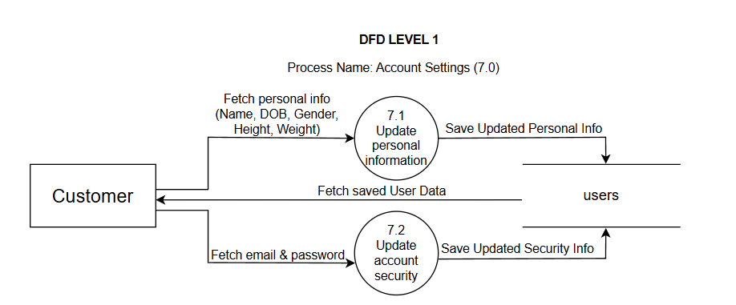

Figure 11: Process 7.0 Account Settings

Data Dictionary:

External Entities

Name: CUSTOMER

Description: The end user can update their personal information, email and password

Input data flows: Fetch personal info (Name, DOB, Gender, Height, Weight), Fetch email & password

Output data flows: Fetch saved user data

Processes:

Name: 7.1 Update Personal Information

Description: Customers can update their personal information

Input data flows: Fetch personal info

Output data flows: Save Updated Personal Info

Name: 7.2 Update Account Security

Description: Customers can update their email and password

Input data flows: Fetch email & password

Output data flows: Save Updated Security Info

Data flow:

Name: Fetch Personal Info

Description: Retrieves user personal details (e.g., Name, DOB, Gender, Height, Weight) from the database.

Origin/Source: users (table)

Destination/Sink: Process 7.1 (Update Personal Information)

Data structure: Name, Date of Birth, Gender, Height, Weight

Name: Update Personal Information

Description: Saves updated personal information entered by the customer.

Origin/Source: Process 7.1 (Update Personal Information)

Destination/Sink: users (table)

Data structure: Updated Name, Updated Date of Birth, Updated Gender, Updated Height, Updated Weight

Name: Fetch Email & Password

Description: Retrieves user email and password from the database for security updates.

Origin/Source: users (table)

Destination/Sink: Process 7.2 (Update Account Security)

Data structure: Email, Password

Name: Update Account Security

Description: Saves updated security details (email and password) entered by the customer.

Origin/Source: Process 7.2 (Update Account Security)

Destination/Sink: users (table)

Data structure: Updated Email, Updated Password

Name: Fetch Saved User Data

Description: Retrieves saved personal and security information for display to the customer.

Origin/Source: users (table)

Destination/Sink: Customer

Data structure: Name, Date of Birth, Gender, Height, Weight, Email

Name: Save Updated Personal Info

Description: Stores the new personal information entered by the customer into the user's table.

Origin/Source: Process 7.1 (Update Personal Information)

Destination/Sink: users (table)

Data structure: Name, Date of Birth, Gender, Height, Weight

Name: Save Updated Security Info

Description: Stores the new email and password entered by the customer into the users database.

Origin/Source: Process 7.2 (Update Account Security)

Destination/Sink: Users Database

Data structure: Email, Password

Data store:

Name: Users

Description: Store users personal information related to the homepage for changing account details

Input data flows: full_name, email, username, password, dob, height, weight, gender

Output data flows: Display user id, weight, height, fitness level, gender, goal, goal value, diet

Data structure: user_id, full_name, email, username, password, dob, height, weight, gender fitness_level, goal, goal_value, diet, created_at, status, role

**Process 8.0: Exercise Suggestions**

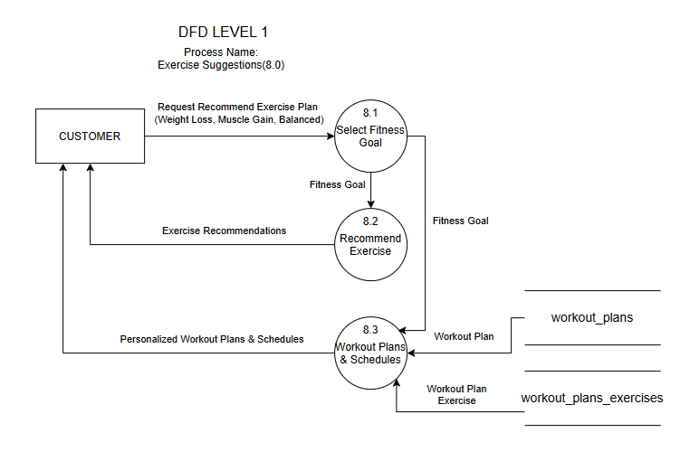

Figure 12: Process 8.0 Exercise Suggestions

Data Dictionary:

External Entities

Name: CUSTOMER

Description: The end-user that interacts with the system. Customer request exercise plan for fitness goal.

Input data flows: Exercise Recommendations

Output data flows: Request Recommend Exercise Plan (Weight Loss, Muscle Gain, Balanced)

Process

Name: 8.1 Select Fitness Goal

Description: Customer selects fitness goal which will display beneficial exercises for the chosen fitness goal.

Input data flows: Request Recommend Exercise Plan (Weight Loss, Muscle Gain, Balanced)

Output data flows: Fitness Goal

Name: 8.2 Recommend Exercise

Description: Exercises are recommended to customer based on fitness goal.

Input data flows: Fitness Goal

Output data flows: Exercise Recommendations

Name: 8.3 Workout Plans & Schedule

Description: Workout Plans & Schedules are recommended to customer based on fitness goal.

Input data flows: Fitness Goal

Output data flows: Personalized Workout Plans & Schedules

Data Flow

Name: Request Recommend Exercise Plan (Weight Loss, Muscle Gain, Balanced)

Description: Customer selects fitness goal.

Origin/Source: CUSTOMER

Destination/Sink: Process 8.1 Select Fitness Goal

Data structure: Fitness Goal

Name: Exercise Recommendations

Description: Exercises recommended for customer.

Origin/Source: Process 8.2 Recommend Exercise

Destination/Sink: CUSTOMER

Data structure: Exercise data.

Name: Fitness Goal

Description: Customer’s fitness goal

Origin/Source: Process 8.1 Select Fitness Goal

Destination/Sink: Process 8.2 Recommend Exercise and Process 8.3 Workout Plans & Schedules

Data structure: Customer’s fitness goal data.

Name: Personalized Workout Plans & Schedules

Description: Personalized Workout Plans & Schedules for customer.

Origin/Source: Process 8.3 Workout Plans & Schedules

Destination/Sink: CUSTOMER

Data structure: Plan name, Plan data (description, difficulty, days, weeks)

Name: Workout Plan

Description: Workout plan data.

Origin/Source: workout_plan table

Destination/Sink: Process 8.3 Workout Plans & Schedules

Data structure: Plan name, Plan data (description, difficulty, days, weeks)

Name: Workout Plan Exercise

Description: Workout plan exercise data

Origin/Source: workout_plan_exercises table

Destination/Sink: Process 8.3 Workout Plans & Schedules

Data structure: Plan data (exercise name, day)

Data Store

Name: workout_plan

Description: Stores workout plan data.

Input data flows:

Output data flows: Workout Plan

Data structure: plan_id, plan_name, description, difficulty, days, weeks

Name: workout_plan_exercises

Description: Stores workout exercise plan data.

Input data flows:

Output data flows: Workout Plan Exercise

Data structure: plan_id, E_id, day_of_week

**Process 9.0: Reports & Analytics** (Wong Zheng Han TP074212)

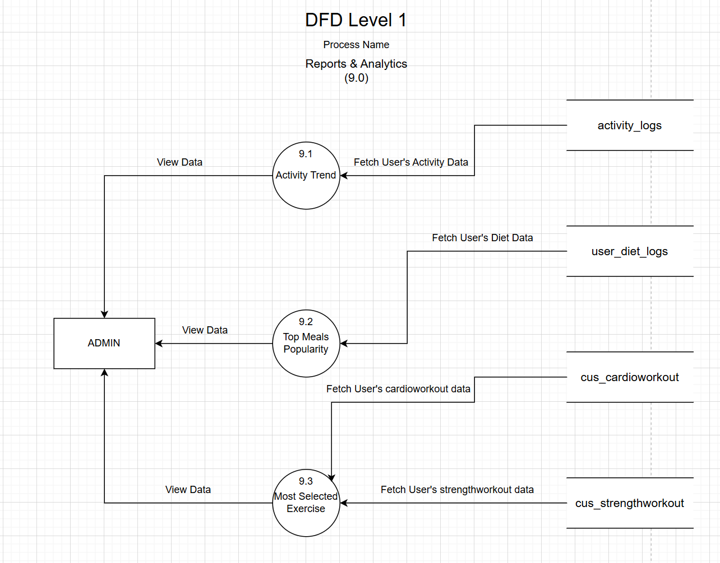

Figure 13: Process 9.0 Reports & Analytics

Data Dictionary:

External Entities

Name: ADMIN

Description: The system administrator manages around system and view summarized data

Input data flows: View Data

Output data flows:

Process

Name: 9.1 Activity Trend

Description: Retrieves data from activity logs data to stores and generate an overall activity trend report.

Input data flows: Fetch User’s Activity Data

Output data flows:

Name: 9.2 Top Meals Popularity

Description: Retrieves data from user diet logs to stores and computes statistic

Input data flows: Fetch User’s Diet Data

Output data flows:

Name: 9.3 Most Selected Exercise

Description: Gathers data from cardioworkout and strengthworkout and shows which exercise is the most trend

Input data flows: Fetch User’s cardioworkout and strengthworkout data

Output data flows:

Data Flow

Name: Fetch User’s Activity Data

Description: Request data from activity logs

Origin/Source: activity_logs data store

Destination/Sink: 9.1 Activity Trend

Data structure: action, log time

Name: View Data

Description: Summarized Data and show to Admin

Origin/Source: 9.1 Activity Trend, 9.2 Top Meals Popularity, 9.3 Most Selected Exercise

Destination/Sink: ADMIN

Data structure:

Name: Fetch User’s Diet Data

Description: Request data from user diet logs

Origin/Source: user_diet_logs data store

Destination/Sink: 9.2 Top Meals Popularity

Data structure:

Name: Fetch User’s Cardioworkout Data

Description: Request data from cus cardioworkout

Origin/Source: cus_cardioworkout data store

Destination/Sink: 9.3 Most Selected Exercise

Data structure:

Name: Fetch User’s Strength Data

Description: Request data from cus strengthworkout

Origin/Source: cus_strengthworkout data store

Destination/Sink: 9.3 Most Selected Exercise

Data structure:

Data Store

Name: cus_cardioworkout

Description: Stores customer cardio exercise data.

Input data flows:

Output data flows: Fetch User Cardio Exercise

Data structure: CW_id, E_id, CW_minutes, CW_calories, CW_date, user_id

Name: cus_strengthworkout

Description: Stores customer strength exercise data.

Input data flows:

Output data flows: Fetch User Strength Exercise

Data structure: SW_id, E_id, SW_minutes, SW_calories, SW_date, user_id

Name: activity_logs

Description: Stores user's action

Input data flows:

Output data flows: Fetch User Activity

Data structure: log_id, user_id, action, log_time

Name: user_diet_logs

Description: Stores user’s meal type & description

Input data flows:

Output data flows: Fetch User Meal Type

Data structure: log_id, user_id, diet_id, meal_description, calories, log_date

**Process 10.0: Content Management (Wong Zheng Han TP074212)**

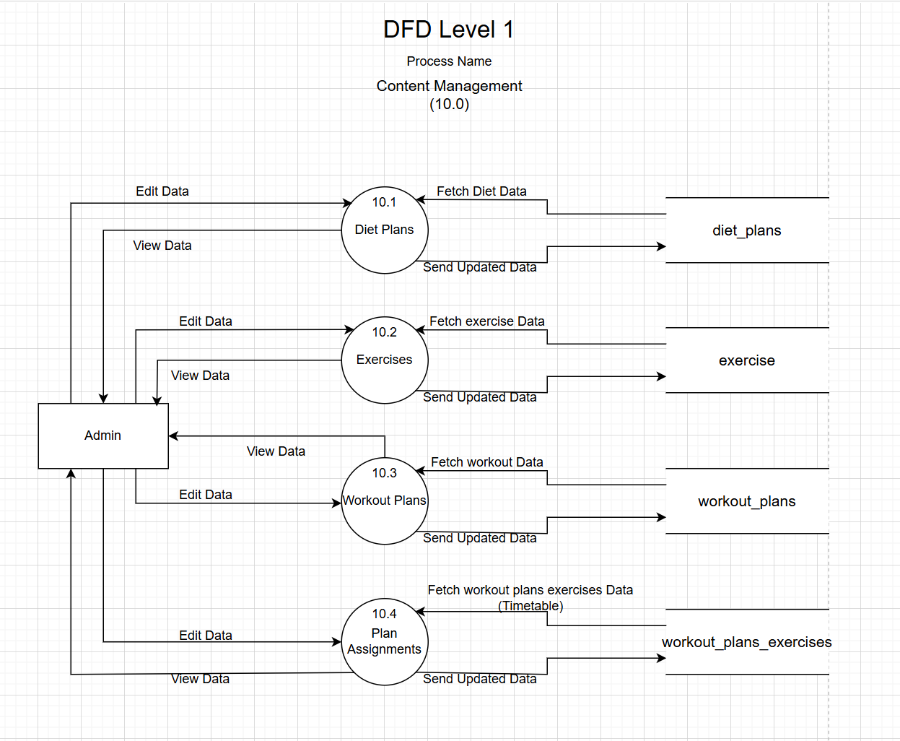

Figure 14: Process 10.0 Content Management

Data Dictionary:

External Entities

Name: ADMIN

Description: The system administrator manages around system and view summarized data

Input data flows: View Data

Output data flows: Edit Data

Process

Name: 10.1 Diet Plans

Description: Retrieves data from Diet plans data to stores and generate a table

Input data flows: Fetch Diet Data

Output data flows: Send Updated Data

Name: 10.2 Exercises

Description: Retrieves data from exercise data to stores and generate a table

Input data flows: Fetch exercises Data

Output data flows: Send Updated Data

Name: 10.3 Workout Plans

Description: Retrieves data from workout plan data to stores and generate a table

Input data flows: Fetch workout Data

Output data flows: Send Updated Data

Name: 10.4 Plan Assignments

Description: Retrieves data from workout plan exercise data to stores and generate a table

Input data flows: Fetch workout plans exercises Data

Output data flows: Send Updated Data

Data Flow

Name: Edit Data

Description: Request data from Diet Plans, Exercises, Workout Plans, Plan Assignments

Origin/Source: diet_plans, exercise, workout_plans, workout_plans_exercises

Destination/Sink: 10.1 Diet Plans, 10.2 Exercises, 10.3 Workout Plans, 10.4 Plan Assignments

Data structure: Description, Calories, Exercise name, Category, target, Difficulty, Plan name, Days, Weeks.

Name: View Data

Description: Summarized Data and show to Admin

Origin/Source: 10.1 Diet Plans, 10.2 Exercises, 10.3 Workout Plans, 10.4 Plan Assignments

Destination/Sink: ADMIN

Data structure:

Name: Fetch Diet Data

Description: Request data from diet plans

Origin/Source: diet_plans data store

Destination/Sink: 10.1 Diet Plans

Data structure:

Name: Fetch exercise Data

Description: Request data from exercise

Origin/Source: exercise data store

Destination/Sink: 10.2 Exercises

Data structure:

Name: Fetch workout Data

Description: Request data from workout plans

Origin/Source: workout_plans data store

Destination/Sink: 10.3 Workout Plans

Data structure:

Name: Fetch workout plans exercises Data

Description: Request data from workout plan exercises

Origin/Source: workout_plans_exercises data store

Destination/Sink: 10.4 Plan Assignments

Data structure:

Name: Send Updated Data

Description: Request data from 10.1 Diet Plans, 10.2 Exercises, 10.3 Workout Plans, 10.4 Plan Assignments

Origin/Source: ADMIN

Destination/Sink: diet_plans, exercise, workout_plans, workout_plans_exercises

Data structure:

Data Store

Name: diet_plans

Description: Stores diet plan data.

Input data flows: Send Updated Data

Output data flows: Fetch Diet Data

Data structure: diet_id, plan_name, description, calories, diet_type

Name: exercise

Description: Stores exercise data.

Input data flows: Send Updated Data

Output data flows: Fetch exercise Data

Data structure: E_id, E_name, E_category, E_target, E_difficulty

Name: workout_plans

Description: Stores workout plan data

Input data flows: Send Updated Data

Output data flows: Fetch workout Data

Data structure: plan_id, plan_name, description, difficulty, days, weeks

Name: workout_plans_exercises

Description: Stores workout plans of the week

Input data flows: Send Updated Data

Output data flows: Fetch workout plan exercises Data

Data structure: plan_id, E_id, day_of_week

**Process 11.0: User Management (Ng Wei Yang TP074904)**

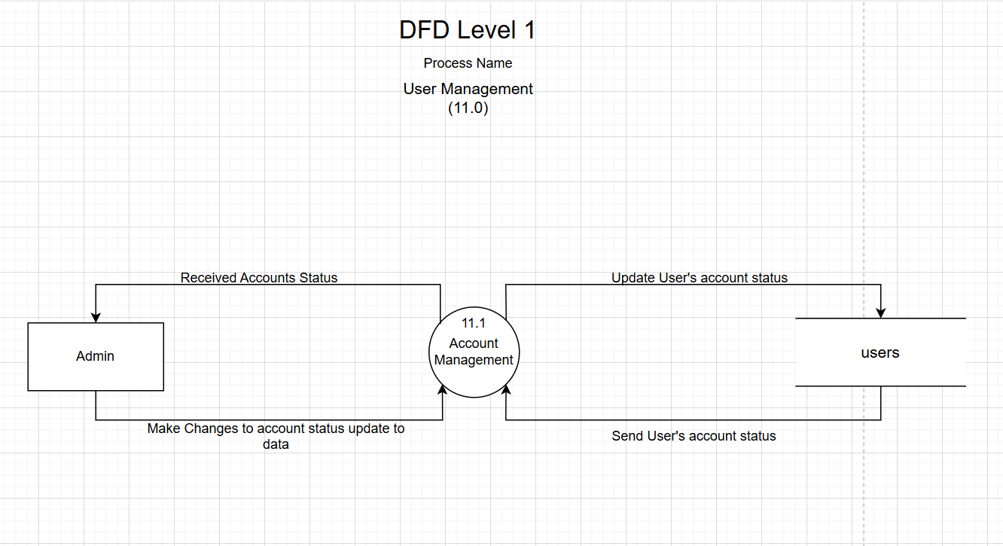

Figure 15: Process 11.0 User Management

Data Dictionary:

External Entities

Name: ADMIN

Description: The system administrator manages around system and view summarized data

Input data flows: Received Accounts Status

Output data flows: Make Changes to account status update to data

Process

Name: 11.1 Account Management

Description: Retrieves data from users data to stores and generate a table

Input data flows: Send User’s account status

Output data flows: Update User’s account status

Data Flow

Name: Make Changes to account status update to data

Description: Send data to Account Management

Origin/Source: users

Destination/Sink: 11.1 Account Management

Data structure: Deactivate account, Reactivate account

Name: Received Account Status

Description: Request data from Account Management

Origin/Source: users

Destination/Sink: ADMIN

Data structure:

Name: Update User's account status

Description: Request data from Account Management

Origin/Source: ADMIN

Destination/Sink: users

Data structure:

Name: Send User’s account status

Description: Send data to Account Management from users

Origin/Source: users

Destination/Sink: Account Management

Data structure:

Data Store

Name: users

Description: Stores user's account information data.

Input data flows: Update User’s account status

Output data flows: Send User’s account status

Data structure: user_id, full_name, email, username, password, dob, height, weight, gender, fitness_level, goal, goal_value, diet, create_at, status, role

**Process 12.0: Logs & Feedback (Ng Wei Yang TP074904)**

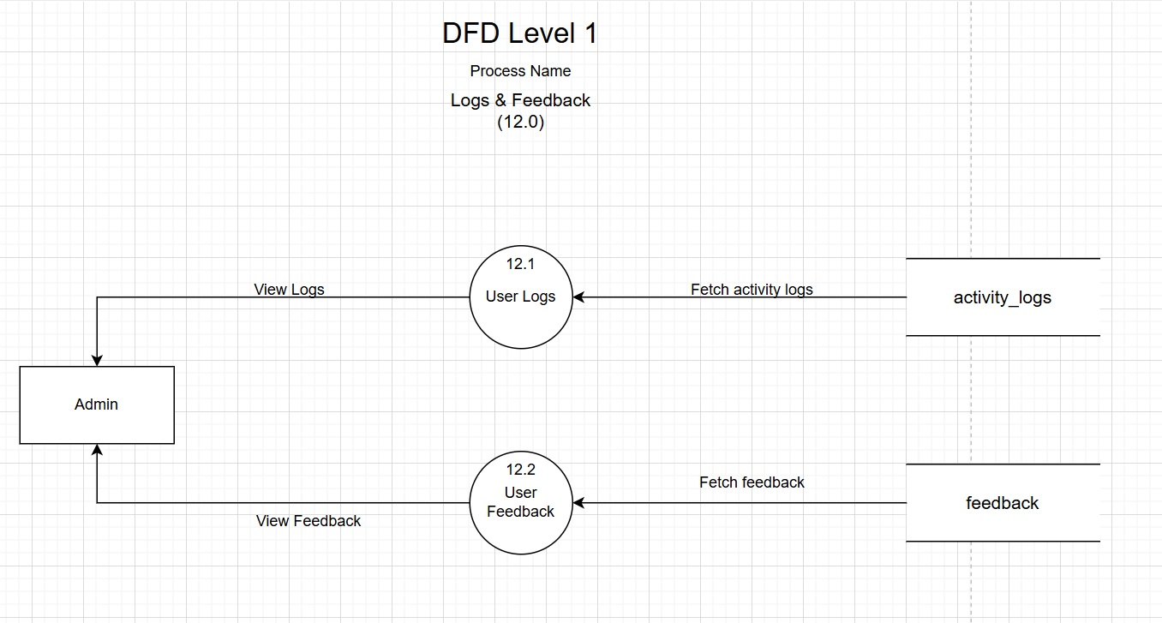

Figure 16: Process 12.0 Logs & Feedback

Data Dictionary:

External Entities

Name: ADMIN

Description: The system administrator manages around system and view summarized data

Input data flows: View Logs, View Feedback

Output data flows:

Process

Name: 12.1 User Logs

Description: Retrieves data from activity logs data to stores and generate a table

Input data flows: Fetch activity logs

Output data flows: View Logs

Name: 12.2 User Feedback

Description: Retrieves data from feedback data to stores and generate a comment

Input data flows: Fetch feedback

Output data flows: View feedback

Data Flow

Name: Fetch activity logs

Description: Send data to activity logs

Origin/Source: activity_logs

Destination/Sink: 12.1 User Logs

Data structure: Data, User, Log Message

Name: View Logs

Description: Request data from User Logs

Origin/Source: User Logs

Destination/Sink: ADMIN

Data structure:

Name: Fetch feedback

Description: Request data from feedback

Origin/Source: feedback

Destination/Sink: Users feedback

Data structure: user id, message

Name: View feedback

Description: Request data from User feedback

Origin/Source: User feedback

Destination/Sink: ADMIN

Data structure:

Data Store

Name: activity_logs

Description: Stores user's activity data.

Input data flows:

Output data flows: Fetch activity logs

Data structure: log_id, user_id, action, log_time

Name: feedback

Description: Stores user's feedback data.

Input data flows:

Output data flows: Fetch feedback

Data structure: feedback_id, user_id, message, submitted_at

**Process 13.0: Sign_out (Timothy Tan Chern Tian TP074658)**

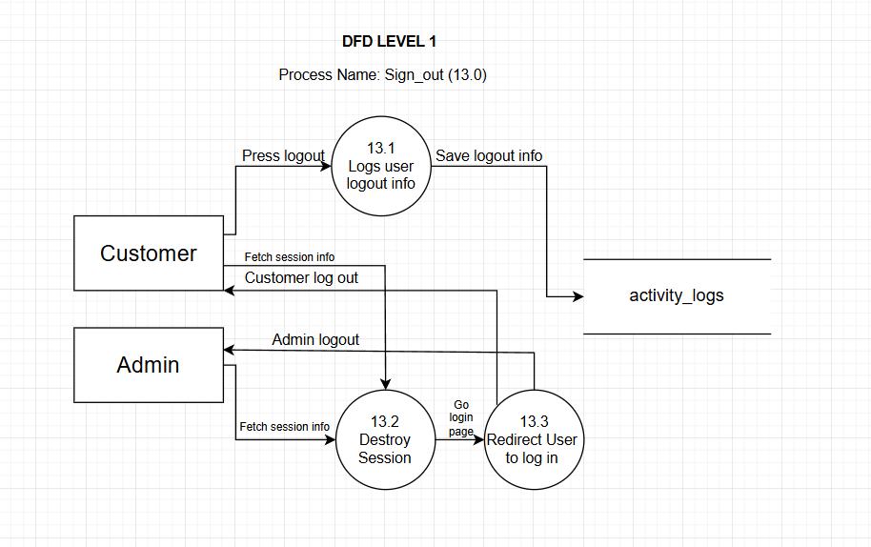

Figure 17: Process 13.0 Sign_out

Data Dictionary:

External Entities

Name: CUSTOMER

Description: An end-user who interacts with the system and performs the logout process.

Input data flows: Press Logout

Output data flows: Customer logout

Name: ADMIN

Description: A system administrator who manages the system and performs the logout process.

Input data flows: Press Logout

Output data flows: Admin Logout

Processes:

Name: 13.1 Logs User Logout Info

Description: Records the user logout information and saves it to the activity_logs data store.

Origin/Source: Press Logout

Destination/Sink: Save Logout Info

Name: 13.2 Destroy Session

Description: Terminates the user session and clears all session data from the server.

Origin/Source: Fetch Session Info (from Customer or Admin)

Destination/Sink:

Name: 13.3 Redirect User to Log In

Description: Redirects the user to the login page after successful logout and session termination.

Origin/Source:

Destination/Sink: Go to Login Page

Data Flow

Name: Press Logout

Description: The action triggered by the user to initiate the logout process.

Origin/Source: Customer or Admin

Destination/Sink: Process 13.1 Logs User Logout Info

Data structure:

Name: Fetch Session Info

Description: Retrieves the current session data before terminating the session.

Origin/Source: Customer or Admin

Destination/Sink: Process 13.2 Destroy Session

Data structure: Session ID, User ID

Name: Customer Logout

Description: Confirms that the customer has logged out

Origin/Source: Customer

Destination/Sink: Process 13.2 Destroy Session

Data structure: User ID, Logout Status

Name: Admin Logout

Description: Confirms that the admin has logged out.

Origin/Source: Admin

Destination/Sink: Process 13.2 Destroy Session

Data structure: User ID, Logout Status

Name: Save Logout Info

Description: Stores the user logout information to the activity_logs table.

Origin/Source: Process 13.1 Logs User Logout Info

Destination/Sink: activity_logs

Data structure: User ID, Timestamp, Logout Status

Name: Go to Login Page

Description: Redirects the user to the login page after successful logout.

Origin/Source: Process 13.3 Redirect User to Log In

Destination/Sink: Login Page

Data structure:

Data Store

Name: activity_logs

Description: Stores the logout information for both customers

Input data flows: Save Logout Info

Output data flows:

Data structure: log_id, user_id, action, log_time

**Process 14.0: Admin Registration (Ng Wei Yang TP074904)**

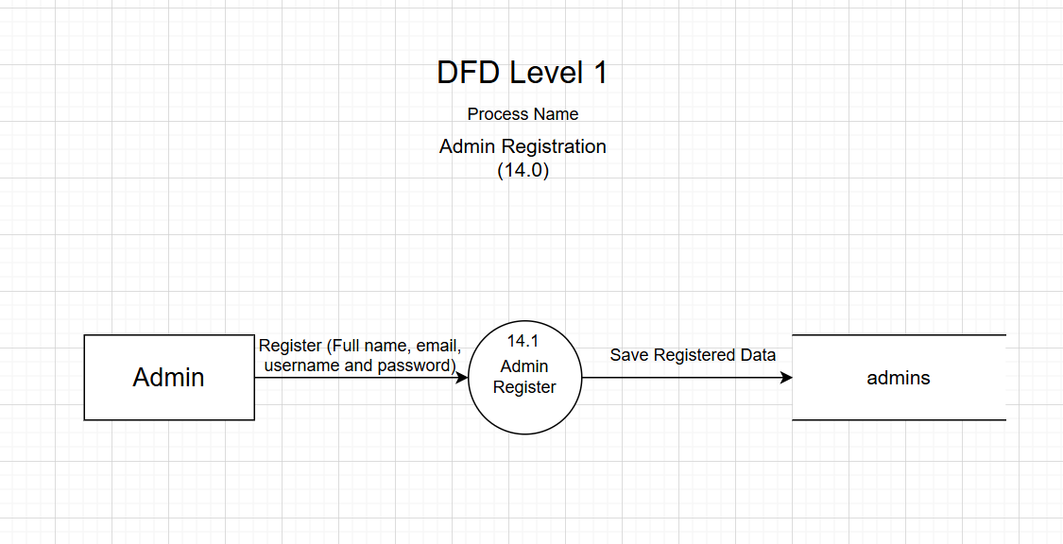

Figure 18: Process 14 Admin Registration

Data Dictionary:

External Entities

Name: ADMIN

Description: The system administrator manages around system and view summarized data

Input data flows:

Output data flows: Register Credentials

Process

Name: 14.1 Admin Register

Description: Obtain Admin’s Registration Data

Input data flows:

Output data flows: Save Registered Data

Data Flow

Name: Register (Full name, email, username and password)

Description: Send data to Admin Register

Origin/Source: ADMIN

Destination/Sink: 14.1 Admin Register

Data structure: Full name, email, username and password

Name: Save Registered Data

Description: Send data to admins

Origin/Source: Admin Register

Destination/Sink: admins

Data structure: Full name, email, username and password

Data Store

Name: admins

Description: Stores the login information of admin

Input data flows: Save Registered Data

Output data flows:

Data structure: admin_id, full_name, email, username, password, created_at

# 6.0 Entity Relationship Diagram (Ng Wei Yang TP074904 & Wong Zheng Han TP074212)

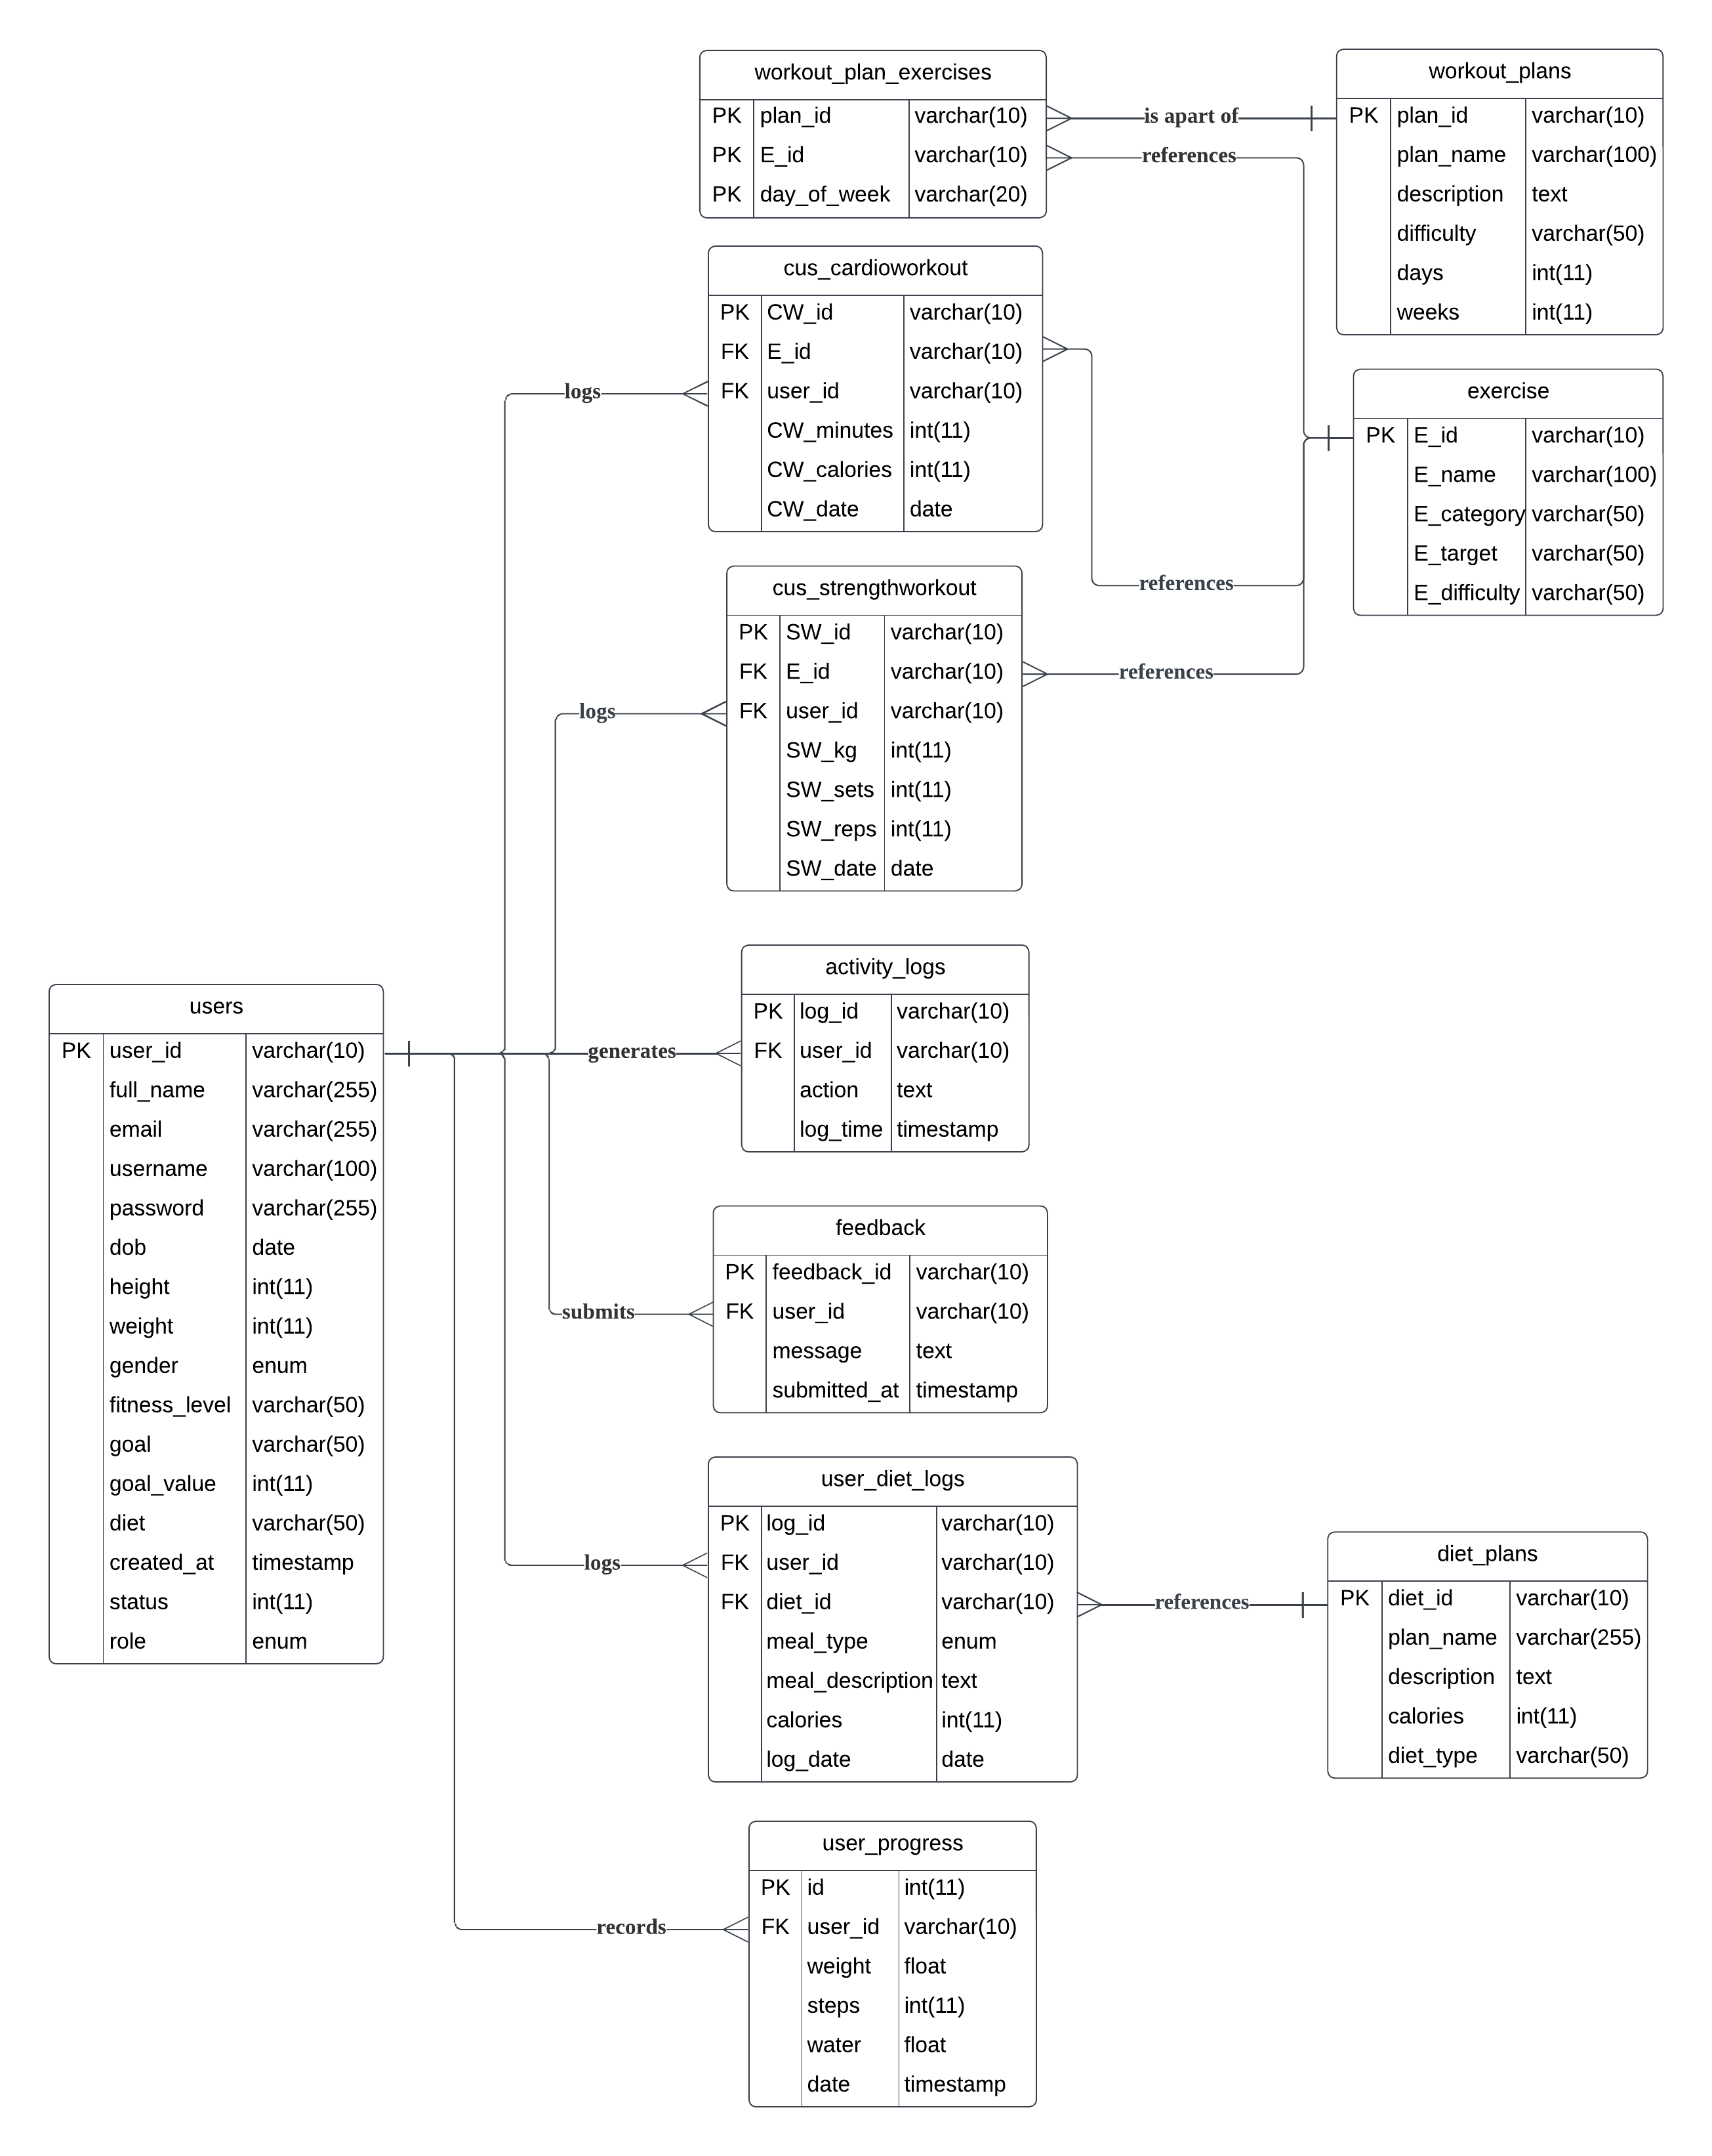

Figure 19: Entity Relationship Diagram

# 7.0 Flowchart

Figure 20: Sign_in Flowchart

# Process 2.0: Sign_up (Calvin Giam Jian Tao TP068321)

Figure 21: Sign_ up Flow chart

# Process 3.0: Homepage (Timothy Tan Chern Tian TP074658)

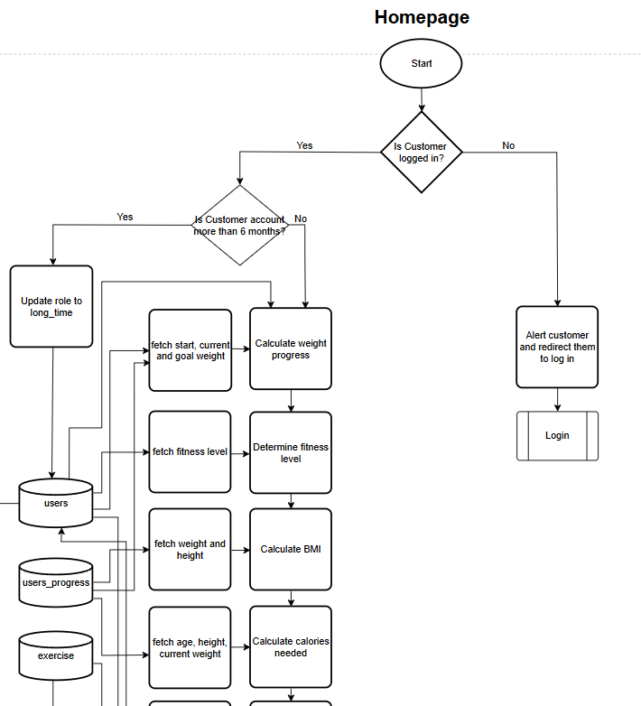

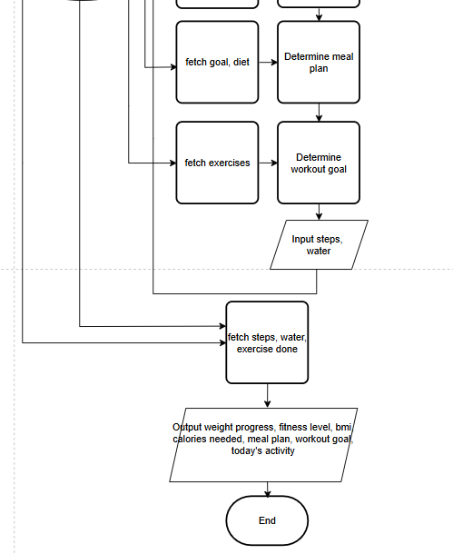

Figure 22: Homepage flowchart

# Process 4.0: Recover_password (Calvin Giam Jian TaoTP068321)

Figure 23: Recover_ password Flow chart

**Process 5.0: Fitness Tracking** (Wong Kap Onn TP074292)

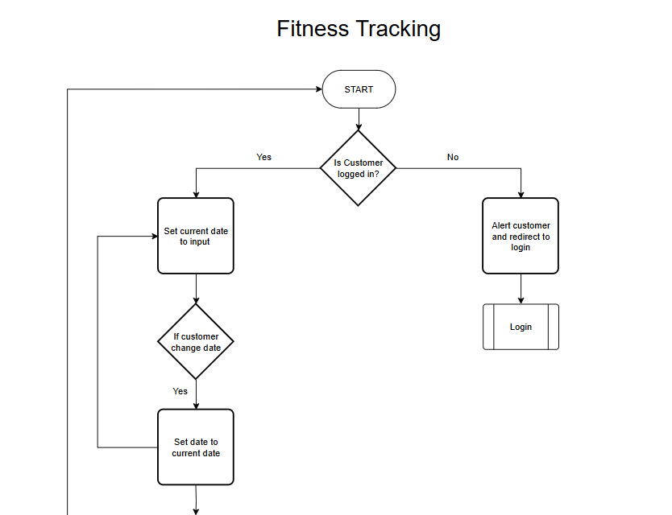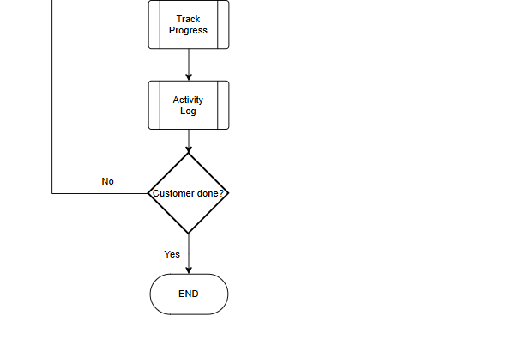

Figure 24: Fitness Tracking Flowchart

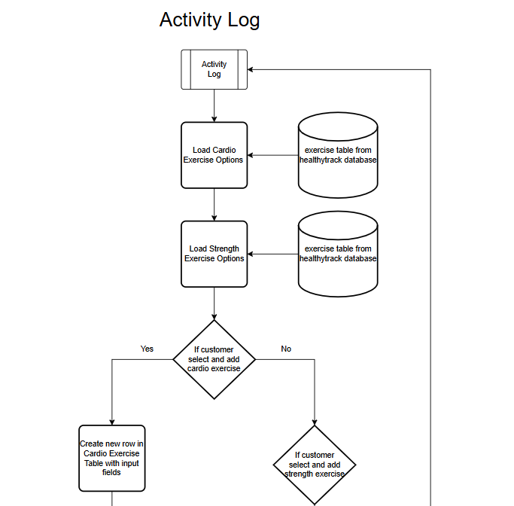

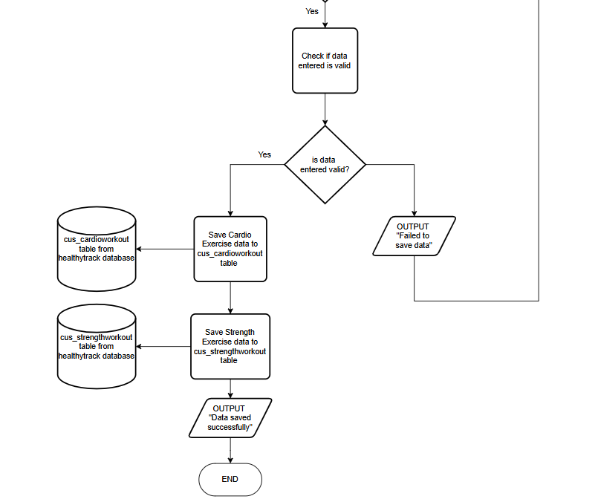

Figure 25: Activity Log Flowchart

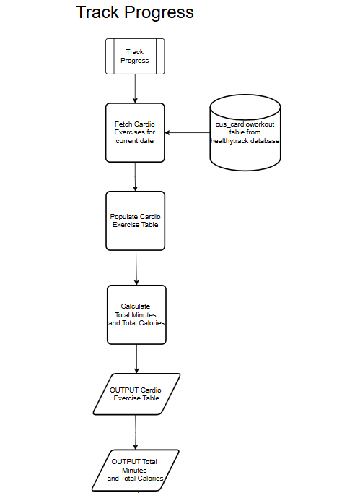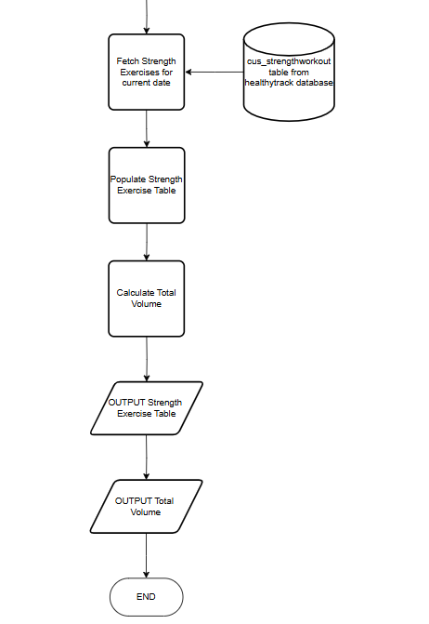

Figure 26: Track Progress Flowchart

**Process 7.0: Account settings**

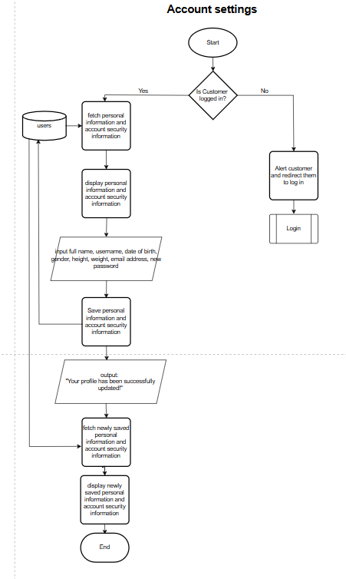

Figure 27: Account settings Flowchart

**Process 8.0: Exercise Suggestions** (Wong Kap Onn TP074292)

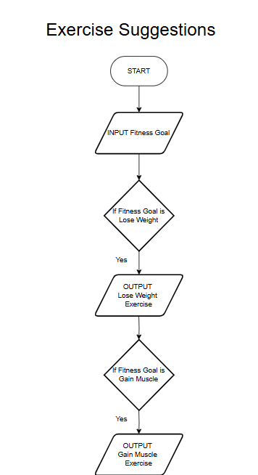

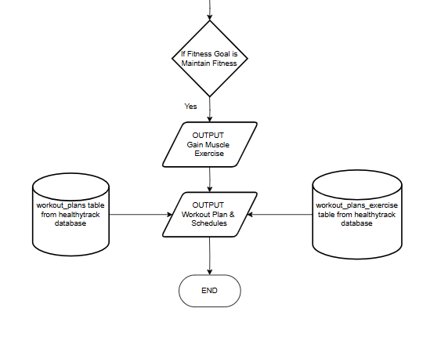

Figure 28: Exercise Suggestions Flowchart

**Process 9.0: Personalized Diet Plan**

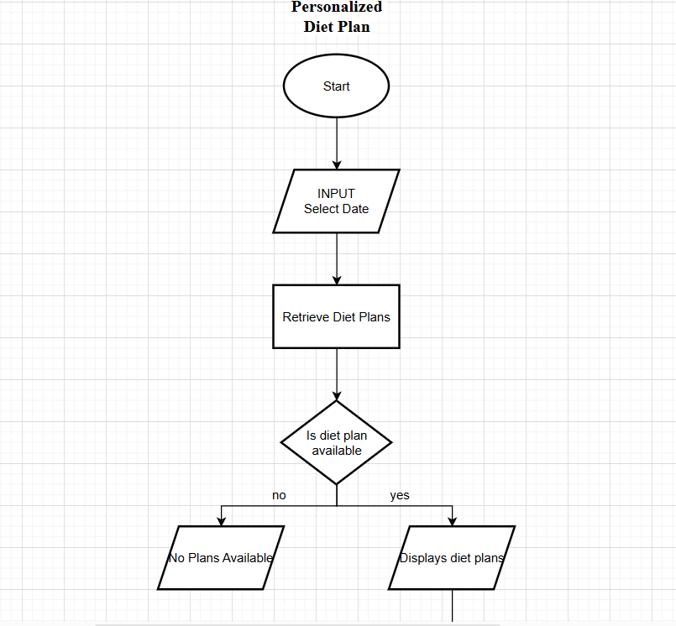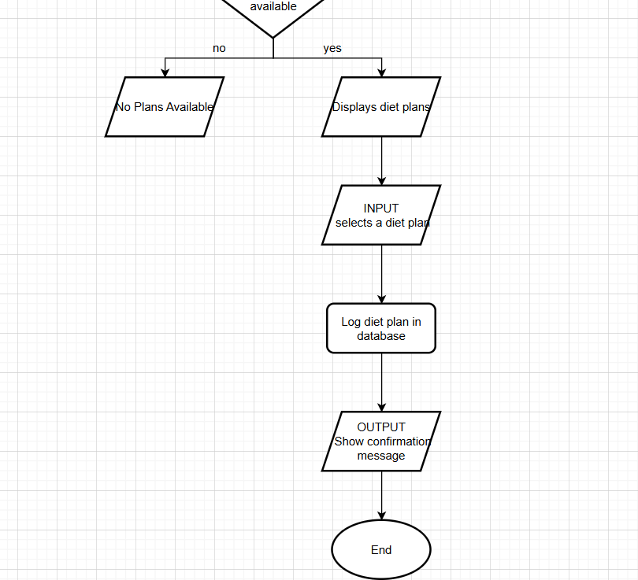

Figure 29: Personalized Diet Plan Flowchart

**Process 13.0: Sign_out**

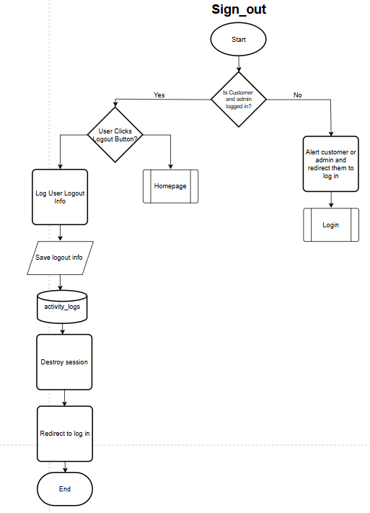

Figure 30: Sign_out Flowchart

**Process 9.0: Reports & Analytics (**Wong Zheng Han TP074212)

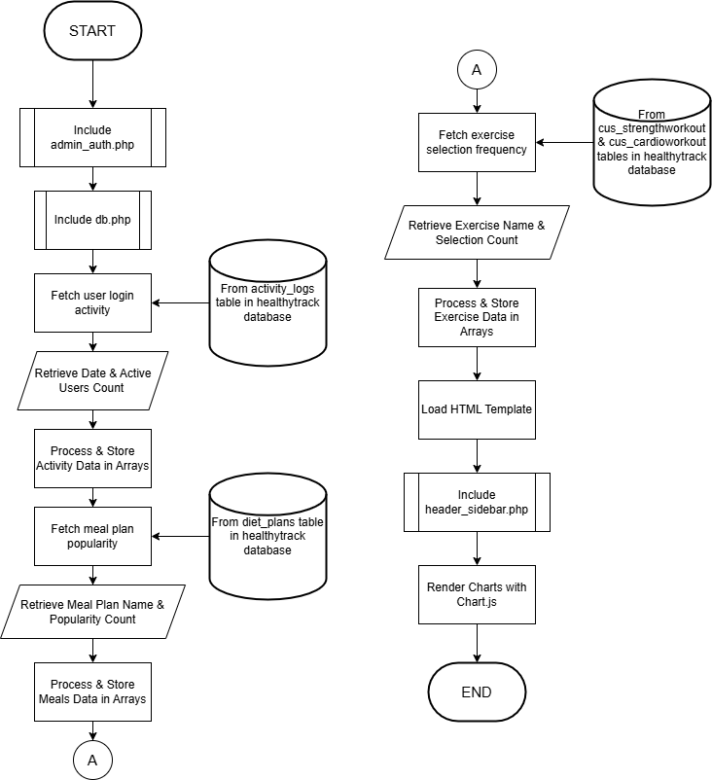

Figure 31: Report and Analytics Flowchart

**Process 10.0: Content Management (**Wong Zheng Han TP074212)

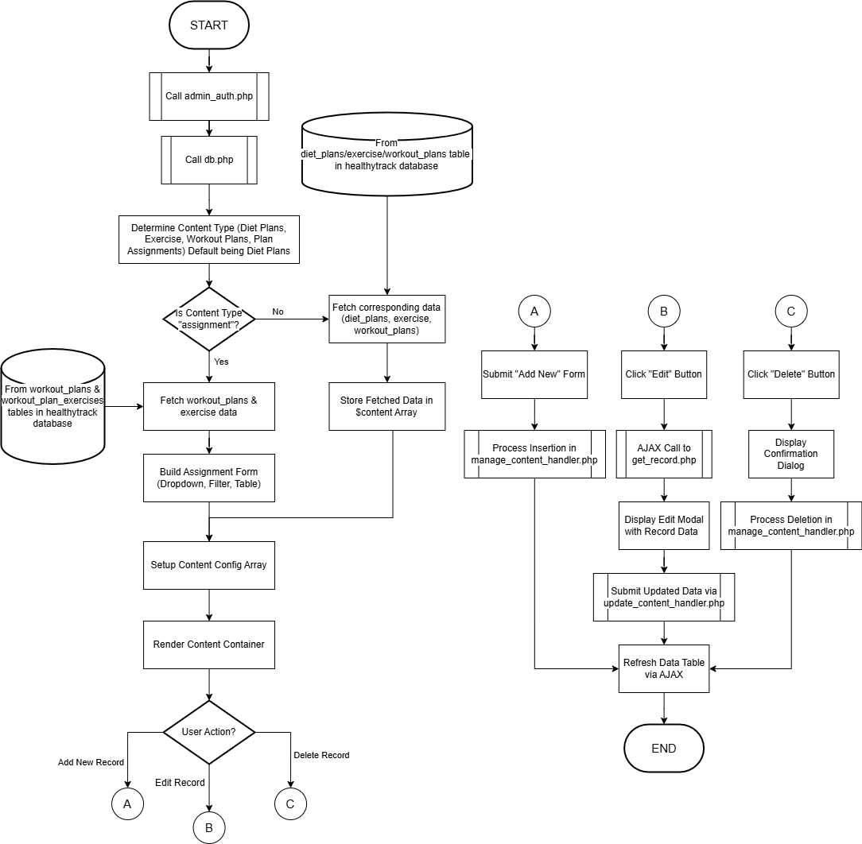

Figure 32: Content Management Flowchart

**Process 11.0: User Management** (Ng Wei Yang TP074904)

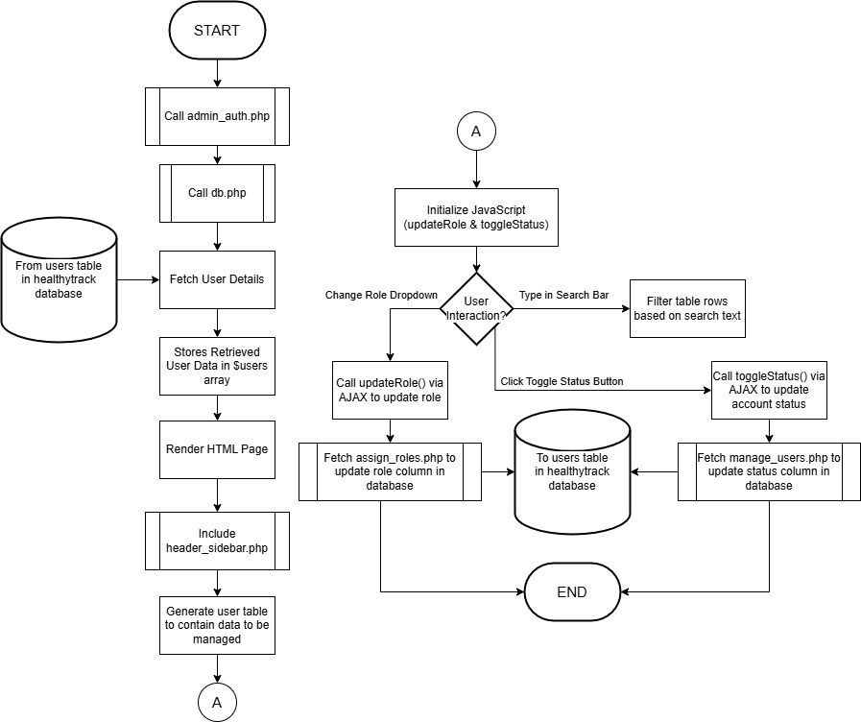

Figure 33: User Management Flowchart

**Process 12.0: User Logs & Feedback** (Ng Wei Yang TP074904)

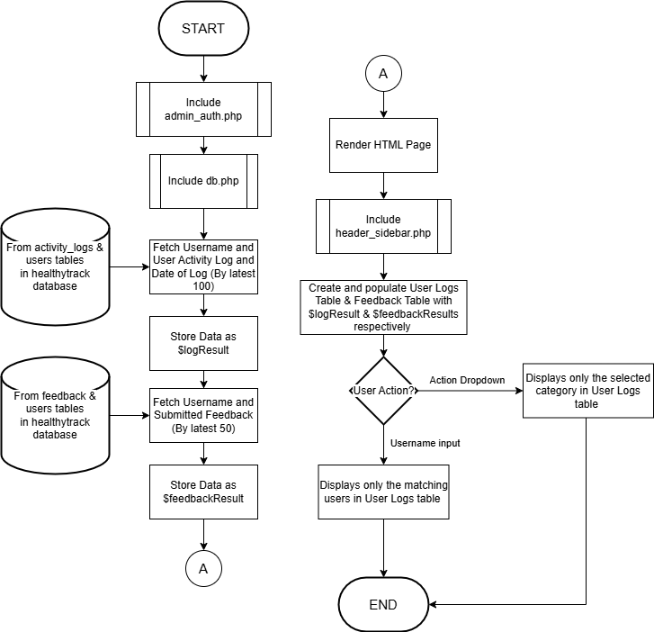

Figure 34: User Logs & Feedback flowchart

**Process 14.0: Admin Registration** (Ng Wei Yang TP074904)

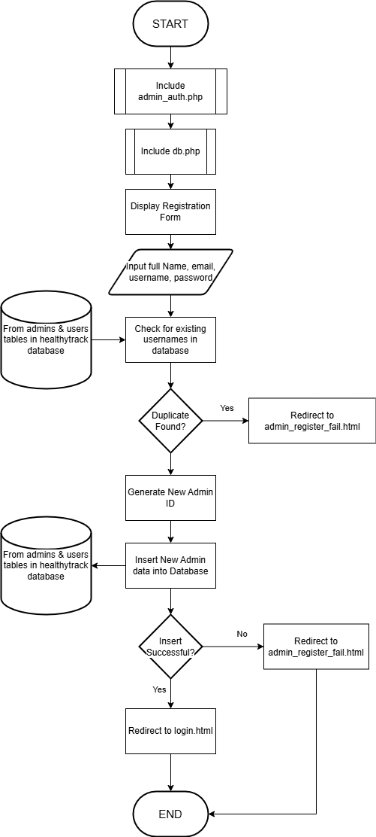

Figure 35: Admin Registration Flowchart

**Figure 15.0: Admin Dashboard (**Wong Zheng Han TP074212)

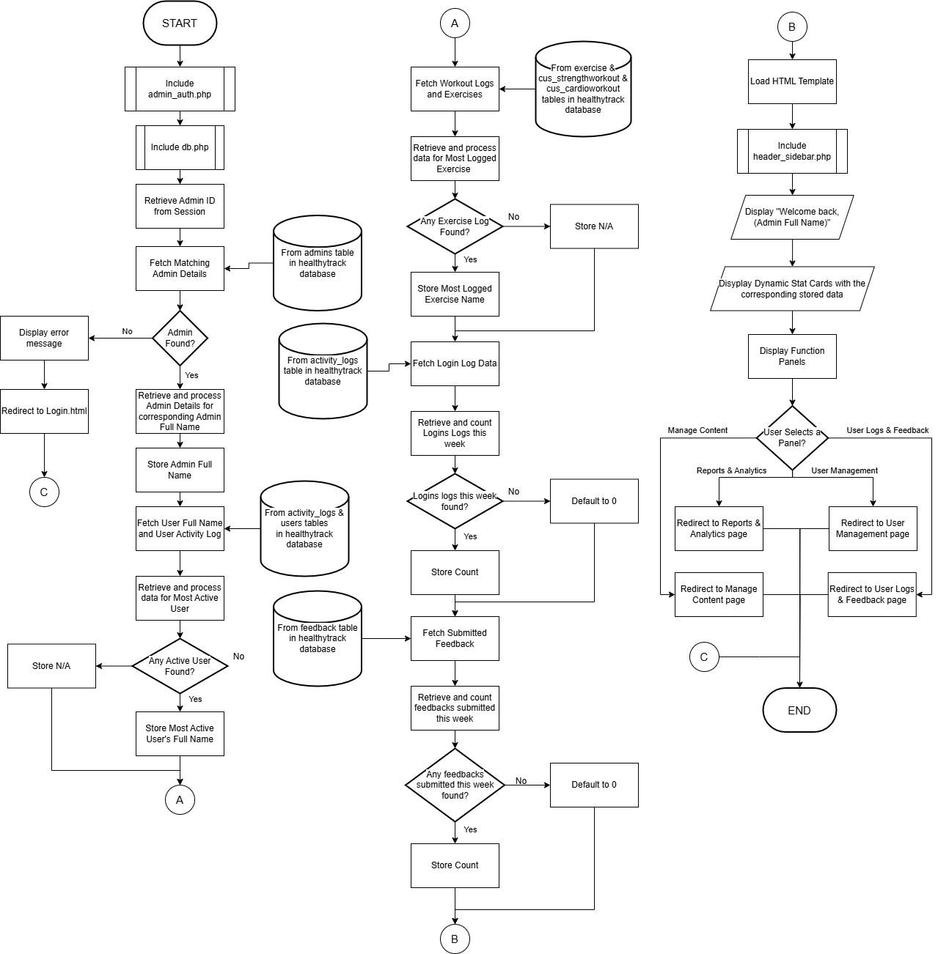

Figure 36: Admin Dashboard flowchart

# 8.0 Screen Design and User Manual

Process 1.0: Sign_in (Calvin Giam Jian Tao TP0683210)

Figure 38: Sign_in

The login screen displays fields where users input their username and password to access the system. New users can register by clicking the "REGISTER" button if they don't have an existing account. The page design remains simple because it positions the login form on the right side. The interface features designated boxes where users can insert their login credentials. A "Show Password" button allows users to confirm their password entry. Users who have forgotten their password can reset it by clicking the "Forgot Password?" link to reset it. The login page allows users to easily access their accounts and start using the system.

Process 2.0: Sign_up (Calvin Giam Jian Tao TP068321)

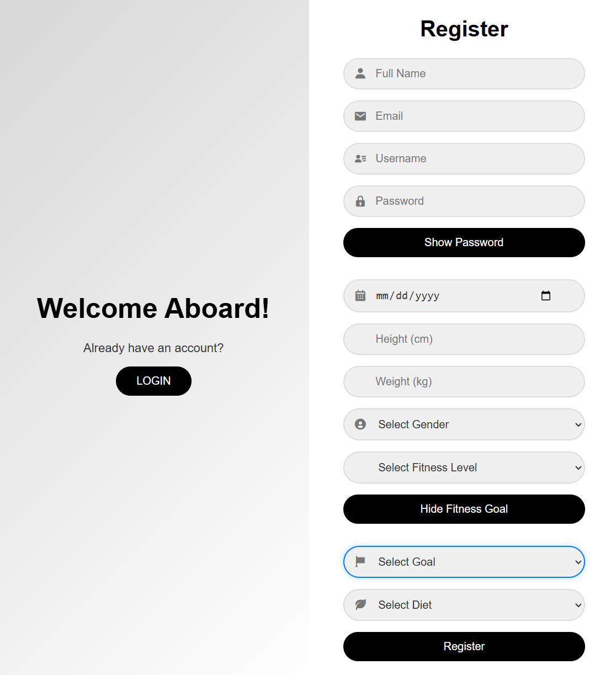

Figure 39: Sign_up

The registration page lets new customers enroll to access the fitness app. Users must provide fundamental information including their full name, email address, username, password details, date when they were born, height measurement, weight measurement, gender identification, fitness standing, specific fitness objectives, and dietary choice preferences. The input boxes have light grey colour and rounded edges which make them easy to read. Users can review their password before submitting it through the "Show Password" button. Users have three fitness goals to select from which includes "Lose Weight," "Gain Muscle," or "Maintain Fitness." A field to enter their weight loss goal will appear once "Lose Weight" is chosen. Users who select "Gain Muscle" will see a field where they can input their muscle gain target. The form adapts to suit every individual's fitness objective.

Users can create an account after completing all required information by clicking the "Sign Up" button. Users with existing accounts should click "Login" to return to the login page. The page features a straightforward white and grey design which enables users to navigate and register without any confusion.

**Process 3.0: Homepage** **(Timothy Tan Chern Tian TP074658)**

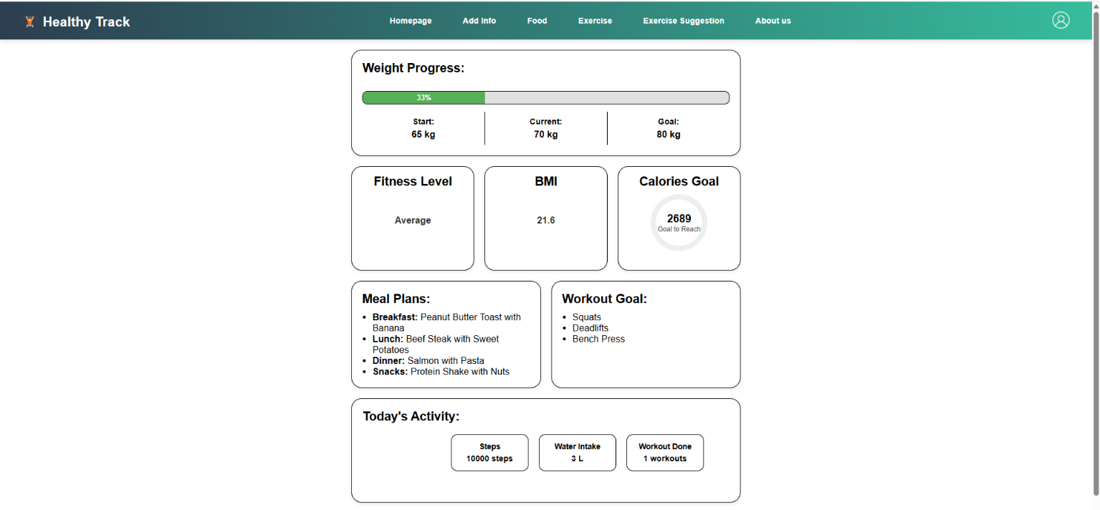

Figure 40: Homepage

This is the first page the user will enter after they log in. This is called the Homepage, in this page, users can go to several other pages such as the add info page, food page, exercise page, exercise suggestions page, about us page and the account settings page when u click on the user icon. In this page, the weight progress will be shown to see how close u are to reach your goal. Other information such as fitness level, bmi, calorie's goal, meal plans, workout goal, steps, water intake and workout done will also be shown here. All these information is specifically catered to each user. What might be here might not be the same for another user. User can use this information to get a better understanding of what meals, workout goal, calories goal, they should follow to reach their weight goal.

Process 4.0: Recover_Password (Calvin Giam Jian Tao TP068321)

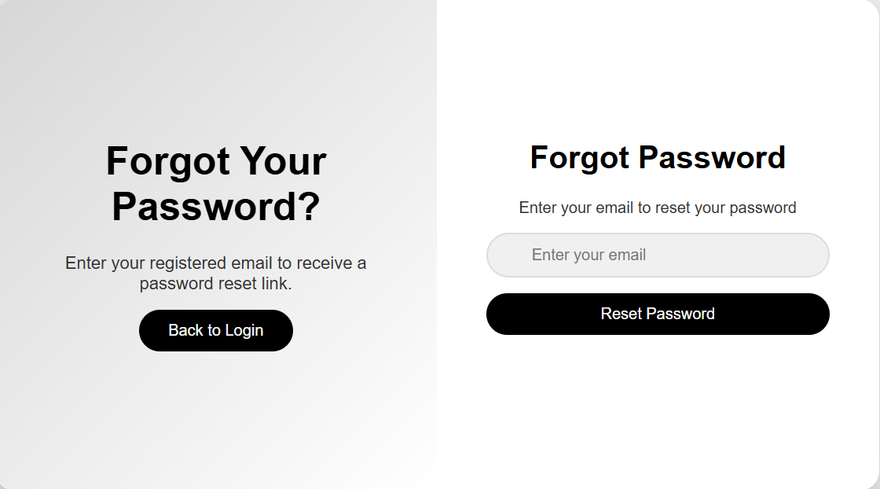

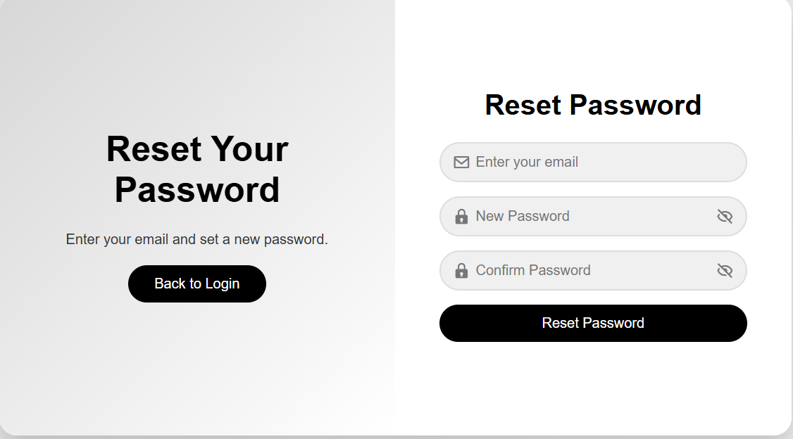

Figure 41: Recover_Password

# This page is for recovering passwords. If the customer forgets their password this will help them reset their password. When customers click on this link, the customer will have to enter their Email for resetting their password, after entering the email and if the email is correct they will need to enter their email again for the password reset and they will need to enter the new password twice and it has to be the same, if everything goes correct the password is successfully reset.

Process 5.0: Fitness Tracking

Figure 42: Fitness Tracking

This is the exercise page where fitness tracking is done for customer. After customer is done exercising, customer can select either cardiovascular or strength exercise, then click on add exercise button to log exercise. After selecting exercise, customer can enter exercise data based on exercise category (strength or cardiovascular). If customer select cardiovascular exercise, customer must enter the duration (minutes) and calories burned. If user select multiple cardiovascular exercise, then the total minutes and total calories burned will be calculated and displayed. If customer select strength exercise, customer must enter weight (KG), sets and reps done for the exercise. If user select multiple strength exercise, then the total volume will be calculated and displayed. When customer has finished exercising for the day, customer can select the save button to save exercises logged. When customer select date, the exercises saved on the date will be displayed automatically. Customer can use navigation bar to navigate the system, go to account setting or logout. The exercise page is completed with the intention of it to be user-friendly and simple, so that new customer will know what to do. As the theme of Healthy Track is health, the colours white and green are used so customer will feel relaxed and refreshed.

**Process 7.0: Account settings (Timothy Tan Chern Tian TP074658)**

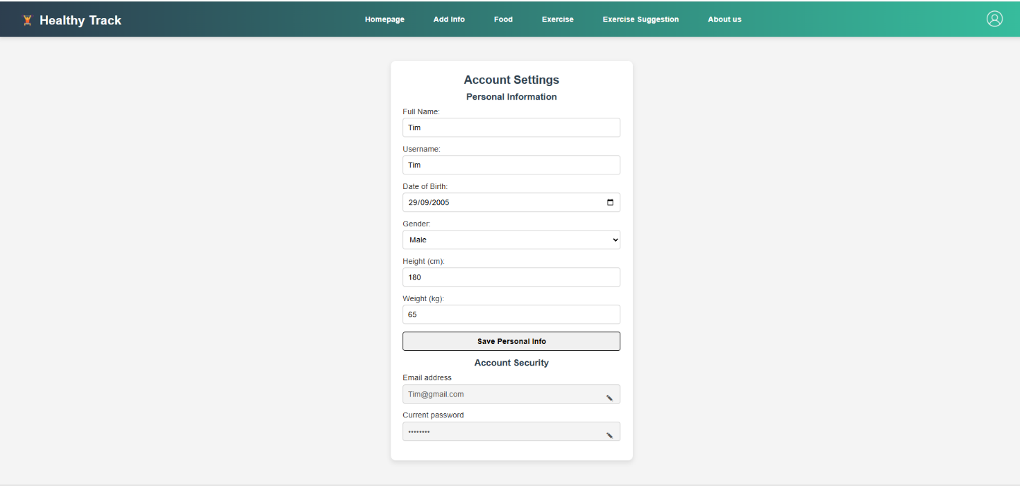

Figure 43: Account Settings

This is the account settings page, on this page various fields such as full name, username, date of birth, gender, height, weight, email address, and password will be shown. On this page, users can edit their information whether it is personal information or account security information. To update their information, users will have to click onto one of the fields they would like to update, after that they will have to delete the fields information and change it to the information the user would like to have. If a user would like to change their gender, it will be a drop-down feature which means two options will be shown and the user can choose it. After the users are satisfied with their changes they can click on the” Save personal info” and the data will be saved. If the user would like to change the email address and current password, they will have to click on the” pen” icon. After that, they can type in a new email address or password and press the button” Save”. After that, the information for account security will be saved. If the user would like to go back, they can click on the” Cancel” button to cancel.

Process 8.0: Exercise Suggestion

Figure 44: Exercise Suggestion

This is the exercise suggestion page where customer can select fitness goal and view recommended exercises provided. Customer can select fitness goal from the choose goal option to get the recommended exercise. Other than that, there will also be the personalised workout plans and schedules provided for customers so that they can have a routine to help them achieve their fitness goals. The exercise suggestion page is designed so it will be user-friendly to the customer. Customers will know what to do as the design is simple and straightforward. For exercises provided, big pictures and detailed descriptions are given so customers can know how to do the exercise and what the exercise are beneficial for.

**Process 13.0: Sign_out (Timothy Tan Chern Tian TP074658)**

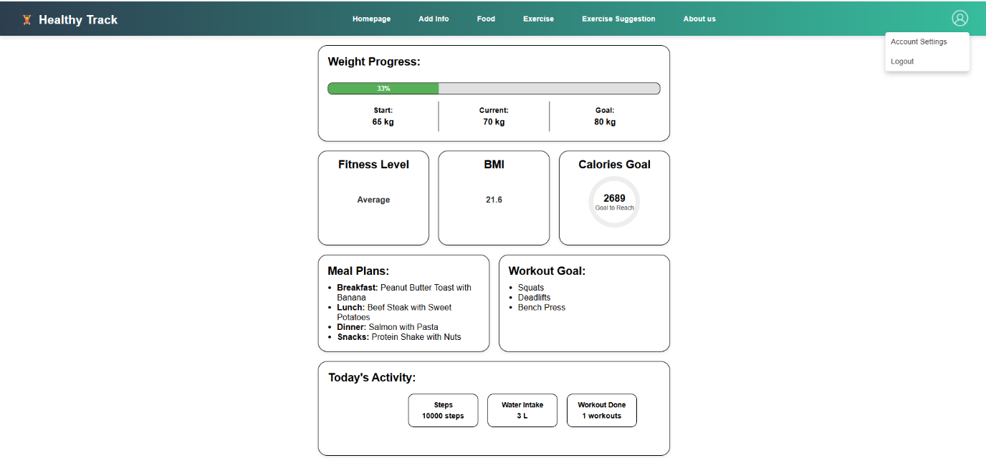

Figure 45: Sign_out

In order to sign out, the user will have to click on the user icon. After they click on it, they will see two options, Account settings and log out. If the user would like to sign out, they would need to click on the” Logout” button and they will be logout and brought to the login page.

**Admin Homepage (Wong Zheng Han TP074212 & Ng Wei Yang TP074904)**

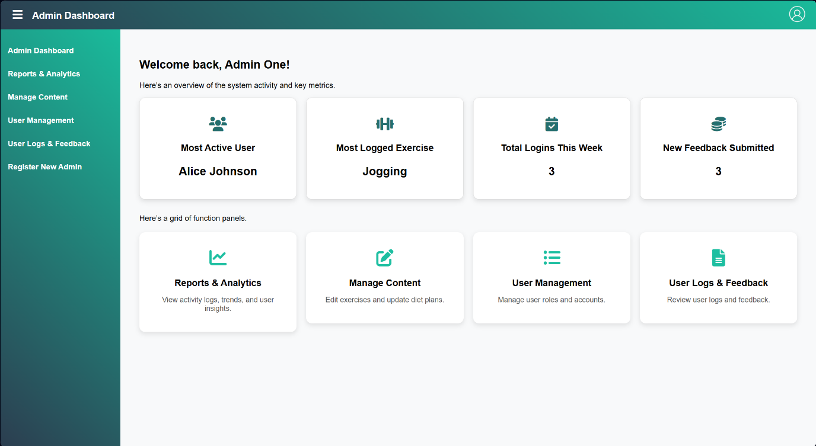

Figure 46: Admin Dashboard

This is the Admin Dashboard page where system administrators can quickly view and manage the overall activity of the platform. When an admin logs in, they're presented with key metrics such as the most active user, the most frequently logged exercise, the total number of logins for the week, and any newly submitted feedback. Below these highlights, there are function panels that allow the admin to navigate to other pages of on the admin’s side of the system to generate reports and analytics, manage and update content, oversee user accounts, and review user logs and feedback. If an admin wants to add a new administrator, they can navigate to the “Register New Admin” section. The navigation bar at the side is used to access various sections of the system with ease. Additionally, a logout button appears when the admin clicks the icon in the top right corner of the page.

**Process 9.0: Reports & Analytics (Wong Zheng Han TP074212 & Ng Wei Yang TP074904)**

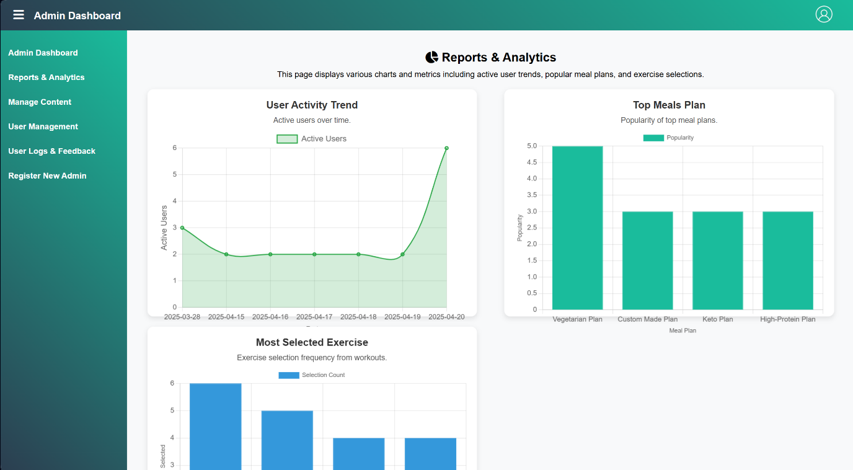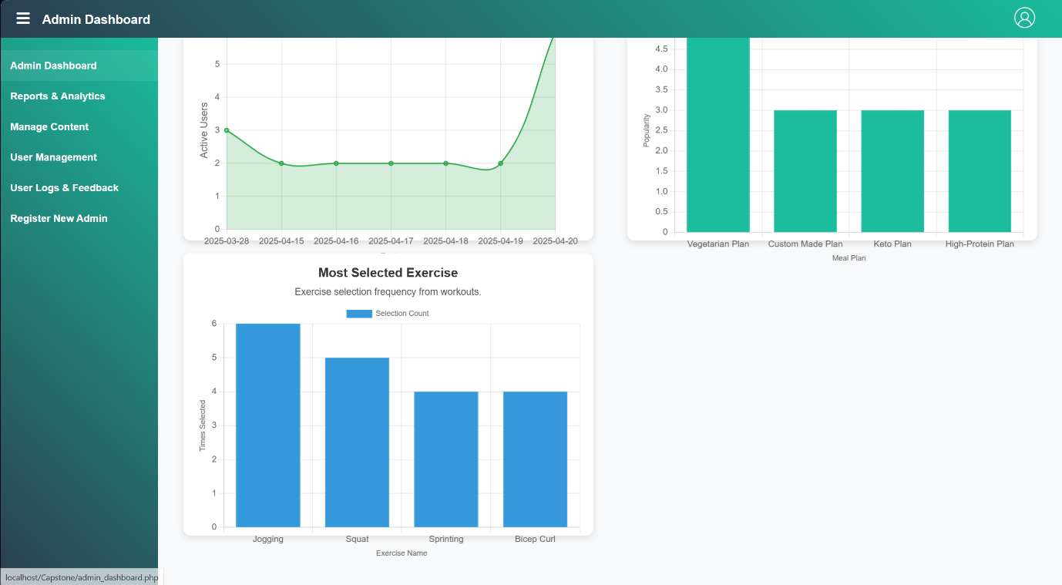

Figure 47: Reports & Analytics

This is the Reports & Analytics page, which presents a concise, graphical overview of various user trends and popular selections across the platform. At the top left, the “User Activity Trend” line chart displays the number of active users over a selected date range, providing administrators with valuable insights into user engagement. On the right, the “Top Meals Plan” bar chart highlights the most popular meal plans ranging from Vegetarian Plans to High-Protein Plans so admins can easily identify which plans are most favoured by users. Finally, the “Most Selected Exercise” bar chart at the bottom shows how frequently different workouts (like Jogging, Squat, and Bicep Curl) are logged, revealing the most performed exercises.

**Process 10.0: Content Management (Wong Zheng Han TP074212 & Ng Wei Yang TP074904)**  
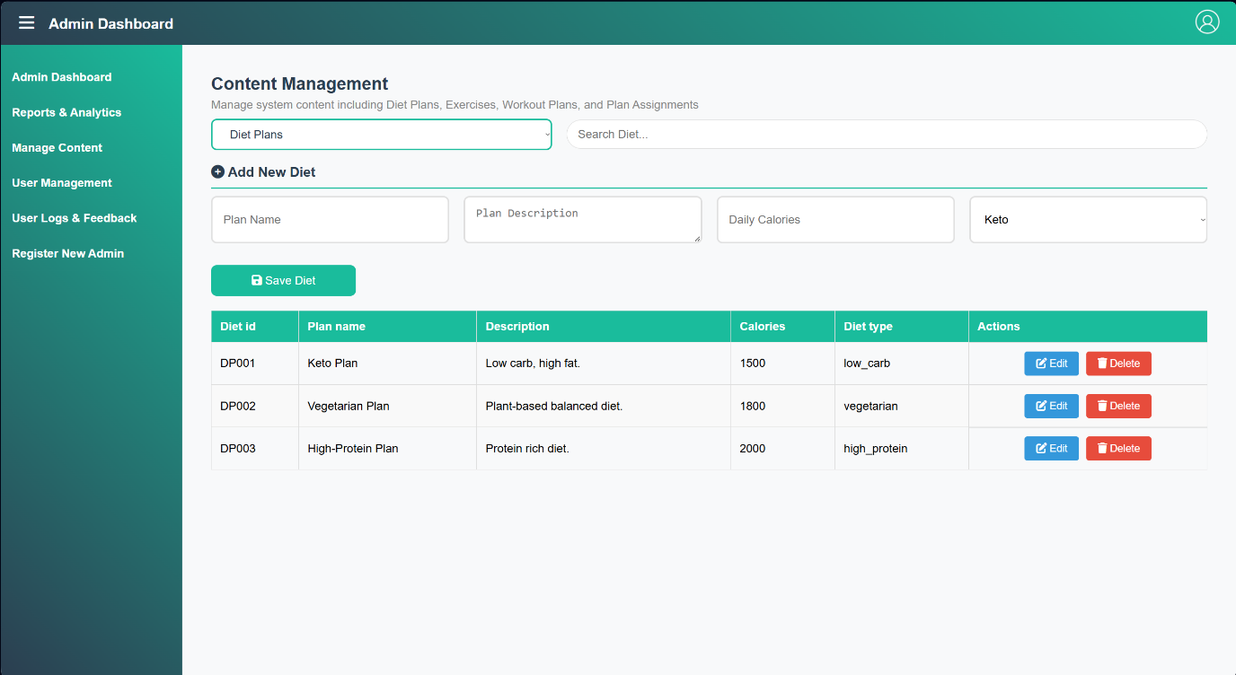

Figure 47: Content Management (Diet Plan)

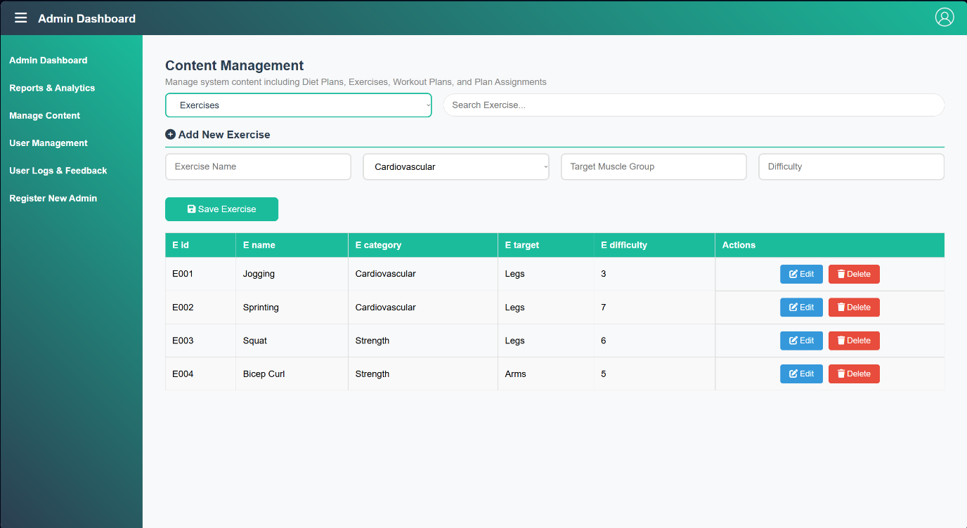

Figure 48: Content Management (Exercise)

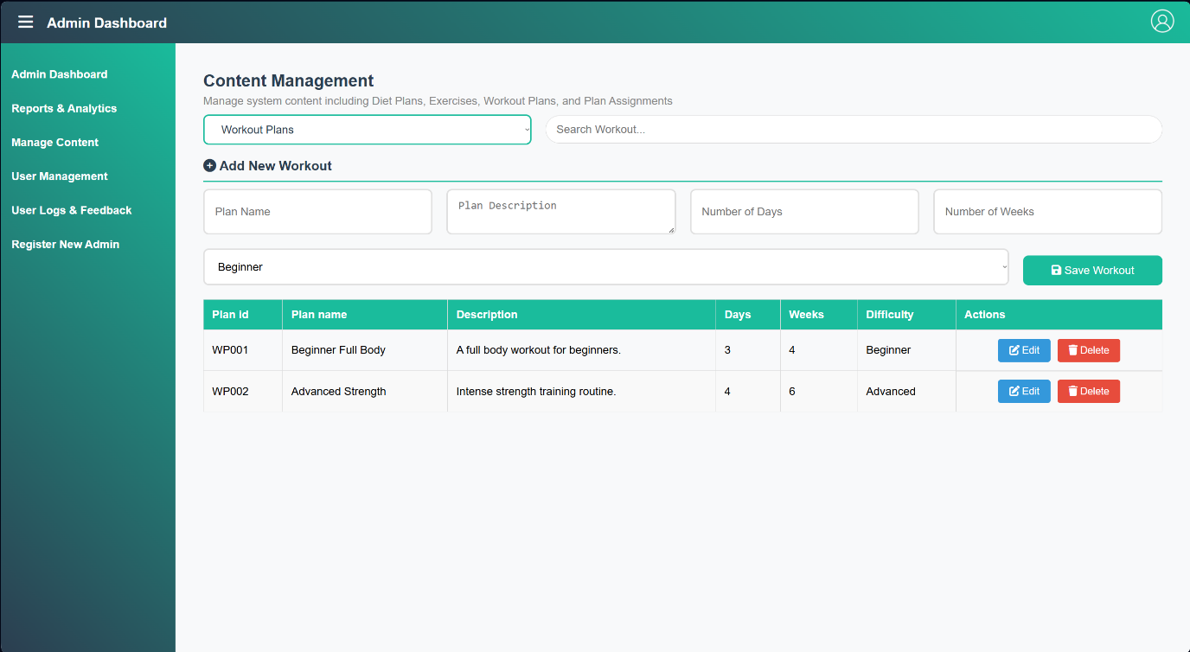

Figure 49: Content Management (Workout Plan)

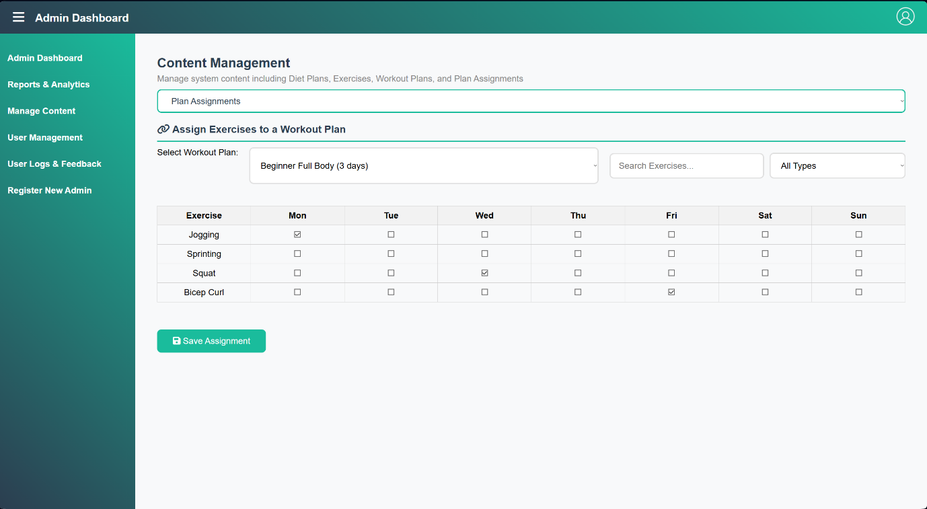

Figure 50: Content Management (Plan Assignments)

The figures above show the Content Management page where system administrators manage diet plans, exercises, workout plans, and plan assignments. Administrators can switch between these four categories through the dropdown menu. In Diet Plans, they can add or update plans by entering details like the plan name, description, daily calories, and diet type, then clicking the "Save Diet" button to store the information, which is subsequently updates table with the newly saved entry; in Exercises, they can add or edit exercises by providing details such as the exercise name, category (cardiovascular or strength), target muscle group, and difficulty level, and then save the exercise and the table below will reflect that save; in Workout Plans, administrators can create or modify plans by entering the plan name, description, number of days, and number of weeks, then clicking "Save Workout" to update the table below in real time; and in Plan Assignments, they can assign specific exercises to a selected workout plan by choosing the plan, checking the appropriate boxes for each day, and clicking "Save Assignment", the system checks whether the days of exercise assignments are the same as the workout plan’s restrictions, if they don’t meet the restriction the changes will be reverted to the original assignment.

**Process 11.0: User Management (Wong Zheng Han TP074212 & Ng Wei Yang TP074904)**

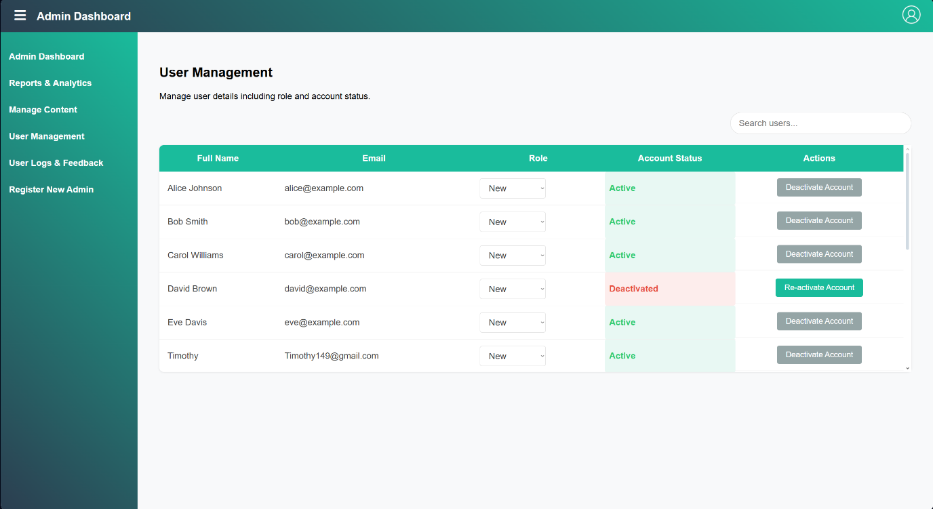

Figure: User Management

This is the User Management page, where administrators can conveniently view and modify user details such as full name, email address, assigned role, and account status. Each user is listed in a table format, making it straightforward to see who’s currently active or deactivated immediately. Administrators can quickly deactivate or re-activate accounts using the buttons in the “Actions” column, ensuring that access remains properly controlled and user records stay up to date. There is also a search bar where the administrator can enter the user’s details to quickly find them which comes in handy as the system’s user database scales.

Process 12.0: Logs & Feedback (Wong Zheng Han TP074212 & Ng Wei Yang TP074904)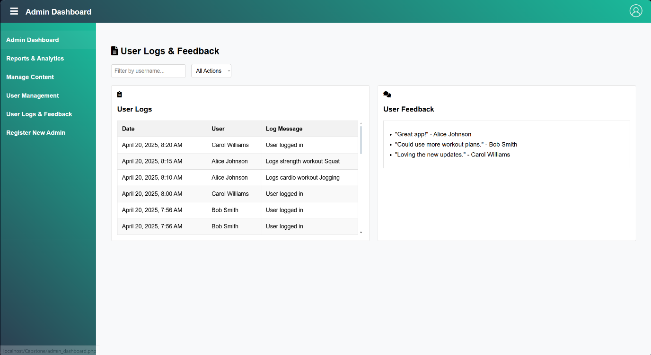

Figure 51: User Logs & Feedback

This is the User Logs & Feedback page, where administrators can keep track of user activities and view feedback in real time. On the left, a table shows the date, user, and log message, making it straightforward to see who performed which action and when. On the right, the user feedback section showcases comments from various users, letting admins quickly gauge their opinions on different features or updates. There’s a search bar at the top for filtering by username, and the “All Actions” dropdown offers additional categorical filtering options like (Login, Logout, Exercises, Food).

# 9.0 Report Design and User Manual

# User Activity Trend Graph (Wong Zheng Han TP074212 & Ng Wei Yang TP074904)

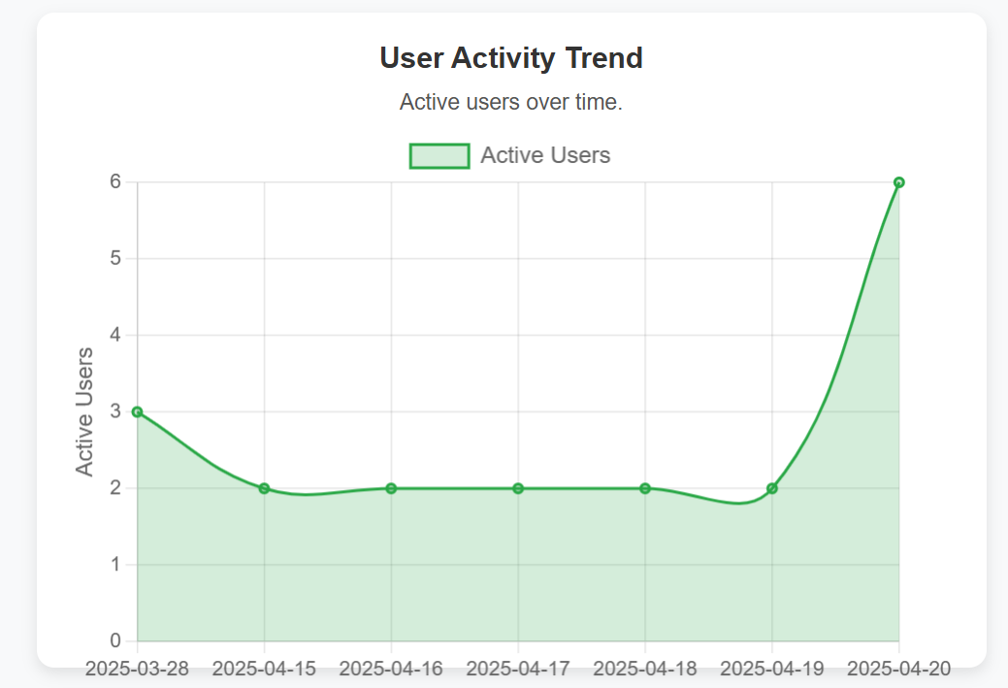

Figure 52: Active Users Chart

This chart presents user activity trends over a selected date range, illustrating how many users were active each day. The green line indicates the number of active users, while the filled area underscores change in engagement. In this example, user activity remains relatively low throughout most of the period, but there’s a noticeable spike near the end, jumping to 6 active users. This chart helps us identify when changes were made to cause such a spike in activity.

Top Meals Plan Graph (Wong Zheng Han TP074212 & Ng Wei Yang TP074904)

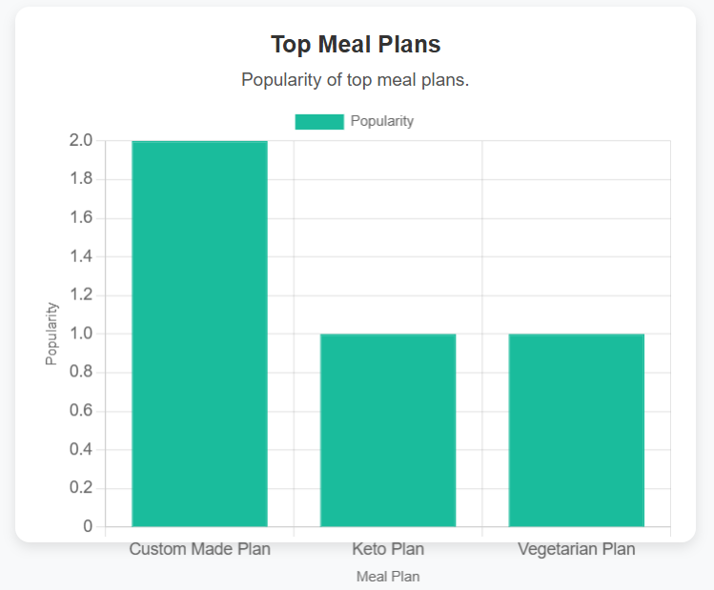

Figure 53: Meal Plan Popularity

This bar chart displays the popularity of various meal plans on the platform, with the Vegetarian Plan clearly taking the top spot. The clear layout makes it straightforward for administrators to compare which meal plans users favour the most. In the figure above, we can clearly see that custom made plans are preferred, this tells the admins that we need to improve our preset diet plan database.

Most Selected Exercise Graph (Wong Zheng Han TP074212 & Ng Wei Yang TP074904)

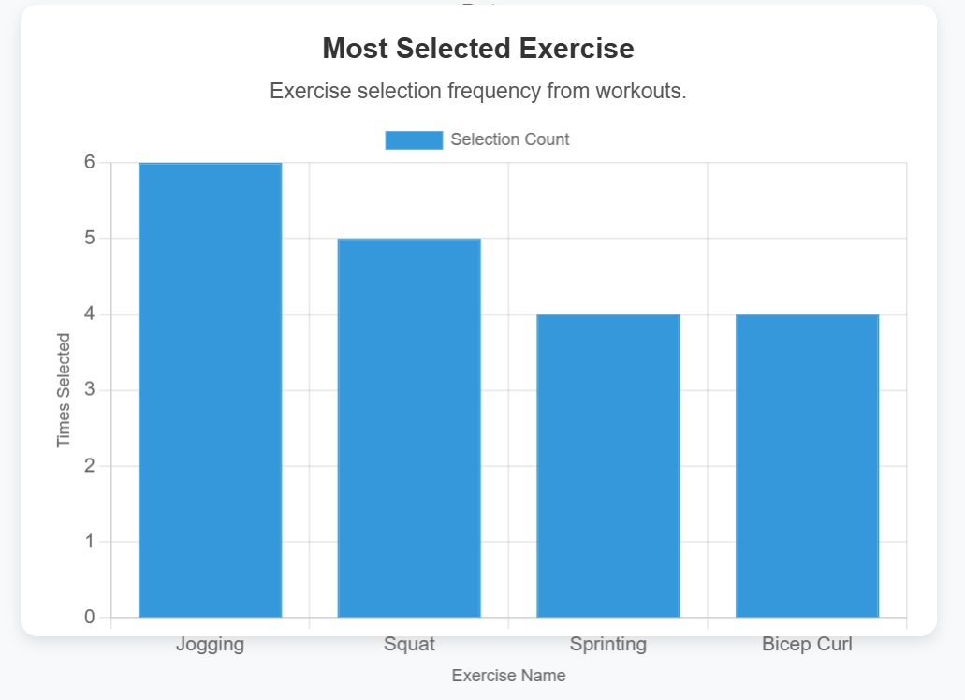

Figure 54: Exercise Selection Count

This bar chart demonstrates how often each exercise is selected by users, with Jogging taking the top spot. Squat is a close second, while Sprinting and Bicep Curl come in third and fourth place, respectively. The straightforward layout and blue colour scheme make it clear for administrators to identify which exercises are most frequently logged. The preference towards simple exercises relating to the leg region might indicate we should add a better variety of exercises in particular ones targeting other muscle regions to the database.

Personalized diet plan (Tan Yen Hann Tp073629)

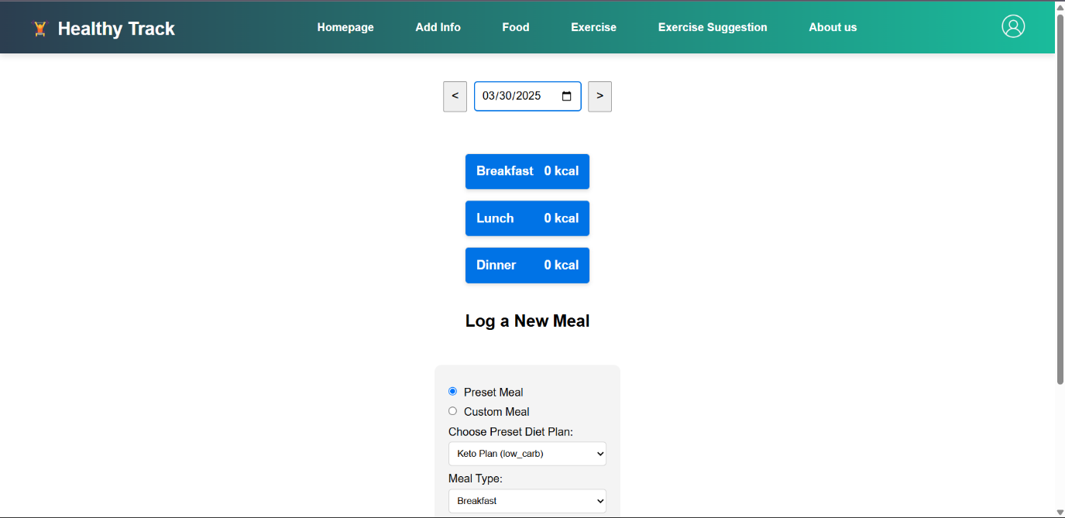

Figure 55: Personalized diet plan

The Personalized Diet Plan page allows customers to select and view tailored diet recommendations. Users can choose a personalized diet plan from the available options to receive customized meal suggestions. Additionally, they have the flexibility to select specific meals for breakfast, lunch, and dinner based on their preferences. This page also calculates the total kilocalories for the selected meals. Furthermore, customers can choose for a custom meal selection, enabling them to create and customize their own diet plan according to their dietary needs.

# 10.0 Test Plan

# Customer Login (Calvin Giam Jian Tao TP068321)

# Customer Register (Calvin Giam Jian Tao TP068321)

# Customer Recover Password (Calvin Giam Jian Tao TP068321)

# Content Management Wong Zheng Han (TP074212)

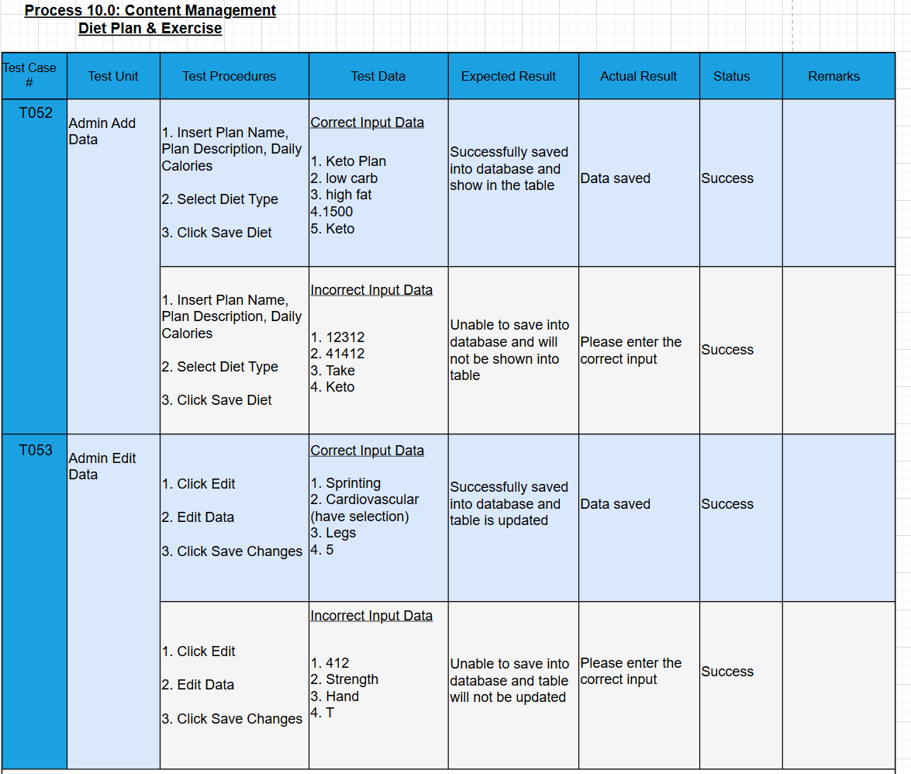

# Content Management Wong Zheng Han (TP074212)

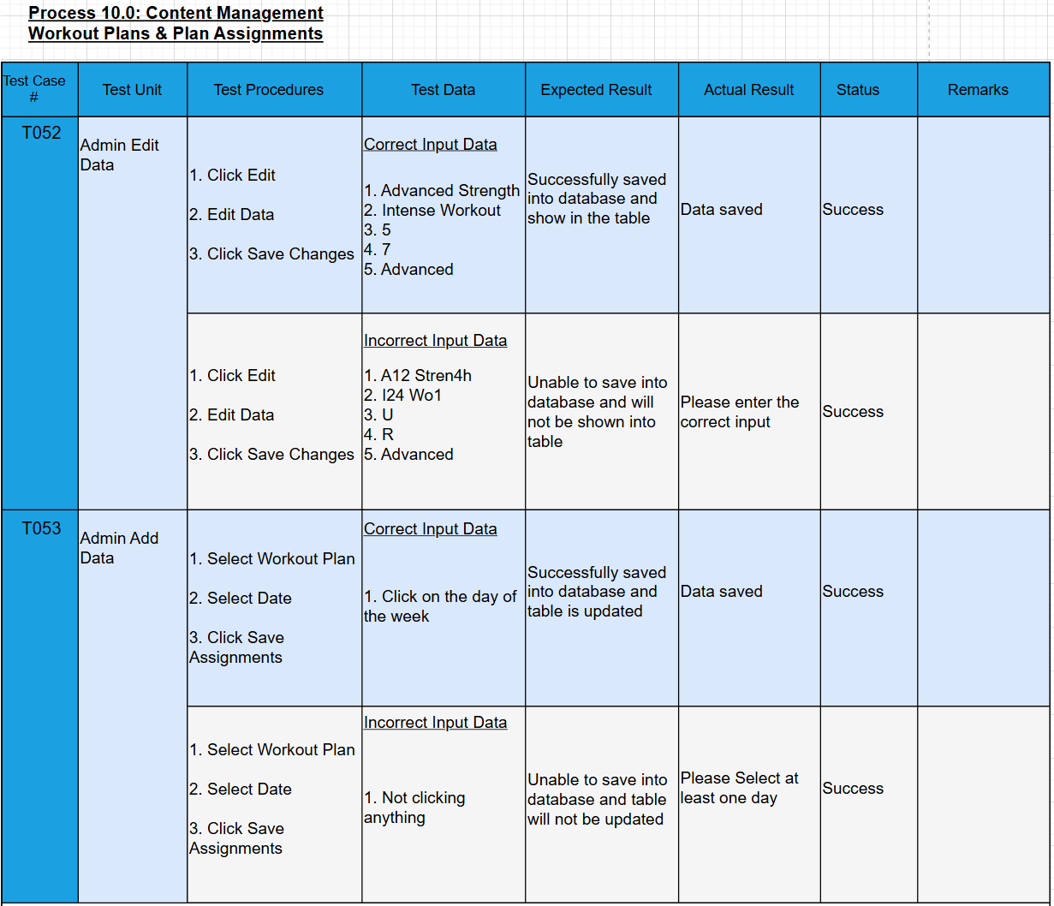

# User Management Wong Zheng Han (TP074212)

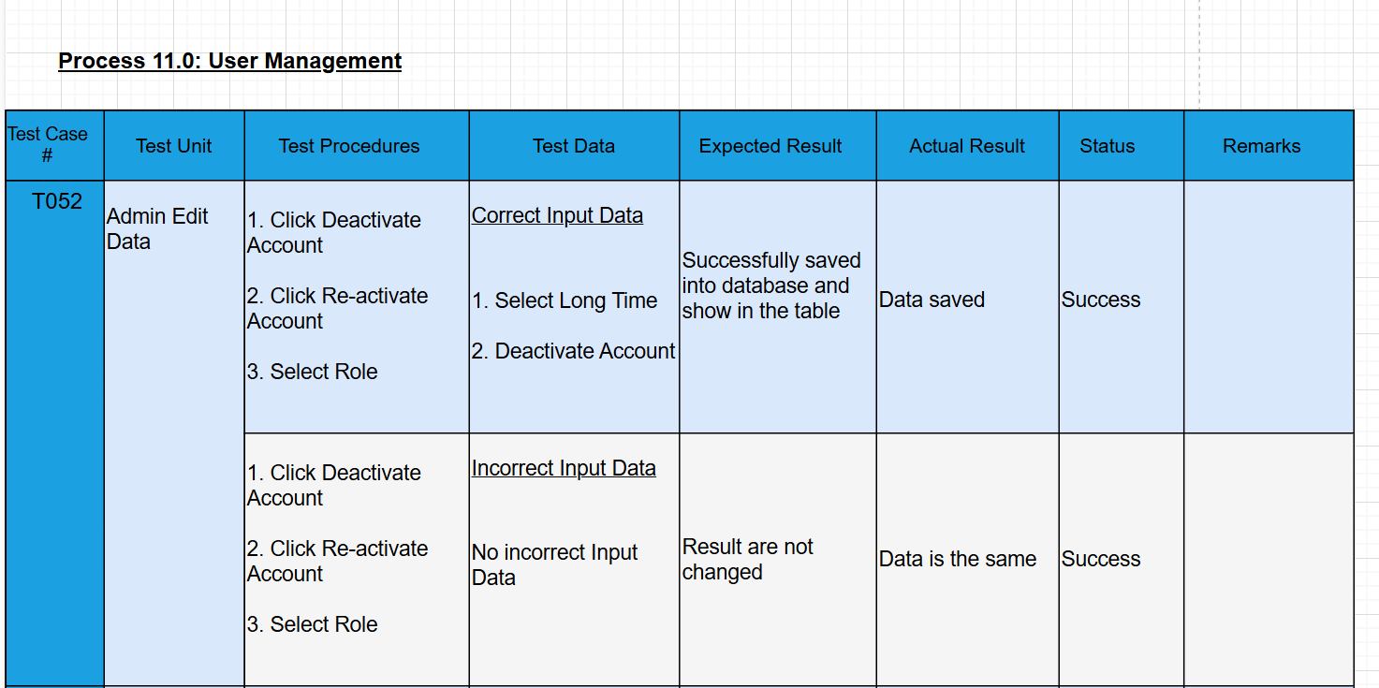

# Admin Registration & Login Wong Zheng Han (TP074212)

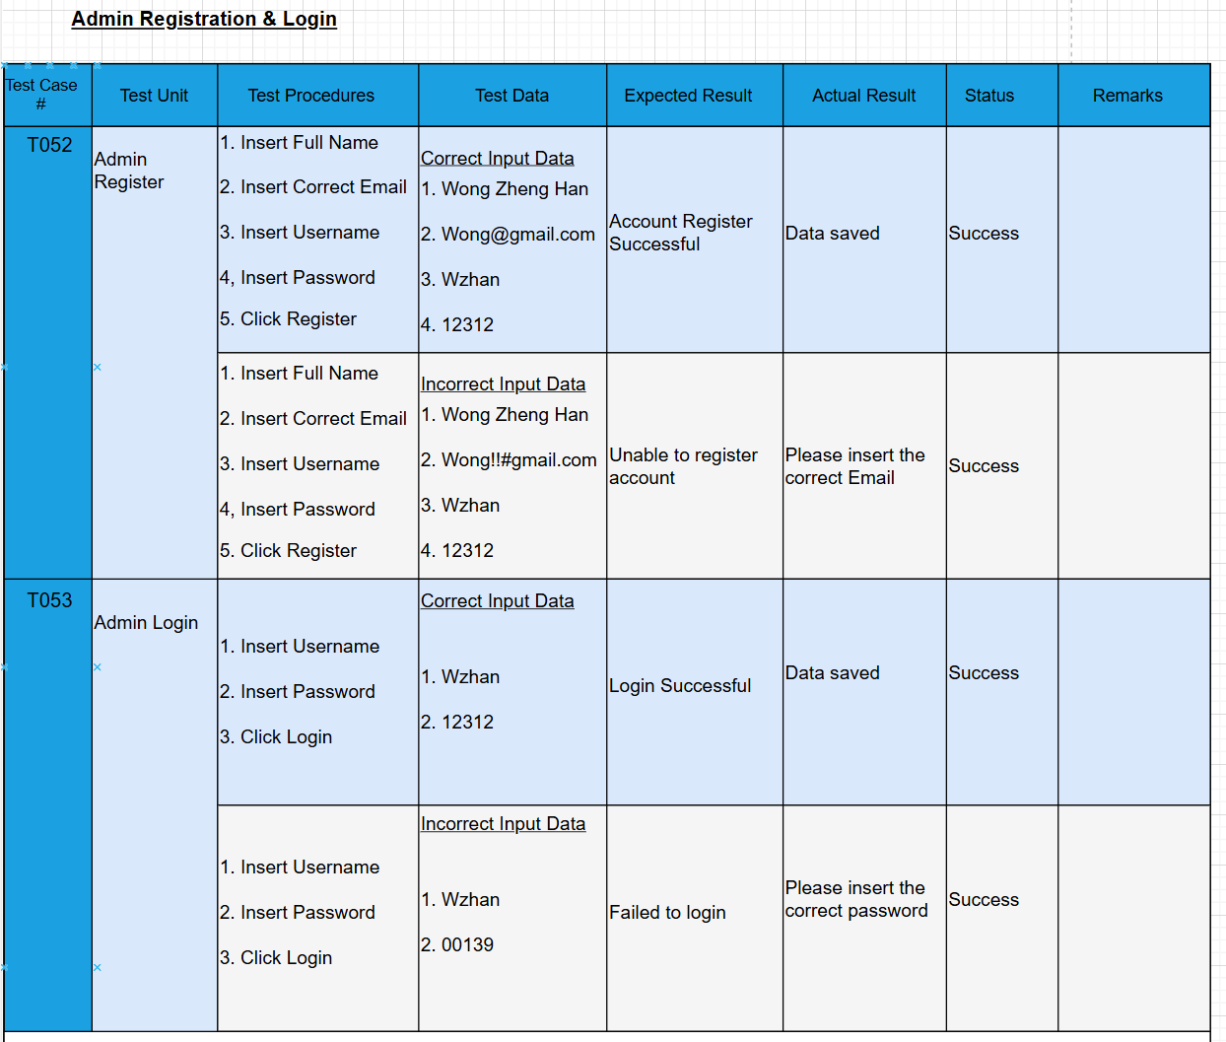

**Personalized Diet Plan** (Tan Yen Hann Tp073629)

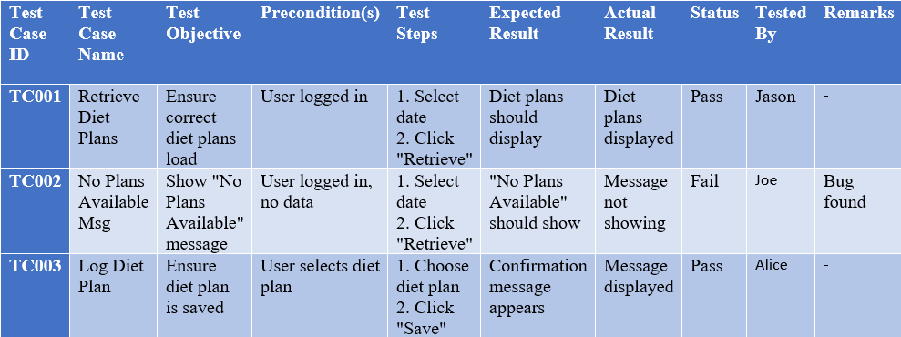

**Homepage** (Timothy Tan Chern Tian TP074658)

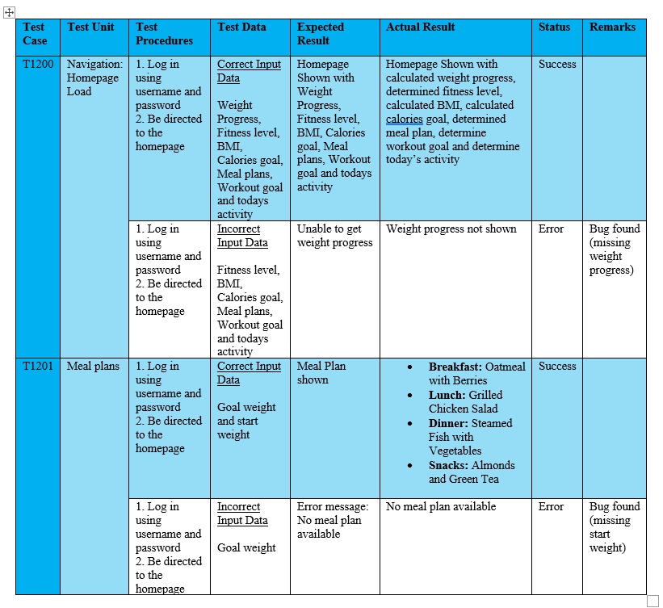

**Account settings (Timothy Tan Chern Tian TP074658)**

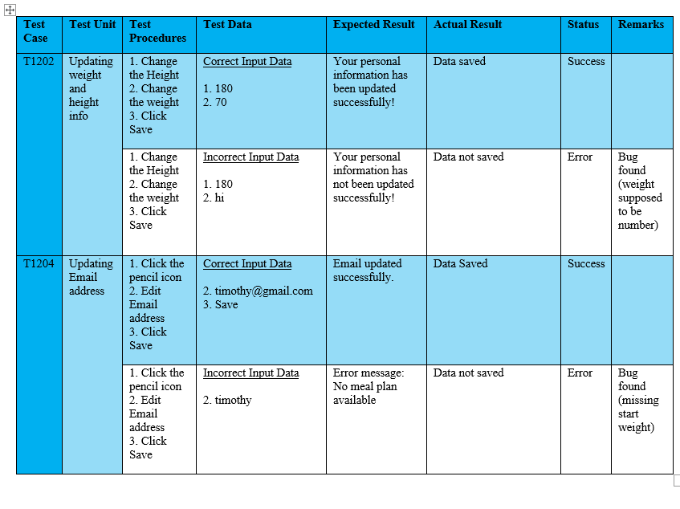

**Signout (Timothy Tan Chern Tian Tp074658)**

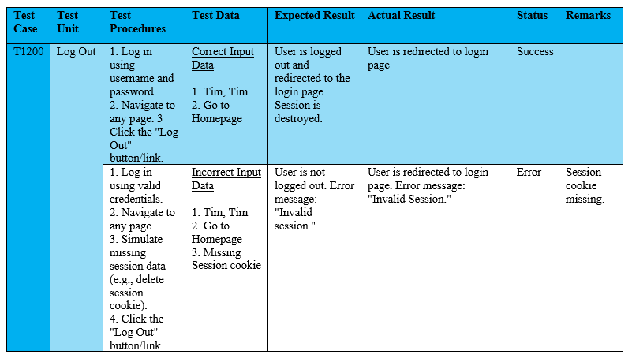

**Exercise** (Tan Yen Hann Tp073629)

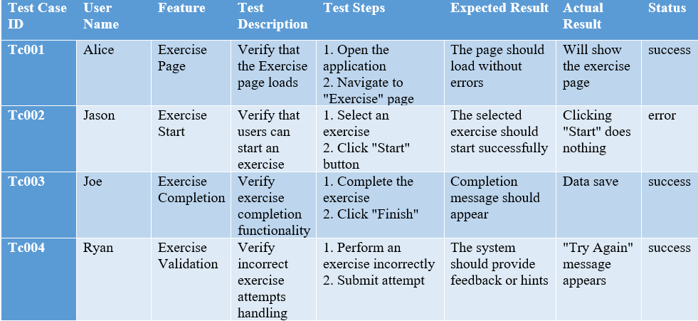

**Exercise suggestion** (Tan Yen Hann Tp073629)

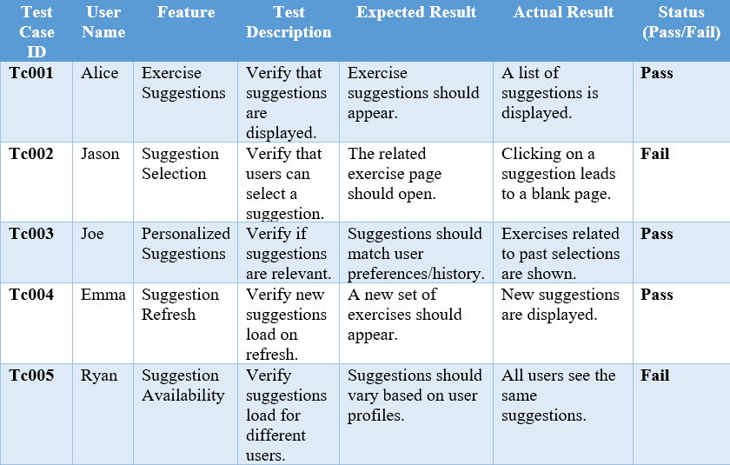

## **User Acceptance Test 1**

|  |  |
| --- | --- |
| Tester Profile | |
| Name: | Anonymous |
| Age: | 20 |
| Phone Number: | N/A |
| Role: | Administrator |
| Date and Time: | 23/3/2025 1:36 PM |

Thank you for helping during the user testing phase of Happy Job. After you have tested our website, please help us to complete the following questions and provide some feedback for the improvement. Please rate for your experience too to let us know about your satisfaction.

Rating Scale:

1 – Very Bad

2 – Bad

3 – Neutral

4 – Good

5 – Very Good

|  |  |  |
| --- | --- | --- |
| No. | Testing Function (Admin Role) | Rating |
| 1 | User Management | 1○ 2○ 3○ 4○ 5● |
| 2 | Content Management | 1○ 2●3 ○ 4 ○ 5○ |
| 3 | Update Profile | 1○ 2○ 3 ○ 4○ 5● |
| 4 | Generate Reports & Analytics | 1○ 2○ 3 ● 4○ 5○ |

Table 2: Testing Administrative Functions

**Comment**

|  |  |
| --- | --- |
| Tester: | Lee Wei En |
| Comment: | * User management was plain to use * Content Management could be better in the exercise assignment section, where it doesn’t notify you that there’s a limit on how many days you can assign to a plan until you try to save it. Having to redo every step I still wanted to keep was annoying. * I think there can be more information in the reports and analytics section. |

## **User Acceptance Test 2**

|  |  |
| --- | --- |
| Tester Profile | |
| Name: | Anonymous |
| Age: | 17 |
| Phone Number: | N/A |
| Role: | Customer |
| Date and Time: | 27/3/2025 3:37 PM |

Thank you for helping during the user testing phase of Happy Job. After you have tested our website, please help us to complete the following questions and provide some feedback for the improvement. Please rate for your experience too to let us know about your satisfaction.

Rating Scale:

1 – Very Bad

2 – Bad

3 – Neutral

4 – Good

5 – Very Good

|  |  |  |
| --- | --- | --- |
| No. | Testing Function (Customer Role) | Rating |
| 1 | Exercise Recommendations | 1○ 2○ 3○ 4● 5○ |
| 2 | Diet Recommendations | 1○ 2○ 3 ● 4 ○ 5○ |
| 3 | Update Profile | 1○ 2○ 3 ○ 4○ 5● |
| 4 | Feedback | 1○ 2○ 3 ○ 4 ○ 5 ● |

Table 3: Testing Customer Functions

**Comment**

|  |  |
| --- | --- |
| Tester: | Lee Young Min |
| Comment: | * Exercise Recommendations could be better if there were more workout plans * Diet Recommendations doesn’t accommodate for my dietary preferences * Enjoy the freedom to be anonymous when providing feedback |

## **User Acceptance Test 3**

|  |  |
| --- | --- |
| Tester Profile | |
| Name: | Anonymous |
| Age: | 20 |
| Phone Number: | N/A |
| Role: | Administrator |
| Date and Time: | 28/3/2025 4:24 PM |

Thank you for helping during the user testing phase of Happy Job. After you have tested our website, please help us to complete the following questions and provide some feedback for the improvement. Please rate for your experience too to let us know about your satisfaction.

Rating Scale:

1 – Very Bad

2 – Bad

3 – Neutral

4 – Good

5 – Very Good

|  |  |  |
| --- | --- | --- |
| No. | Testing Function (Admin Role) | Rating |
| 1 | Admin Dashboard | 1○ 2○ 3○ 4○ 5● |
| 2 | User Logs & Feedback | 1○ 2○ 3 ○ 4 ○ 5● |
| 3 | Registering New Administrator | 1○ 2○ 3 ○ 4○ 5● |
| 4 | Sidebar and Content Responsiveness | 1○ 2○ 3 ● 4 ○ 5○ |

Table 4: Testing Administrative Functions

**Comment**

|  |  |
| --- | --- |
| Tester: | James Lim |
| Comment: | * Everything is plain and simple to user * Responsiveness of most pages are great |

# 11.0 Installation & Setup Guide

**Installation Guide (**Wong Kap Onn TP074292)

Step 1: Download xampp.

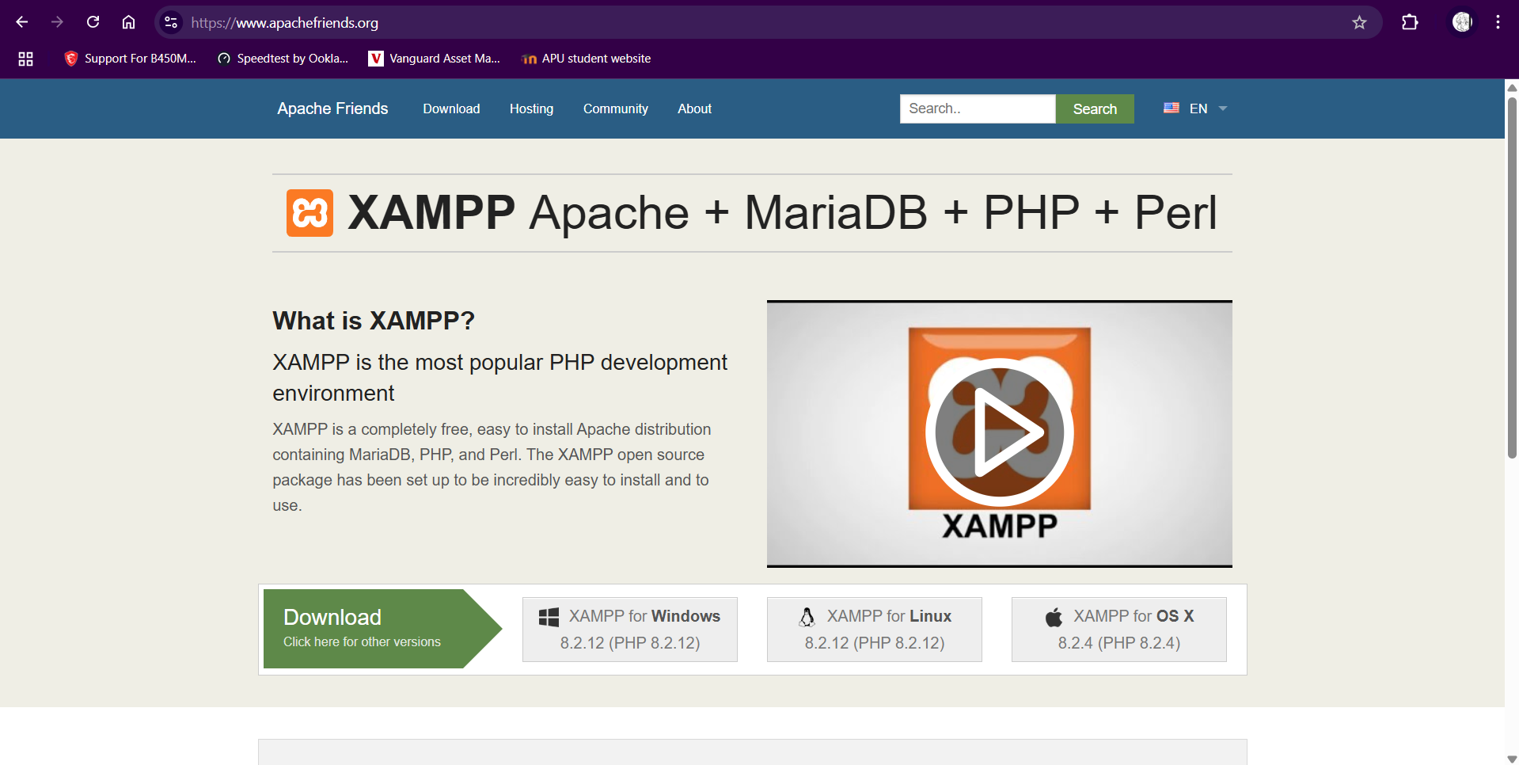

Xampp will be used as the local web server which will allow the machine to run and test websites and applications. Installation can be done through <https://www.apachefriends.org/> . When starting xampp installer, select next button and install, so xampp will have default settings.

Step 2: Download Visual Studio Code.

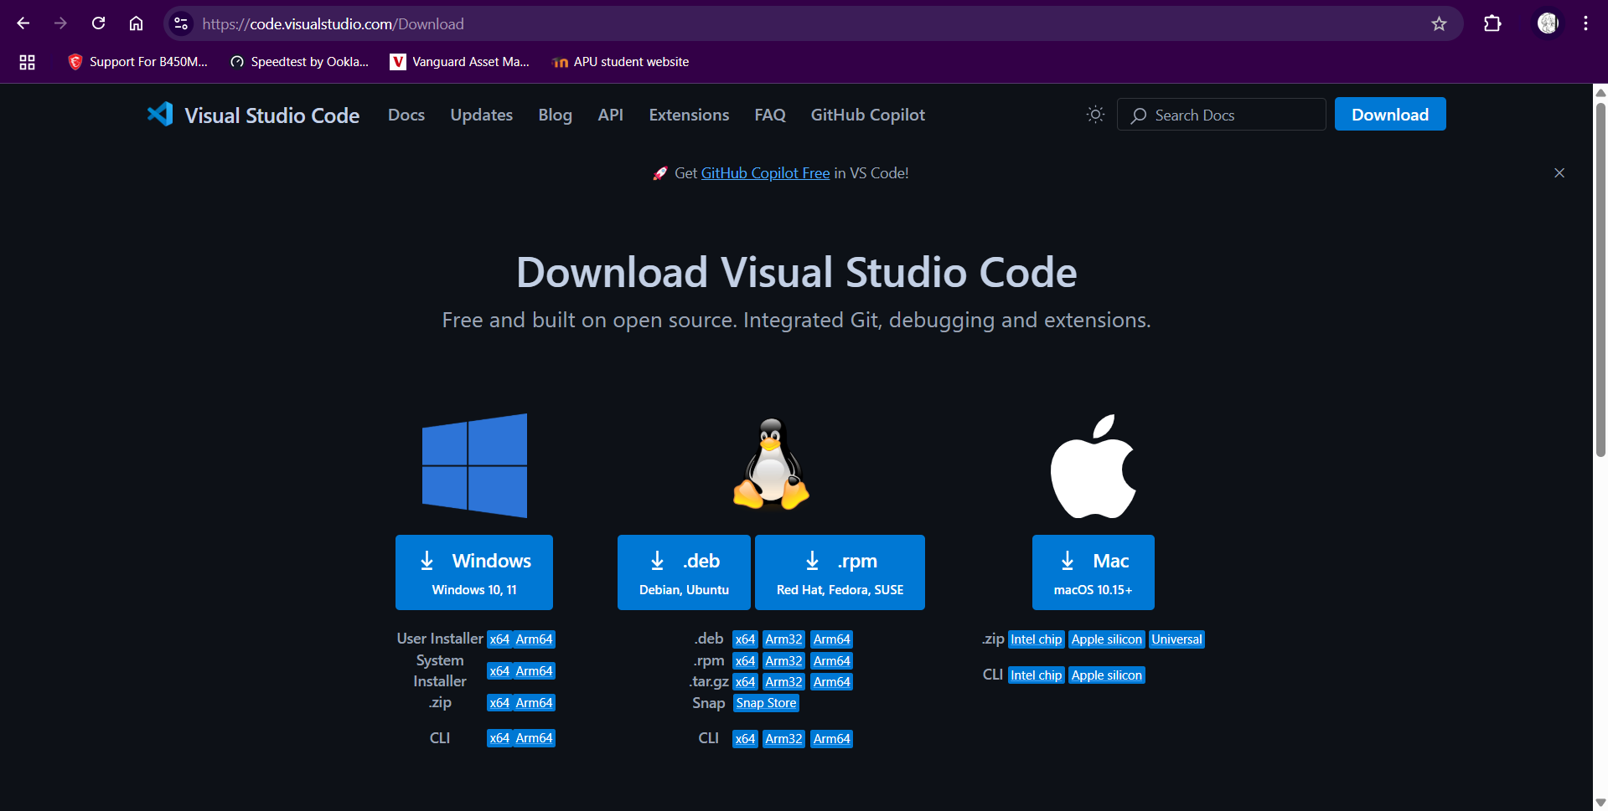

Visual Studio Code will be used as a coding platform for the code. Installation can be done through <https://code.visualstudio.com/Download> . When installing visual studio code, select next button and install, so visual studio code will have default settings.

**Setup Guide** (Wong Kap Onn TP074292)

Step 3: Open XAMPP Control Panel

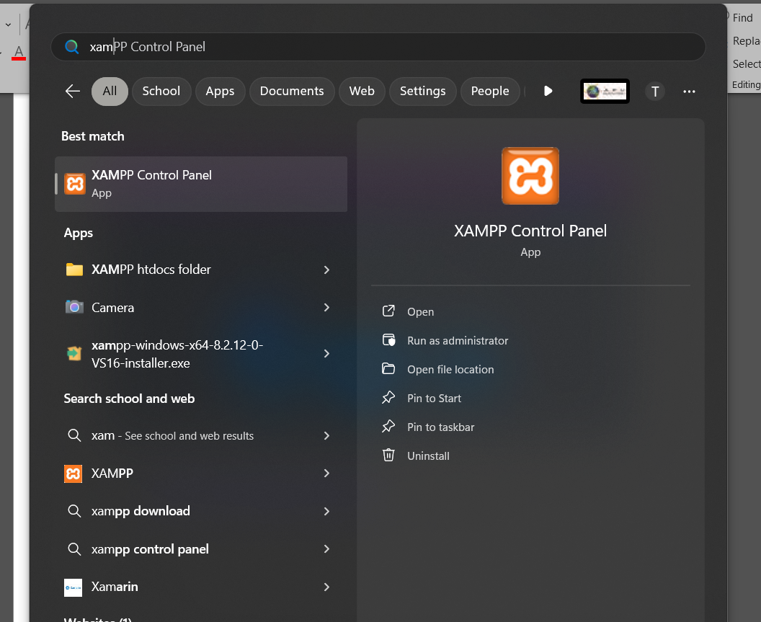

Step 4: Select Start for Apache and MySQL

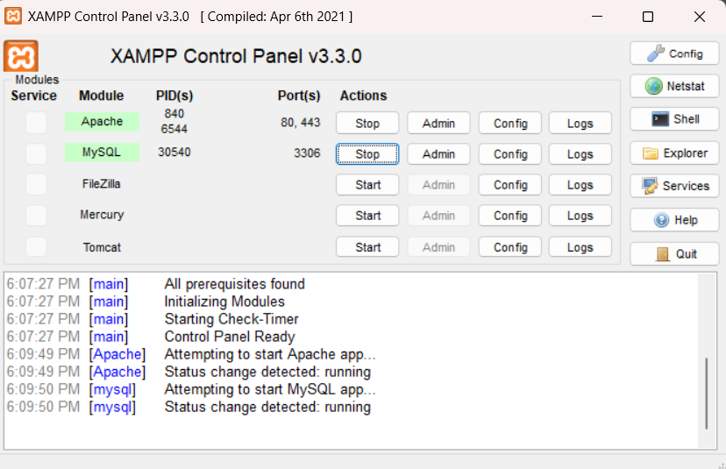

Step 5: Select Admin in MySQL

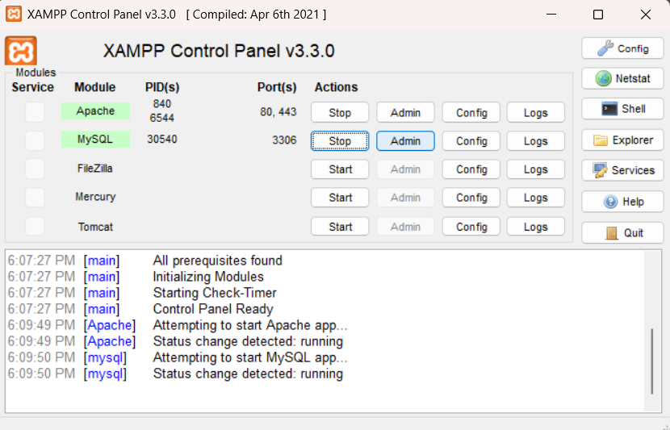

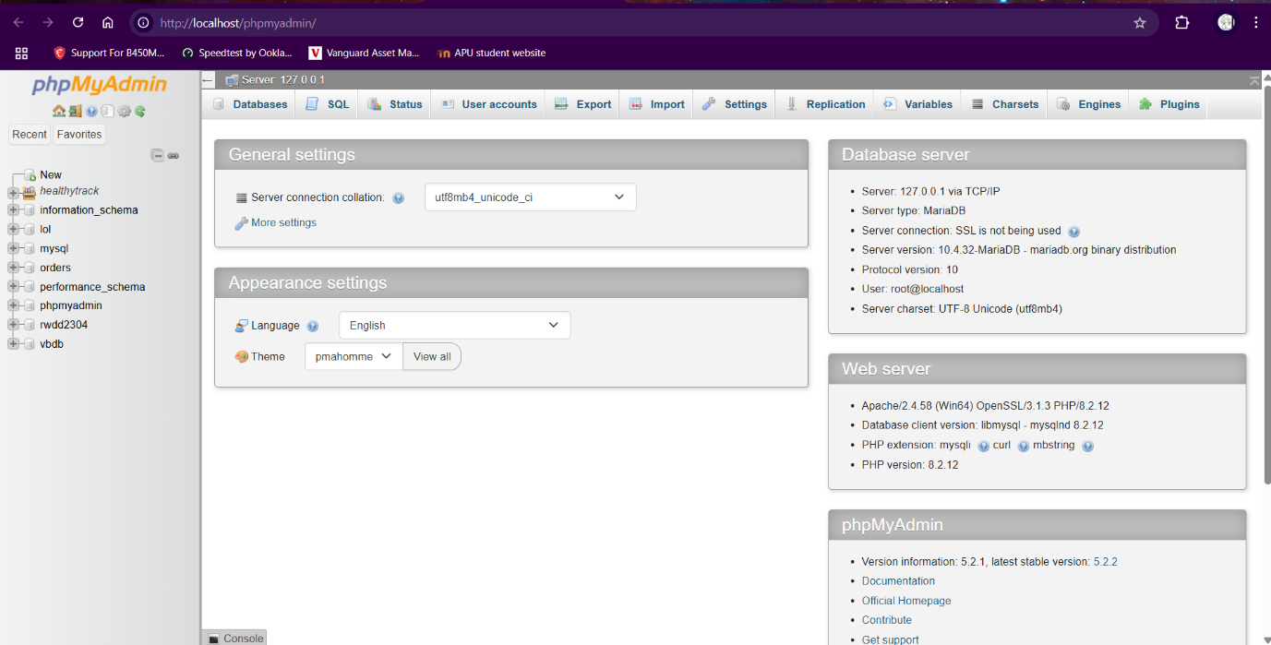

Step 6: Select New and name database as healthytrack

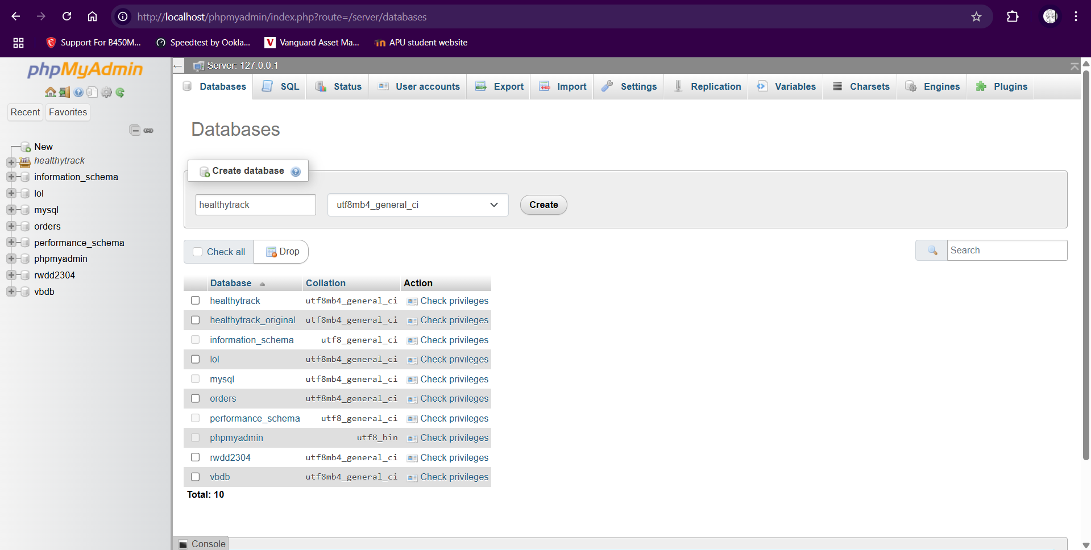

Step 7: Import the database file (healthytrack.sql)

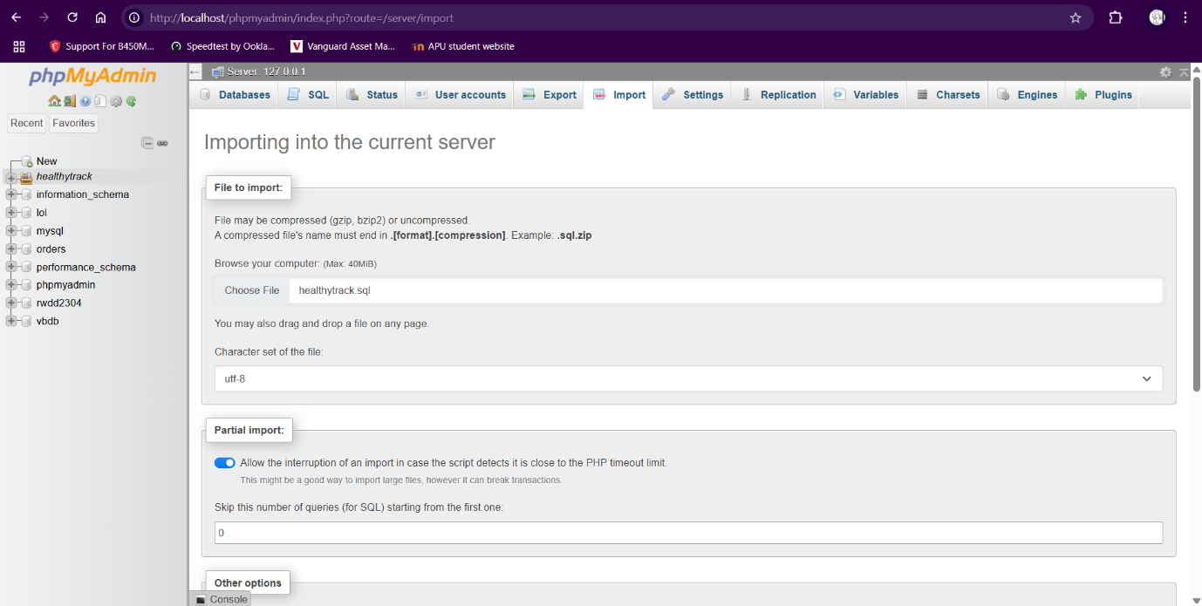

Step 8: Open Visual Studio Code

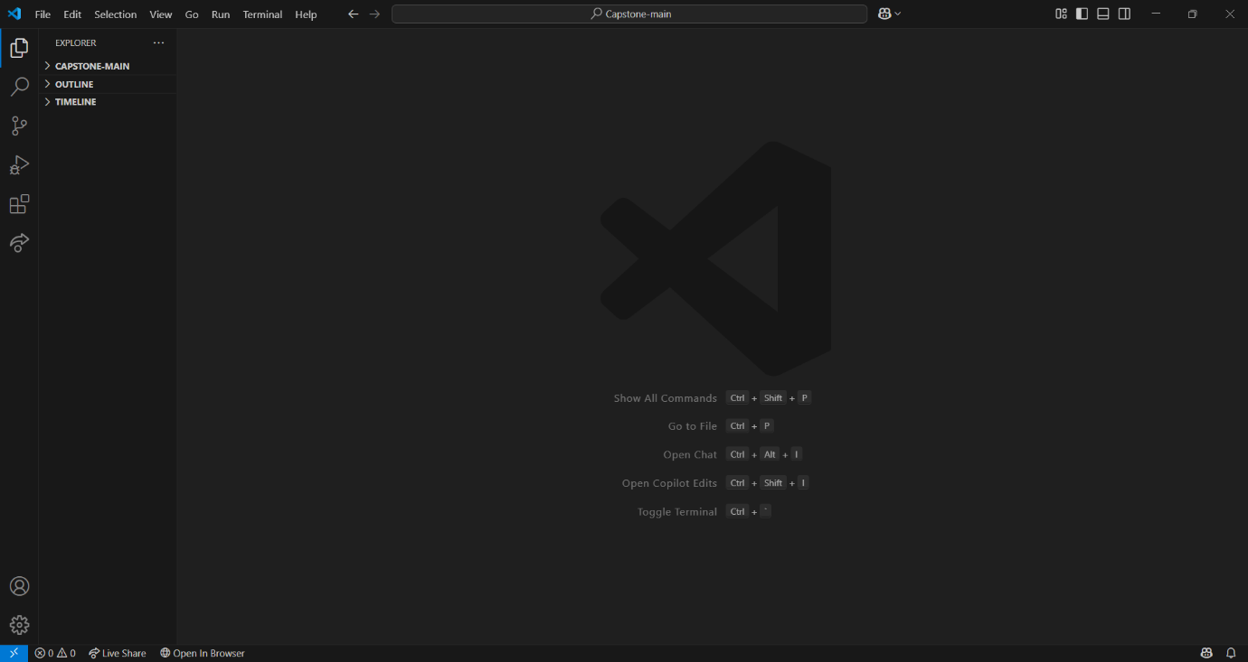

Step 9: Select File, Open Folder and select folder.

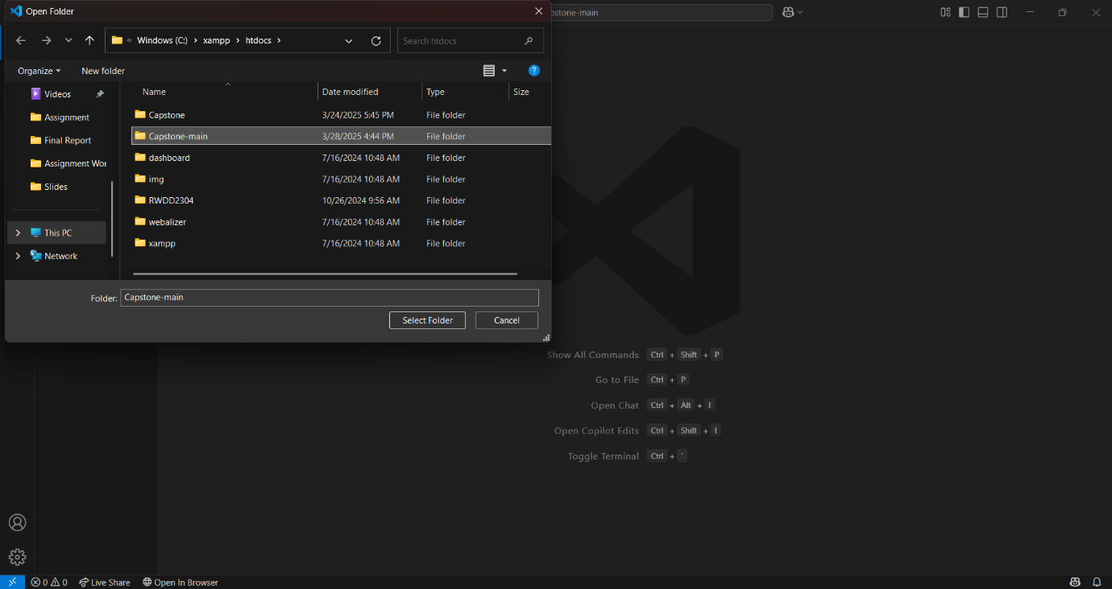

Step 10: Install the plugin: “Open PHP/HTML/JS In Browser” in Visual Studio Code.

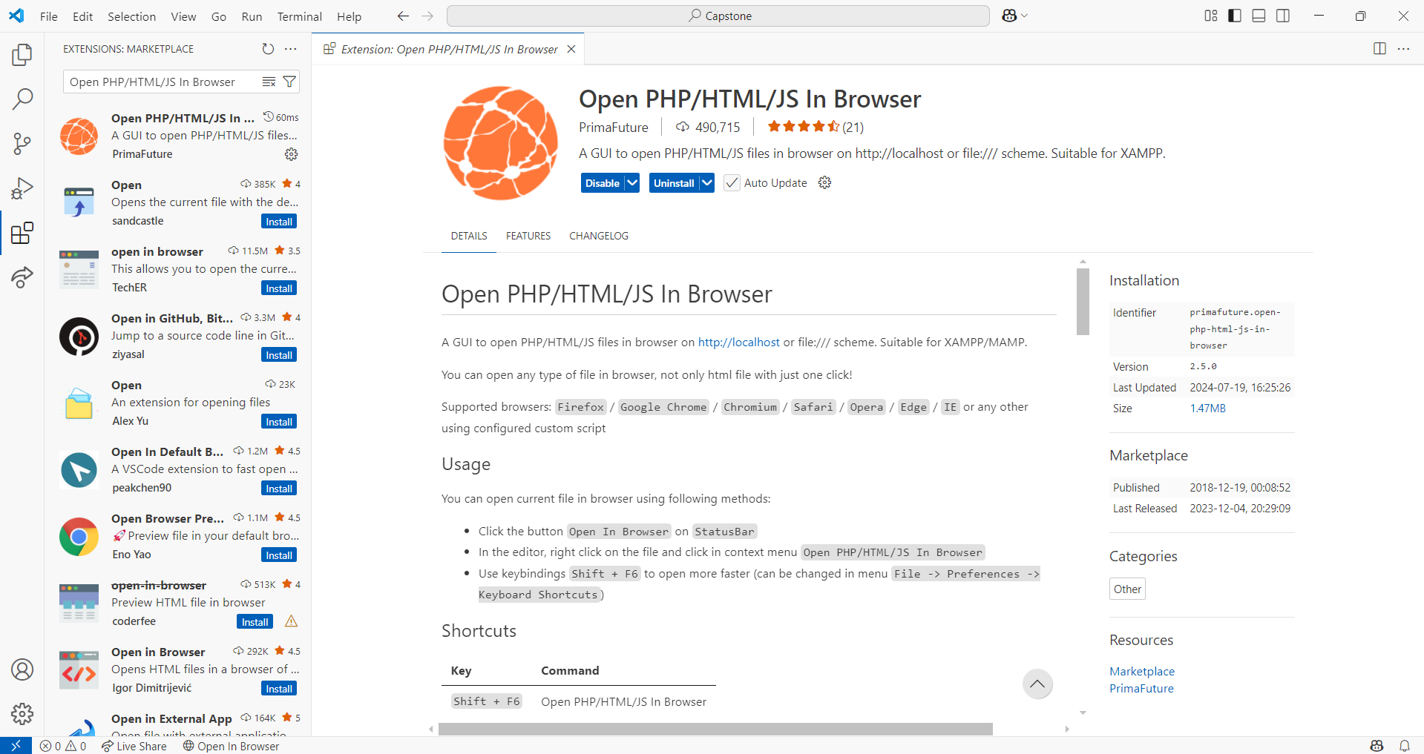

Step 11: Select Register.html, right-click and select Open PHP/HTML/JS in browser.

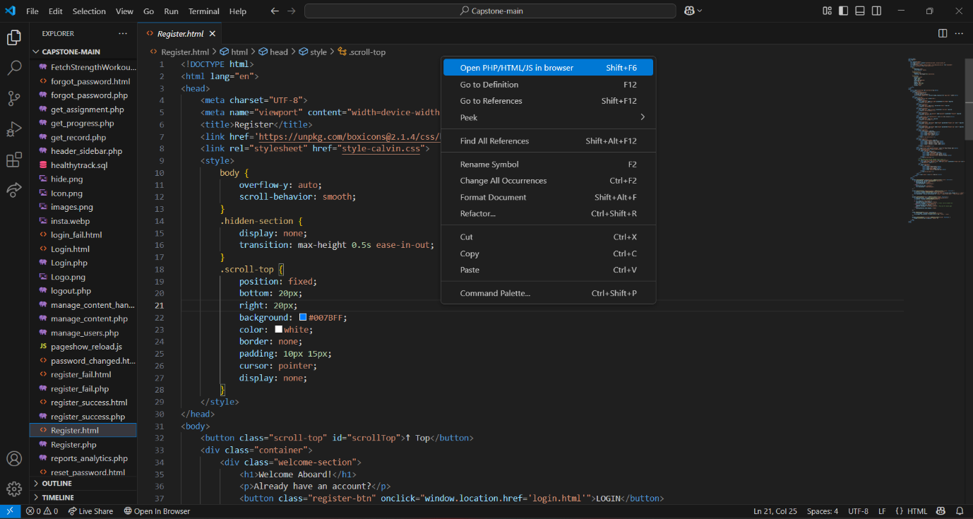

Step 12: Have fun with the system!

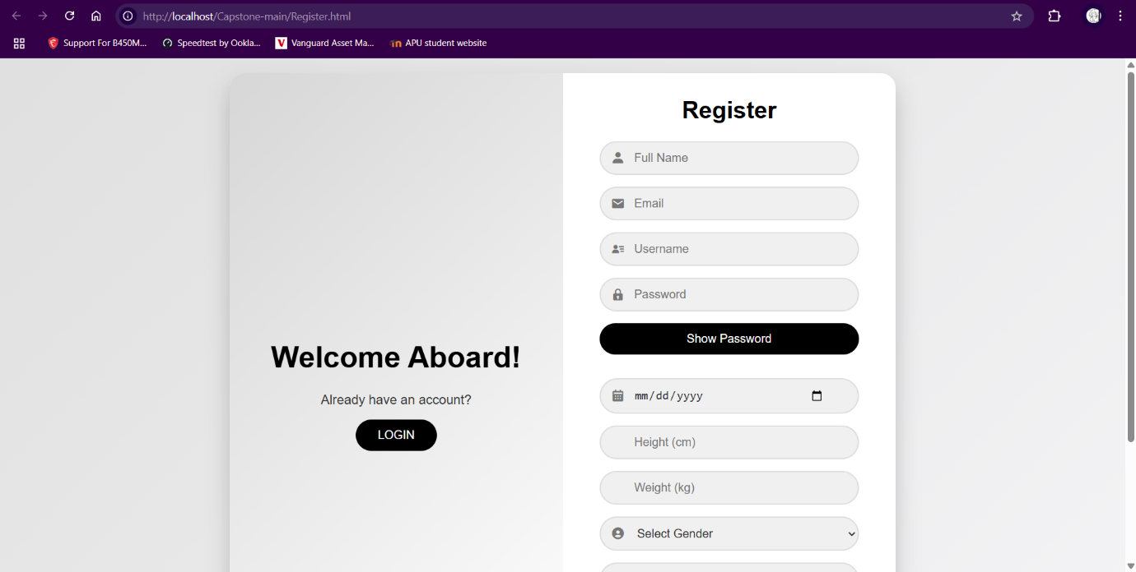

Additional Information:

Admin Username: 222

Admin Password: 222

# 12.0 Conclusion (Ng Wei Yang TP074904)

As we move forward with the development of the Fitness Management System with Personalized Diet Plans, we have identified key assumptions and anticipated challenges that may arise:

**Expected Assumptions**

* **User Data Accuracy:**

The key to the system is one’s ability to provide accurate personal information which includes age, weight, gender, dietary preferences, exercise routines and so on. For the effectiveness of the recommendations given by the system, it is assumed that user will input their data honestly and keep it updated on regular bases.

* **Consistent Usage:**

We assume that the users will use the system often, logging their progress daily, sticking to the suggested diets and exercise routines. Tracking improvements and flaws, through repeated refinement of the recommendations to achieve optimal fitness results is impossible without consistent usage.

* **System Accessibility:**

The presumption is that users will have good internet stable and devices which are compatible. With this assumption, users will have access to all system features like updates, progress tracking and database queries without interruptions.

* **Dietary Diversity:**

It is assumed that for most users, there will be enough variation in the meal database that their preferences and restrictions will be met. The systems should have the ability to easily accommodate various dietary preferences.

**Anticipated Issues**

* **User Engagement:**

Long term user engagement will be a challenge, since users could easily become unmotivated to track progress or follow plans over time.

* **Incomplete Data:**

Users may provide less than perfect or inconsistent data and as a result, the recommendations are less accurate, in other words, human error that our system cannot overcome.

* **Meal Plan Limitations:**

The system may not be able to accommodate users with very unusual or specific dietary restriction, this includes rare allergies or highly specific diets.

* **Cultural and Regional Barriers:**

To be able to make practical diet recommendations for certain users, the system needs to be robust database that takes into the considerations of food availability or in regional food preferences.

* **Hardware Limitations:**

The options for users are limited depending on the compatibility of their hardware, such as progress tracking through wearable devices.

In conclusion, we have identified these assumptions and potential issues early in development process and based on them, we can implement mitigation strategies and design a robust, user-friendly system that addresses the largest part of user's needs while acknowledging the limitations.

# 13.0 References

*Fitness Guide: A Holistic Approach for Personalized Health and Wellness Recommendation System*. (2024, April 18). IEEE Conference Publication | IEEE Xplore. <https://ieeexplore.ieee.org/document/10533529>

*Health monitoring web platform for real-time expert-user interaction*. (2017, August 1). IEEE Conference Publication | IEEE Xplore. <https://ieeexplore.ieee.org/document/8316423?utm_sourc=>

Adobe Communications Team. “Waterfall Methodology: Project Management | Adobe Workfront.” Adobe.com, 2022, <https://business.adobe.com/blog/basics/waterfall#what-is-the-waterfall-methodology>

GeeksforGeeks. (2018, March 18). Waterfall Model - Software Engineering. GeeksforGeeks. <https://www.geeksforgeeks.org/waterfall-model/>

Font awesome. (n.d.). Font Awesome. <https://fontawesome.com/> <https://cdnjs.cloudflare.com/ajax/libs/font-awesome/6.0.0-beta3/css/all.min.css>

Chart.js. (n.d.). Open Source HTML5 Charts for Your Website. <https://www.chartjs.org/>

<https://cdn.jsdelivr.net/npm/chart.js>

*MyFitnessPal*. (n.d.). <https://www.myfitnesspal.com/exercise/diary>

*W3Schools.com*. (n.d.-b). <https://www.w3schools.com/php/php_mysql_insert.asp>

*W3Schools.com*. (n.d.-c). <https://www.w3schools.com/js/>

Maurya, S. (2022, October 12). How to add a date picker in HTML? - Scaler Topics. *Scaler Topics*. <https://www.scaler.com/topics/date-picker-in-html/>

GeeksforGeeks. (2022, June 6). *How to fetch data from localserver database and display on HTML table using PHP ?* GeeksforGeeks. <https://www.geeksforgeeks.org/how-to-fetch-data-from-localserver-database-and-display-on-html-table-using-php/>

GeeksforGeeks. (2024, June 5). *How to Insert Form Data into Database using PHP ?* GeeksforGeeks. <https://www.geeksforgeeks.org/how-to-insert-form-data-into-database-using-php/>

# 14.0 Appendix

Minutes of Meeting

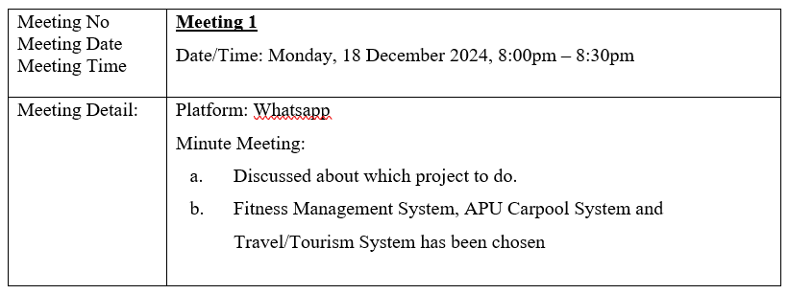

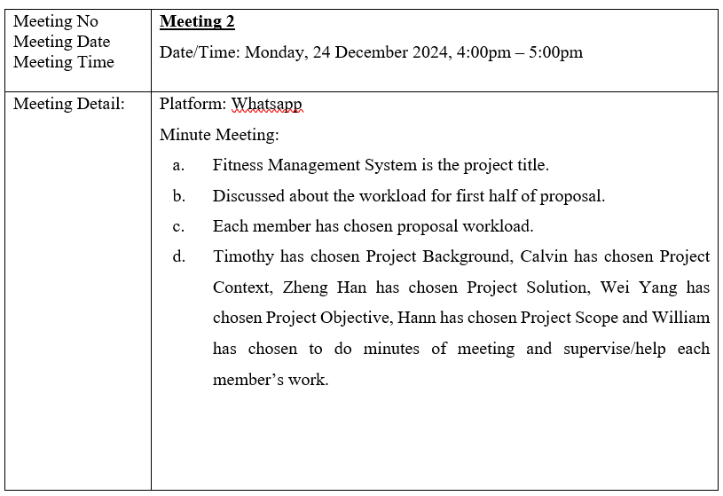

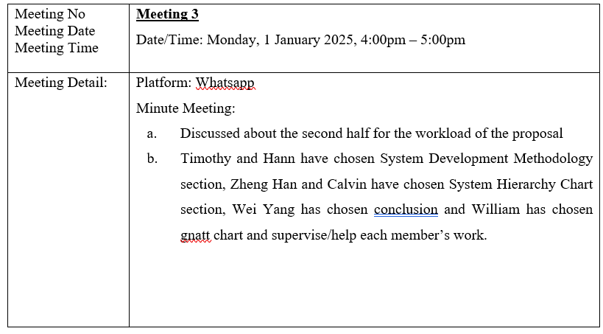

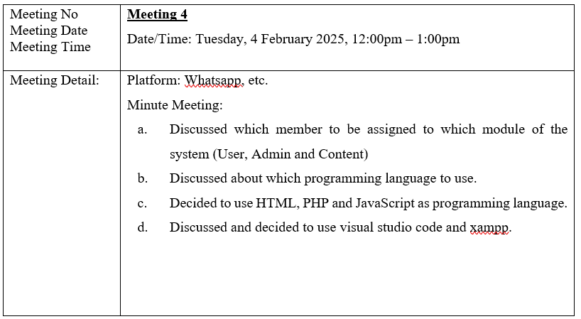



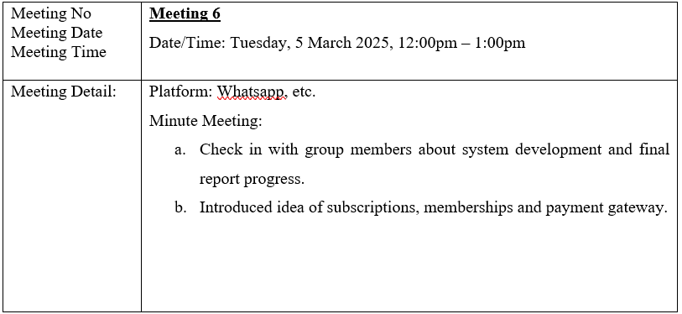

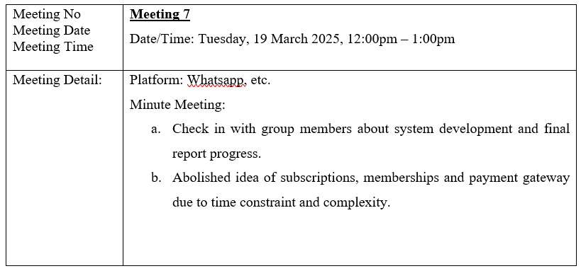

Project Gantt Chart Link:

<https://cloudmails-my.sharepoint.com/:x:/g/personal/tp074292_mail_apu_edu_my/EYQZWytnuQtDg-qP9agHsjMB4QfqfIfXY-_O2jA0uRoEQw?e=hotDl2>